Harpoon game

By Luke Allenhj

Contents

Analysis 5

• Problem Identification – 5

• Stakeholders 6

• Computational Approach 6

• Research of the problems 7

Mr Gun 7

Angry Birds 8

Happy wheels game maker 8

Super smash bros brawl 8

Minecraft 9

• Interviews/ Questionnaire 10

Interview 10

Questionnaire 10

• specifications 22

Hardware 22

Software 22

• Specify the proposed solution 22

• Limitations of the solution 23

Design 24

User interface 25

Data structures 32

Object: Sprite 32

Object: Block (parent class: sprite) 32

Object: Player (parent class: Block) 32

Object: Button 33

Algorithms 34

Class Block 34

Class Button 34

Class Player 36

Design of AI algorithms 38

Test Plan 39

Implementation 42

Iteration 1 – Continuous 42

Constants and Imports 42

Player class 42

Block Class 45

Objects 45

Iteration 2 -level building 48

Creating blocks 48

Selecting blocks 48

Moving blocks 48

Making blocks larger or smaller 48

Turning blocks 48

Making area where harpoon starts 48

Testing game and making it playable in levels 48

Saving the level 48

Loading levels 48

Levels being locked with a message appearing if so 48

Iteration 3 – options and menus 49

4 – Buttons 50

5 – Scrolling using mouse 50

6 – Typing 50

7 – Colour and key changers 50

General 51

1 – game loop 51

3 – Blocks 51

Continuous 51

Level builder 51

Levels 51

Testing 51

Test 1 51

Test 2 52

Test 3 52

Test 7 53

Test 11 53

Test 13 54

Test 14 54

Test 15 54

Test 16 55

Test 19 56

Test 20 56

Test 21 56

Test 22 57

Test 23 57

Test 32 58

Evaluation 60

# Analysis

## Problem Identification –

There are multiple online arcade games where people are able to play for short periods of time, whether it is in their lunch or coffee break or they just want to relax for a short amount of time. Although one major problem is that people get bored of these arcade games quickly due to there repetitiveness and lack of anything different. Another major problem is that a lot of people are split into preferring either reflex-based, intuitive, or creative games.

My idea is to create a game with all 3 different genres of arcade game, whereby the games is split into 3 different sections: Continuous, levels and self-built.

Continuous is a solo player unlimited score game where the player will press space to turn a gun on the screen, once player releases the space button, the gun will shoot a harpoon. If the space button was released at the correct time the harpoon will hit the next wooden block and the gun will replace the wooden block and you will be able to spin the gun again. This will be the reflex-based part of the game due to the fact that the speed at which the screen comes down and the speed at which the gun will turn will speed up. Every time you hit the correct wooden block a point will be added to your score – the aim of the game is to get the highest score therefore friends can compare results and compete in who can get the highest score. The wooden blocks will spawn above the gun and with random x coordinates.

In levels, I will have 6 levels to do. Here I will have already pre-made 6 levels, 3 of the levels will be speed trial and 3 will be puzzle (puzzle type is where there are many possible blocks that you can hit and many different routes but only one of the routes will get to the finishing block, speed trial is when there is 1 route which all get to the golden block but the main aim is to get to the golden block as fast as possible). This part of the game includes a mix of reflex-based and intuitive To be able to play level 2 of the speed trials, you will have to get a silver medal at the least in level 1, and to be able to play puzzle 2, you will have to have completed level 1 of the puzzle levels.

In Self-built, which you can unlock after reaching a score of 20 in continuous. To start off the creation of a level, the creator will need to state the name that they are giving the level, how hard they would rate the level out of five, and whether it is a puzzle level or a speed trial level. After this they will be able to start making their course, they’ll do this by selecting the colour, red or blue and then they will create areas made up of rectangles, after they create the rectangle they will then be able to turn they rectangle they created. After this they will be putting down their wooden blocks, golden block(s) [if more than one way to win] and checkpoint blocks if it is a really long speed trial. This final part of the game is a mix of intuitive and creative arcade games. This also allows more social activity as you will be able to share levels.

## Stakeholders

My stakeholders will be those in the general public with free time to spare. My main targets in the general public will be those less than 70; this is due to the people above 70 have significantly slower reflexes and therefore it will be hard for them to get scores exceeding 15.

The main targets will be kids in the age between 6 and 22 due to the amount of free time the possess and the higher percentage of gamers in the age group. The main target age bracket dropped to age of 6 because this game allows young kids to be creative in making levels and should help their non-verbal areas as they will be solving puzzle type levels as well. Specifically, my 6-year-old cousin Ki would be a stakeholder as it would help his creative side and also help his reflexes.

## Computational Approach

I believe this is a computational problem because the main problem is to create a game that has all 3 types of arcade games. By definition an arcade game is a type of computer game, this is because there aspects to these solutions that require a computer; for example the enemies need to control themselves and the screen needs to move itself downwards at a certain pace which might not be possible for a human due to time consuming equations. Also, another large problem is that this game is quick so that the clients will be able to play a game in their coffee breaks. If this was a board game, then less people would play because it is time consuming to set up.

## Research of the problems

Whilst researching for the solution to my problem and for the design of my game, I came across a few arcade games which I thought had some very good ideas which I could possibly implement into my game.

### Image result for mr gunImage result for mr gunMr Gun

Mr Gun is a game I found on my phone, where you are the player on the lower platform, and you have to shoot the bad guy above you; your gun starts at a horizontal level, then rotates anti-clockwise until either you shoot by tapping down on the phone, or by getting to the vertical line and then moving clockwise until either a shoot or it gets to horizontal line and repeats, when you get a headshot. Once the gunner has reached the 100th level, you in effect restart the level but keep your score, so it ends up being continuous. If you miss your shot, then the enemy shoots you and you die. After you die a death screen appears which a replay button, a leader board button and an Instagram button; it also shows your score and the best score. This game also has a coin system where you can buy guns in the store, or different skins for the gunner

The aspect about this game that I would like to incorporate into my game is the feature of once the gun has reached a specific direction, it will suddenly start turning the other way instead. I also wish to incorporate the idea that if you do not hit the enemy first time then you die. I also wish to use the death screen like in this game but instead of an Instagram button, a home button. I’m not going to have a coin system because in full honesty I do not know what the player would be buying with these games.

### Related imageImage result for angry birds levelsAngry Birds

Here in angry birds, there is a level screen, where you choose which level you want to do by clicking on the number, each level shows you what star rating you have out of 3. There is also a back button if you want to go back to the home screen. Within the actual levels the aim of the game is to knock over some premade towers by shooting birds at them; one factor you have to account for in this game is gravity.

I will be using the idea of putting a little symbol below my levels to show weather it is complete or has 3 stars. I will also be using the idea of just having a simple background like this. Another aspect that I may be taking from this game is the use of gravity in my levels – this will make it more interesting and put a completely new dynamic on it.

### Happy wheels game maker

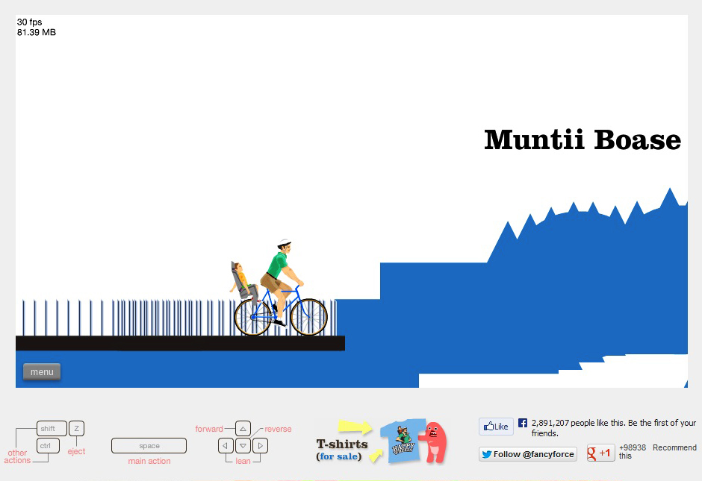

The objective of happy wheels is to get to the finish line without dying, one of the aspects that is similar in this game that is similar in what I want is that there is a level builder within it. Some aspects that I like about this game is that they pre-place the player, and if you want to drag the player around you can. Excluding that it gives complete freedom to place a selection of, different kinds of, blocks down wherever you want. Another thing I like about this game is that you can rotate blocks so that they are set down differently, this gives even more freedom to the player and also allows them to make shapes like being in a snake.

### Super smash bros brawl

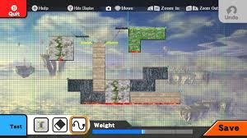

In super smash bros brawl, there is also a level builder here, what this has which would be nice to add to my level builder is a grid, although the only problem with this is if I where to turn an object it might not be able to fit on to the grid correctly. The main thing that I like about Super smash bros brawl is the layout, where it has a quit on the top left, a save button on the bottom right and most importantly a test button where you are able to test whether your game plays out as how it did in your head, and whether your game is possible to complete. Another main feature which I may include in my game is the ability to undo an action meaning if you accidentally moved it if you place this button it will go back to the place it was originally at.

I also really like the eraser feature, but I feel as though there might be a lot of accidentally deleting, which is why I have decided to keep the deleting to just selecting the item and then hitting the backspace button.

### Minecraft

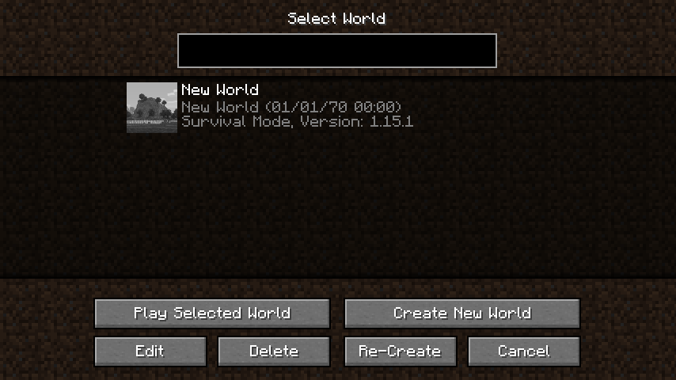

In Minecraft a self-generated world is built for you and then you add to this world by building various things from houses to rollercoasters but when selecting which world you want to edit, this page comes up, I thought this was a really good way of laying out which self-built level you want to play.

## Interviews/ Questionnaire

* + What do they want (enemies? gravity? Scoreboard? Time?)

### Interview

1. Do you play arcade games a lot?
   1. If not, why not?
2. How long is one average session of arcade game playing?
3. On what console do you normally play video games and why?
4. Does the time between first playing the game and last playing the game vary a lot between you arcade games?
5. Do you like different parts of a game?
6. How long do you like the duration of a level in an arcade game?
7. Is there a specific type of arcade game that makes you more relaxed than other types?
8. What have you found to be a good point scoring system?
9. Have you found brighter coloured games to be more annoying or better?
10. Would you like to be able to make levels?
11. Would you like to be able to change friends’ levels (this also means that friends can change your levels)?
12. What normally makes you stop playing an arcade game?
13. If you made your own arcade game, what would you do to it to make it different?
14. What specific features of arcade games do you like?
15. What specific features of arcade games do you hate?

Question 1 and 2 is really to see how useful the interviewee will be because if they do not play a lot of these games then they might not know as much on these games and they will not be the ones playing these games so their opinion is less on the priority list. Question 3 is to see what types of controls they prefer to use and why they think it is better. Question 4 is to see if the interviewee gets bored of specific features and to see if they know what they want. Question 5 is to see if my theory of people liking having more than one type of game to play. Question 6 is to see if they would prefer multiple games in their small breaks or 1 slightly longer game. Question 7 is to check that the solution I have come up with will allow the player to also relax and not just have fun. Question 8 is due to the fact that some people hate types of scoring system like timed or distance. Question 9 is due to the fact that some people get distracted by having colour in the game whereas other prefer it. Question 10 is to check how much of a creative person this interviewee to allow me to assess if this person is the type that could play my game. Question 11 is a rather serious opinion to get their opinion on the topic. Questions 12 and 13 are to see what else I can add/ not add to the game to make game better. Questions 14 and 15 allows me to see exactly what the client wants and doesn’t want.

#### Responses

##### Friend : tom

1. Do you play arcade games a lot?

‘sometimes, but not a lot’

* 1. If not, why not?

‘they tend to be very repetitive and get rather boring quickly’

1. How long is one average session of arcade game playing?

’10-15 minutes’

1. On what console do you normally play video games and why?

‘PC and phone’

1. Does the time between first playing the game and last playing the game vary a lot between you arcade games?

‘yes, the longest would be around 6 months and shortest a week’

1. Do you like it if there are different parts of the game?

‘yes, as if I get bored of one I can switch’

1. How long do you like the duration of a level in an arcade game?

‘5 minutes, 10 minutes max’

1. Is there a specific type of arcade game that makes you more relaxed than other types?

‘I like puzzles, if they count as arcade games, because there is not timer or death’

1. What have you found to be a good point scoring system?

‘distance’

1. Have you found brighter coloured games to be more annoying or better?

‘I like to have colours but not extremely bright colours’

1. Would you like to be able to make levels?

‘yes, as I can control the difficulty’

1. Would you like to be able to change friends’ levels (this also means that friends can change your levels)?

‘no, as I don’t like the idea of friend’s possibly ruining my levels also means that they could possibly cheat on my levels, but I would like to be able to play friends’ levels’

1. What normally makes you stop playing an arcade game?

‘very repetitive, same objectives’

1. If you made your own arcade game, what would you do to it to make it different?

---

1. What specific features of arcade games do you like?

‘Games getting faster’

1. What specific features of arcade games do you hate?

‘Slow starts’

##### Analysis of Tom’s interview

Tom doesn’t play a lot of arcade games, which either means he simply doesn’t like them in general or there are specific features of arcade games that he doesn’t like (meaning he could be a terrible interviewee for this topic or a really good one). Tom plays average of 10-15 minutes which is good because we are aiming are clients to be ones that play this game in their breaks which are roughly this time. He plays on the computer and phone meaning he does know how to play on pc. He seems as though he finds a lot of arcade games repetitive and would like have different parts to an arcade game. Another useful thing is he likes the idea of friends’ being able to play each other’s games’ Also implies he doesn’t want to brighter colours maybe as he doesn’t want to have to be squinting or it distracts him. Something I need to make sure is that the game gets faster, possibly in continuous or speed trial levels and also make sure that there are no slow starts within the game.

##### Friend: Elisa

1. Do you play arcade games a lot?

‘a reasonable amount of time’

* 1. If not, why not?

1. How long is one average session of arcade game playing?

’10 mins, but have often number of session, roughly 4 a day’

1. On what console do you normally play video games and why?

‘phone normally’

1. Does the time between first playing the game and last playing the game vary a lot between you arcade games?

‘yes, if I do not like the game I will delete it after first playing it, but if I like it I will keep it’

1. Do you like it if there are different parts of the game?

‘yes, but admittedly I have not encountered many of these games’

1. How long do you like the duration of a level in an arcade game?

‘ 5 mins’

1. Is there a specific type of arcade game that makes you more relaxed than other types?

‘a creative type of game like minecraft’

1. What have you found to be a good point scoring system?

‘distance, or objects hit’

1. Have you found brighter coloured games to be more annoying or better?

‘only annoying if colours are changing every second, but if changing at constant rate, it could make it more difficult’

1. Would you like to be able to make levels?

‘definitely, as I find that kind of thing more fun’

1. Would you like to be able to change friends’ levels (this also means that friends can change your levels)?

‘yes as I may add to their levels’

1. What normally makes you stop playing an arcade game?

‘when there is another new game which is better’

1. If you made your own arcade game, what would you do to it to make it different?

‘One more line, I play it a lot because it has average score and want to beat my friend at this.’

1. What specific features of arcade games do you like?

‘constant scrolling’

1. What specific features of arcade games do you hate?

‘not being able to do special moves easily or non-logical controls’

##### Analysis of Elisa’s interview

Elisa sounds as though she plays a lot of arcade games, although she plays a lot of them on the phone which means her sense of controls could be a lot different. She prefers creative types of games meaning that the level builder solution area is more likely to work. Some noteworthy things she has said would be that she would want controls to be obvious so I may need put a controls panel to show the controls necessary.

##### Overall summary

Altogether I have learnt that a lot of people do play arcades for a short amount of time roughly, 5-15 minutes within one go, this is exactly what I expected and is very good because it means that doing an arcade game will be perfect for short breaks like coffee breaks. I’ve also learnt that first impressions are very important because some people delete the app if they do not like it straight away. Throughout it has been very consistent with the liking of having the game split into different segments. For the scoring system it has been confirmed that a very good way of scoring is distance as it is consistent and fair. For colours changing it is clear that people tend to find it more difficult when the background changes, but this could be used to make the game more difficult. Definitely a positive feedback for creating your own levels, although very mixed feelings about friends being able to change your level (also a good point was risen by tom about cheating), so I believe it would probably be best if I did not include this. Things that I have been told to include would be having the game become faster and constant scrolling, both of which I was already going to do. But what I will make sure I do not have are slow starts (especially to continuous) and to make sure that the player can find out what the controls are easily, and that there are not too many of them.

### Questionnaire

* Continuous game

1. Would you like to see the score as you go, or would you like to only see it after you have died?
2. Do you think there should be trick wooden blocks later where they look slightly different and therefore if you attach onto them you die?
3. Do you think I should add extra wooden blocks so that you can get points quicker?

* Levels

1. Do you think that the user should have to get to a certain score on continuous to unlock levels?
   1. If so, what score do you think it should be?
2. For speed trial do you think that the time should be shown on the screen whilst the game is playing?
3. For puzzle do you believe that the screen should move vertically, horizontally or in direction of movement?

* Level builder

1. Do you think there should be a change in game control settings?
   1. If not, do you believe moving the screen should be done by (left mouse button held down + movement of cursor) or (button pressed [e.g. p] + movement of cursor) or (up, down, left and right keys)?
2. Should the blocks be created by using specific keys for specific blocks or by selecting a block from a list of blocks?
3. Should the blocks be selected using the left click of a mouse or by the blocks being numbered and then pressing on their number?
4. Should the rotation of a block be like the rotation of an image in word, using a bar or an entry of no. of degrees on the image?
5. Would you like to be able to scroll in and out of level when editing it?
6. Should player be allowed to scroll in and out of level when playing it?
7. Should the creator of a level have to complete the level for it to be classified as ‘playable’
8. Should editor be able to increase size of wood.

Questions 1 and 5 are there to see the proportion of people dislike having constantly changing numbers in the corners of the screen because it distracts them, question 2 is asking to see if the clients would like the game to get harder, after certain scores or whether they would prefer the game to just get faster. Question 3 is asking if the clients would prefer the game to be sped up at the start or not. Question 4 is to see if the clients would like an objective in the continuous area instead of just having to get highest score. Question 6 is there because most puzzles might not be linear, therefore the screen might have to move in different ways.

Question 7 is there because some people may like to change the game controls whereas others might want fixed original keys. Question 8 is to see who would find who prefers creating blocks quicker or easier.

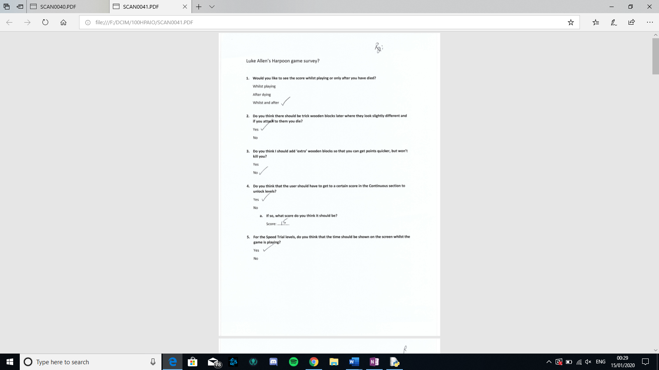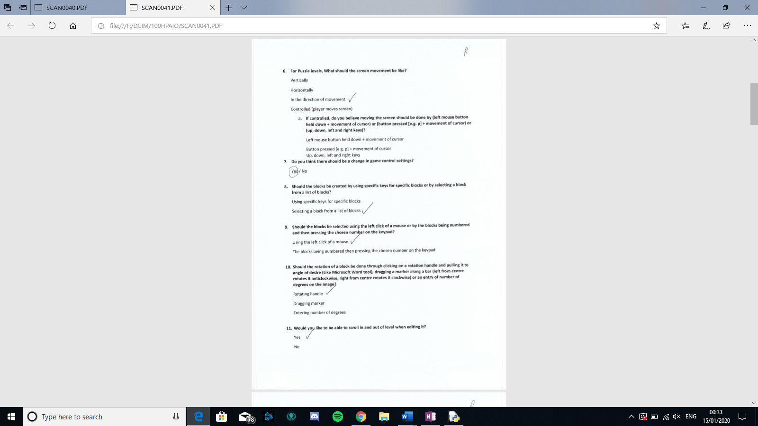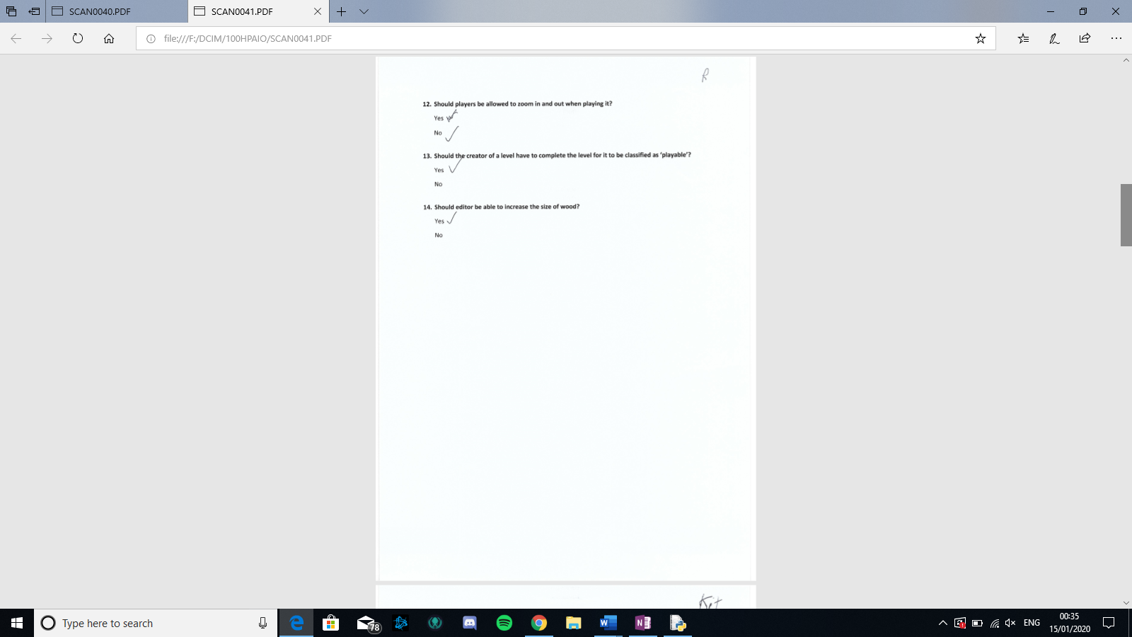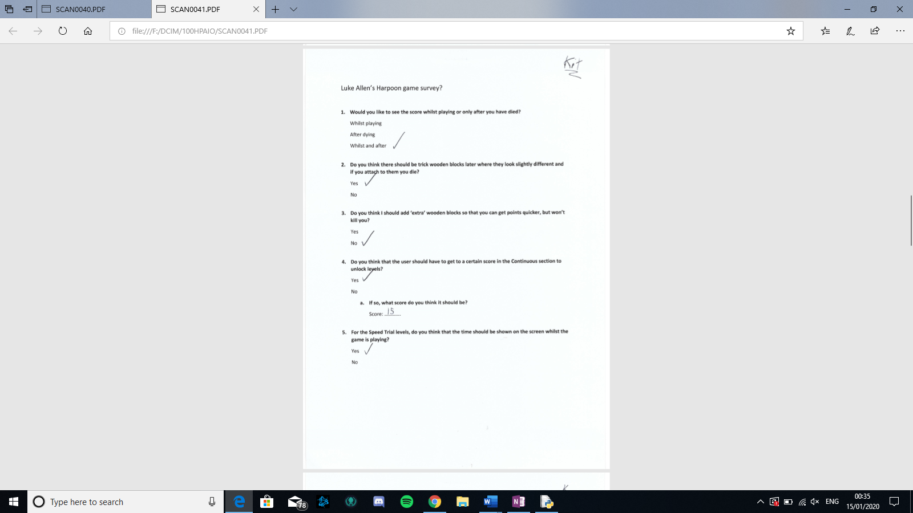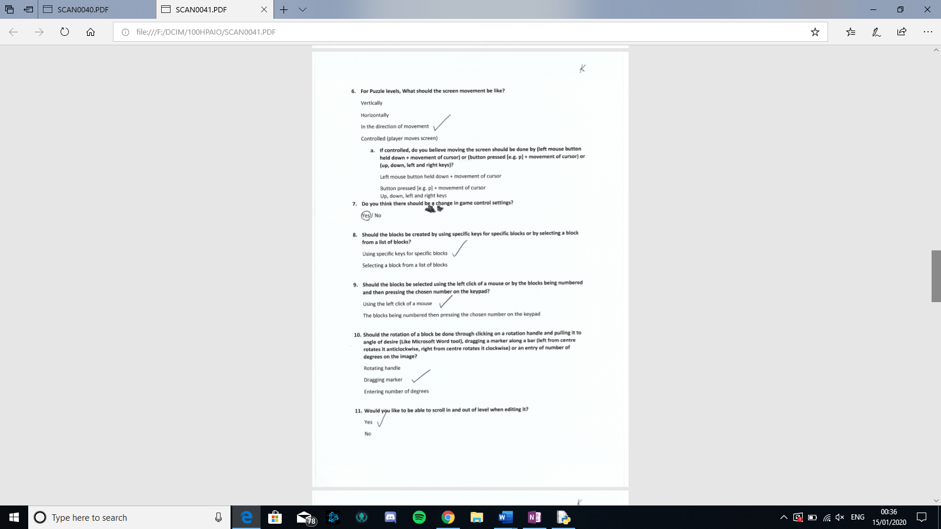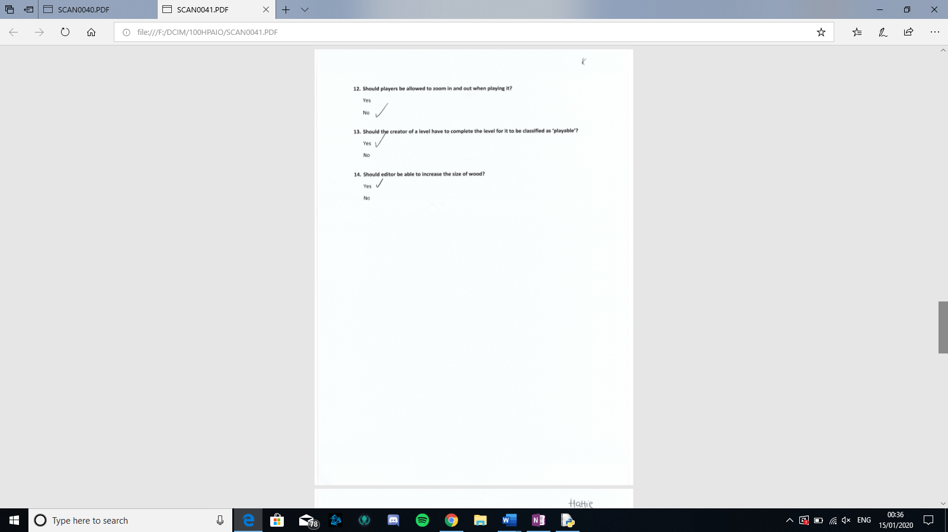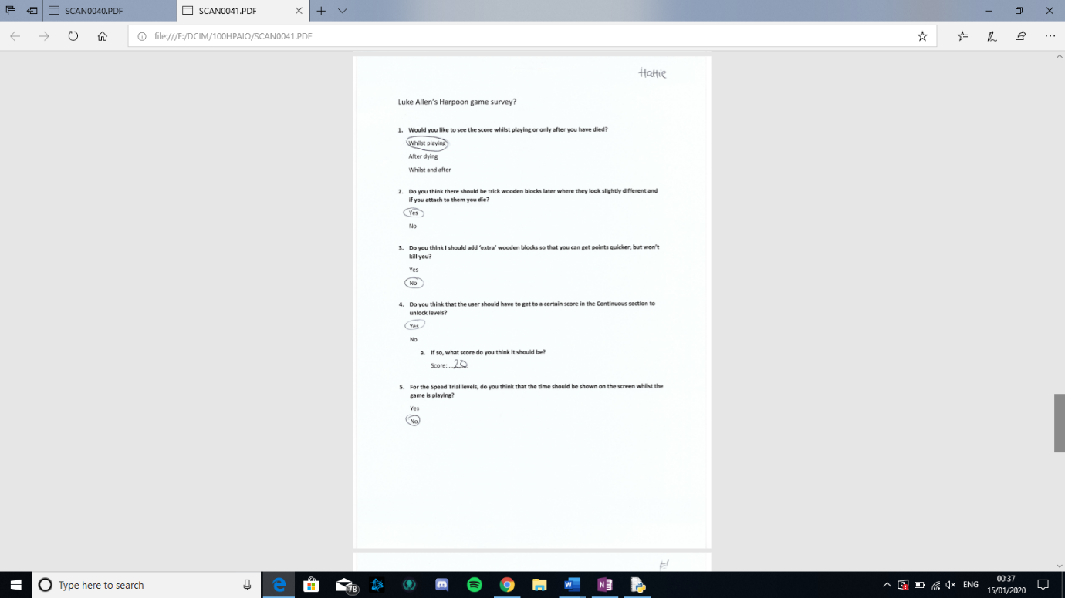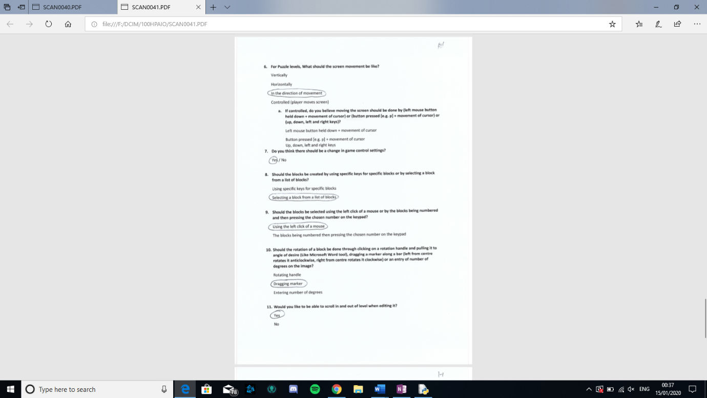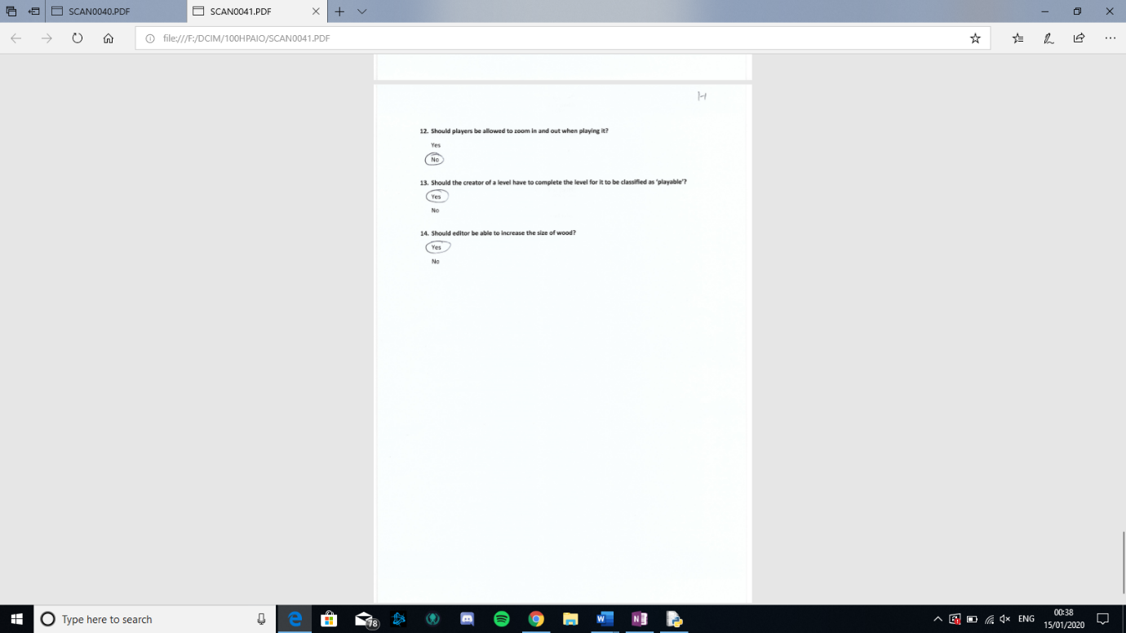

Questionnaire analysis

|  |  |  |  |  |
| --- | --- | --- | --- | --- |
|  | Option 1 | Option 2 | Option 3 | Option 4 |
| Q1 | 0 | 1 | 2 |  |
| Q2 | 3 | 0 |  |  |
| Q3 | 0 | 3 |  |  |
| Q4 | 3 [20, 15, 15] |  |  |  |
| Q5 | 2 | 1 |  |  |
| Q6 | 0 | 0 | 3 | 0 |
| Q7 | 3 | 0 |  |  |
| Q8 | 1 | 2 |  |  |
| Q9 | 3 | 0 |  |  |
| Q10 | 1 | 2 |  |  |
| Q11 | 3 | 0 |  |  |
| Q12 | 0 | 3 |  |  |
| Q13 | 3 | 0 |  |  |
| Q14 | 3 | 0 |  |  |

1. Would you like to see the score as you go, or would you like to only see it after you have died?
2. Do you think there should be trick wooden blocks later where they look slightly different and therefore if you attach onto them you die?
3. Do you think I should add extra wooden blocks so that you can get points quicker?

* Levels

1. Do you think that the user should have to get to a certain score on continuous to unlock levels?
   1. If so, what score do you think it should be?
2. For speed trial do you think that the time should be shown on the screen whilst the game is playing?
3. For puzzle do you believe that the screen should move vertically, horizontally or in direction of movement?

* Level builder

1. Do you think there should be a change in game control settings?
   1. If not, do you believe moving the screen should be done by (left mouse button held down + movement of cursor) or (button pressed [e.g. p] + movement of cursor) or (up, down, left and right keys)?
2. Should the blocks be created by using specific keys for specific blocks or by selecting a block from a list of blocks?
3. Should the blocks be selected using the left click of a mouse or by the blocks being numbered and then pressing on their number?
4. Should the rotation of a block be like the rotation of an image in word, using a bar or an entry of no. of degrees on the image?
5. Would you like to be able to scroll in and out of level when editing it?
6. Should player be allowed to scroll in and out of level when playing it?
7. Should the creator of a level have to complete the level for it to be classified as ‘playable’
8. Should editor be able to increase size of wood.

## specifications

### Hardware

Due to this game be a rather simple game with no special needs like a specific controller, the only thing needed for this game to run smoothly is the computer must have an estimate of 2GB RAM, a dual 1.5Ghz core processor, a mouse, keyboard and a screen

### Software

Because I created this game using python and pygame, the user will have to also have, excluding the game itself, python (version 3.6.2 minimum)/a python converter and also the pygame library which is all easily free and accessible online.

## Specify the proposed solution

**Necessary**

1. Continuous – when you press space, the harpoon gun will spin
2. Continuous – when you let go of space, the harpoon gun will go in the direction that it is pointing
3. Continuous – there is a death page that shows up when you die which will contain following:

* Score
* Back button
* Play again button
* Settings button

1. Continuous – the screen will scroll down
2. Levels – the levels will be unlocked when the necessary requirements are met (the previous level is completed)
3. Levels – there is a levels page of which the player chooses from
4. Maker – can do the following:
   * Add blocks
   * Delete blocks
   * Move blocks
   * Rotate blocks
   * Create checkpoints
   * Create finish points
5. Maker – the levels can be saved, opened and played.

**Good to have**

1. Settings – you can choose the colour of the following:
   * background image
   * KLC
   * BLC
2. Continuous – the death screen will fade the game and then have the box on top
3. General – there is a settings button at the top right corner of the screen excluding home page and when game is being played.
4. Maker – has a start page where you enter details of the level:
   * Name
   * Creator
   * Time limit

**Aspirational**

1. Maker – includes aspects of gravity like:
   * Can create specific areas of gravity
   * Can control the level of gravity of gravity
   * Can adjust the strength of the gravity
2. Maker – lines can do following:
   * Lines can move back and forth in set directions
   * Lines move a specified amount
3. There are optional sound affects

## Limitations of the solution

The main limitation of my solution is that the user will have to install python, this means that more storage of the user’s computer will be taken up; this also means that due to the need of python this game will not be able to be played on another console, although most of the interviewees said that they played most on pc and laptop anyway so this should be fine.

# Design

## User interface

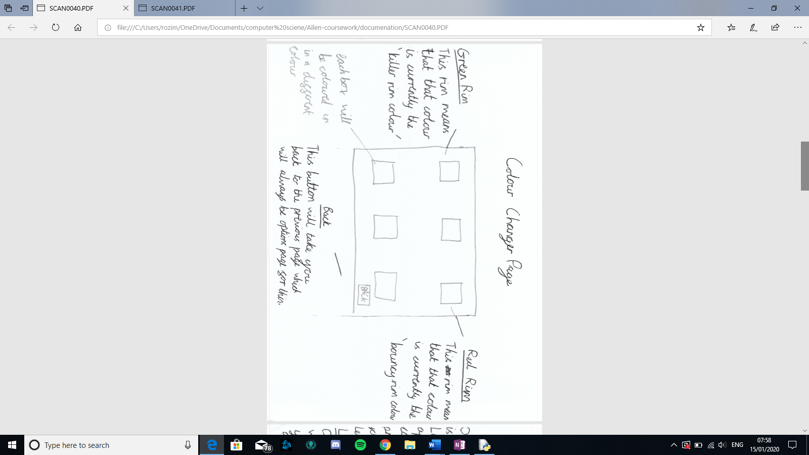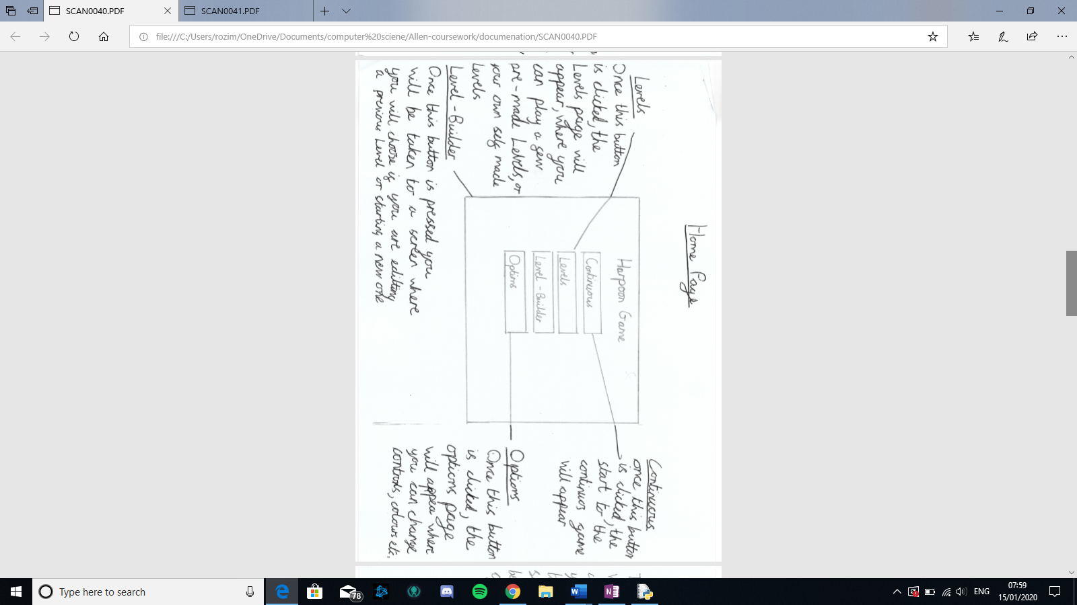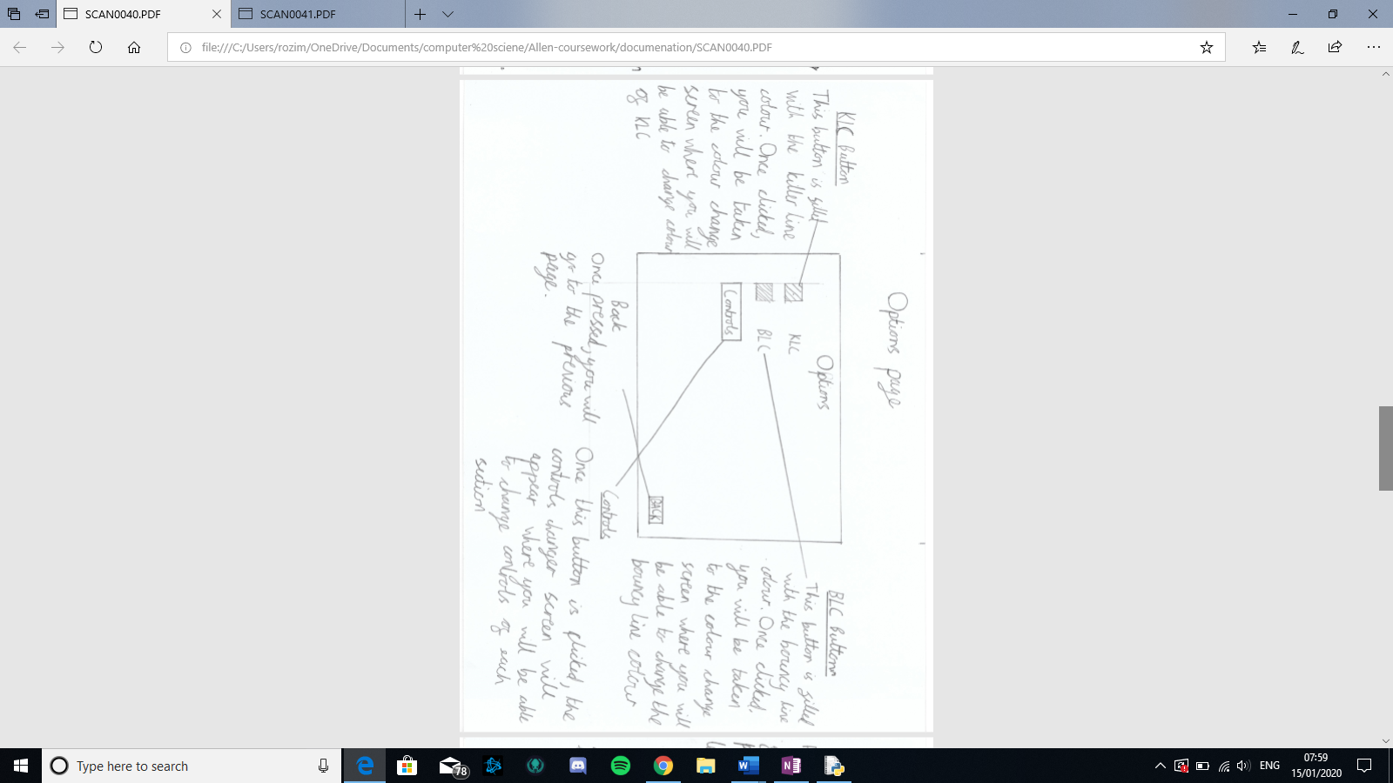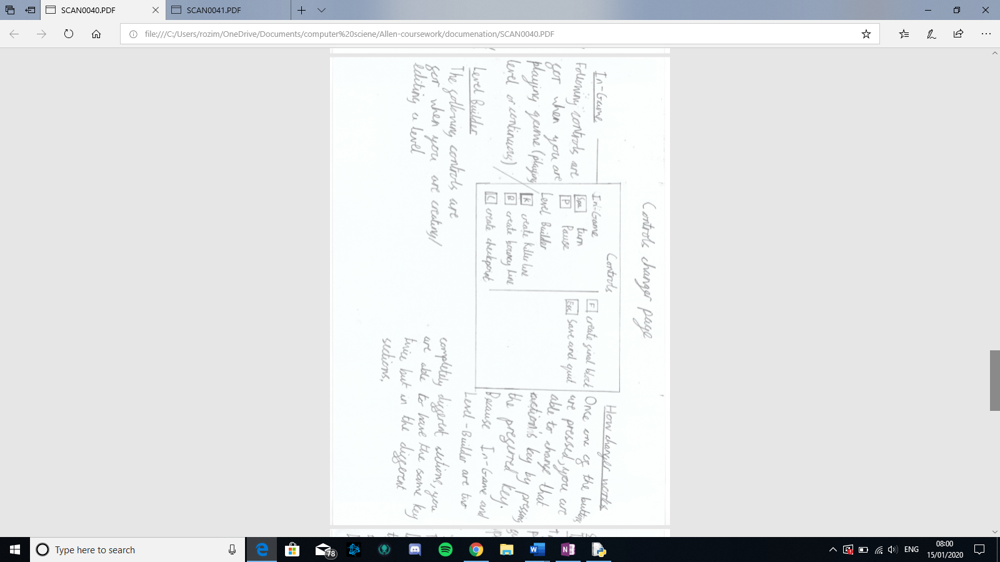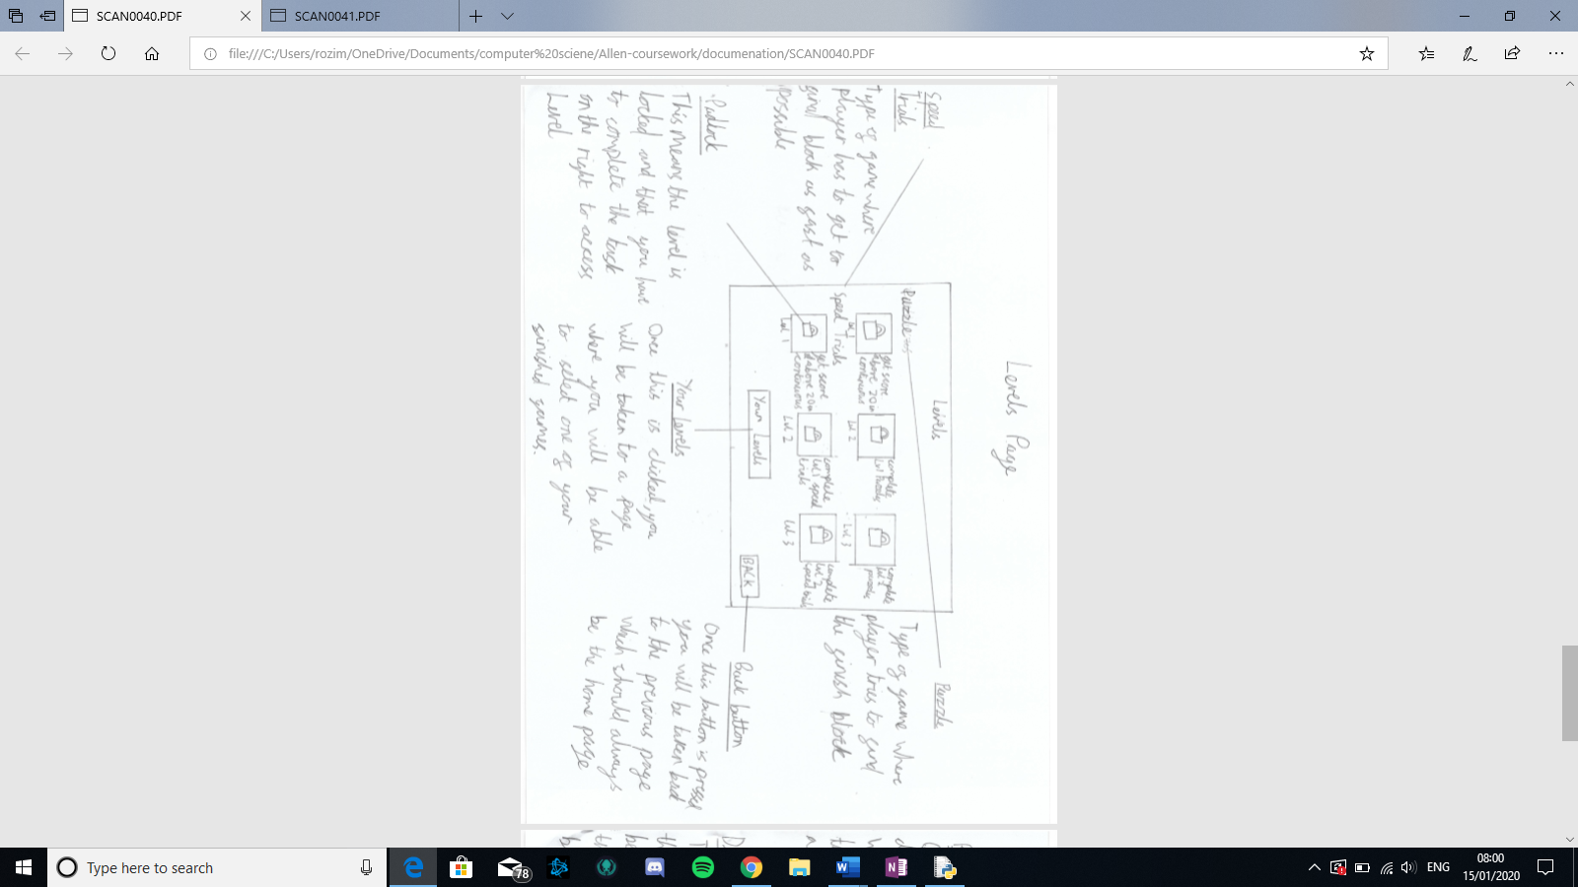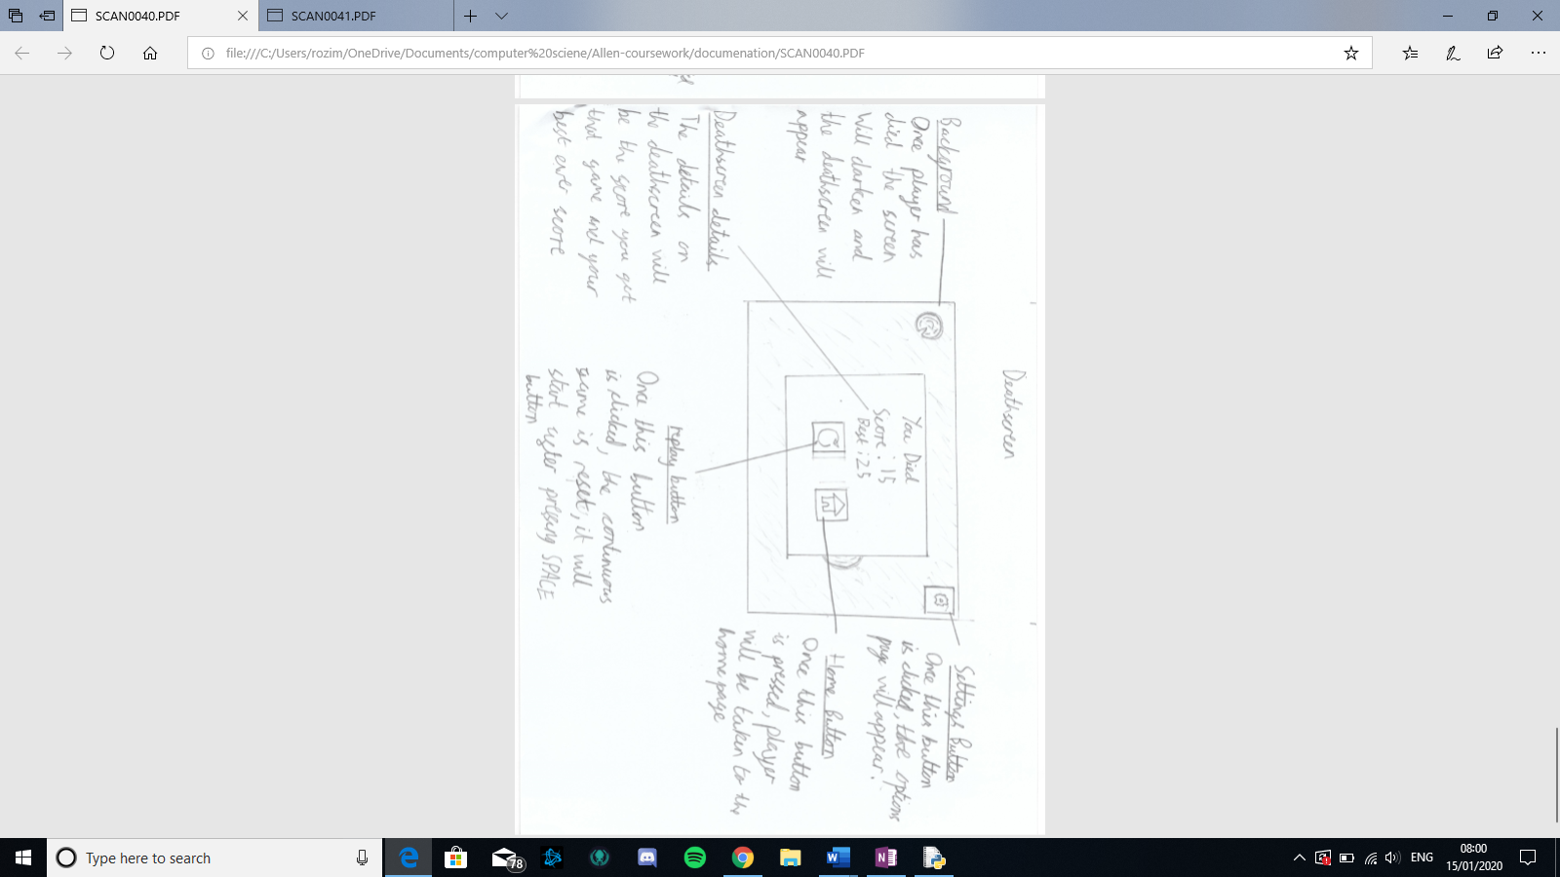

## Data structures

### Object: Sprite

What it does: This class is part of the pygame library which I will be using as a parent class so that my objects are able to cause an action when colliding with each other when in a sprite group. (I will not be writing down all the attributes and methods but only the ones which are necessary for this project.

Attributes: the attributes necessary for the methods come from the child class

Methods:

|  |  |
| --- | --- |
| Name | Explanation |
| Draw | This draws all sprites onto the screen |
| SpriteCollide | Creates a list for any sprite, that is in a group, that collides with a chosen sprite |
| GroupCollide | Creates a list for any sprites within separate groups to collide. |

### Object: Block (parent class: sprite)

What it does: This class was created as a child class of sprites which is a class from within the library pygame. The objective for the creation of this class is to be used as a parent class for Player() and create (). This means that the main use of it is to create wooden blocks/checkpoints in all 3 of the different parts of the game. These attributes are encapsulated using this class, meaning the attributes within the class are bundled together, making the program more organised.

Attributes:

|  |  |
| --- | --- |
| Name | Explanation |
| Width | This is to keep track of width of object |
| Height | This is to keep track of height of object |
| OG_image | This is needed because when turning an image in python, you have to use the original image and change that by and increasing angle otherwise it deforms the image. |
| Center | This is so that the image can be moved around its center and not in an unorderly manner. |
| Rect.x | To keep track of objects x cords/ change them |
| Rect.y | To keep track of objects y cords/ change them |
| Image_angle | So that the image can be turned properly without being deformed |
| Image | This is the image that will be printed |

Method: There are no methods to this as not all the child class’ need any of the same methods, and therefore it would make the code quicker if they had them as new methods in their separate child class’

### Object: Player (parent class: Block)

What is does: this is a child class of Block meaning that it also has all of Blocks attributes. The objective of this class was to have an encapsulation function on the player so that the player can be tracked easily on the screen due to being able to encapsulate the players position and other features.

Requirement numbers met: 1 and 2

Methods:

|  |  |
| --- | --- |
| Name | Explanation |
| Spin | This spins the player clockwise, by the “speed” |
| Move | This move player in direction that harpoon gun is pointing |

### Object: Button

What it does: This class makes Buttons of which when pressed performs a function (normally going to a different page). The main use of this class is to connect the different pages to the home page; but will also help replay a game, go to settings, see leader boards etc.

Requirement number met most of 3, most of 6 and most of 10

Attributes:

|  |  |
| --- | --- |
| Name | Explanation |
| X | This is to help with click method |
| Y | This is to help with click method |
| Width | To keep track of width for drawing object |
| Height | To keep track of height for drawing object |
| Font | Font of the word that is part of the object |
| Word | What the word is |
| Fill | What the colour of the button is |
| Outline_colour | What the colour of the rim of button is |
| Clicked | So that the program can tell when the button is clicked |
| Func | What the function of the button is |

Methods:

|  |  |
| --- | --- |
| Name | Explanation |
| Draw | This draws the button on the page when needed |
| Click | This checks if button is clicked and if so performes the function of button |

## Algorithms

### Class Block

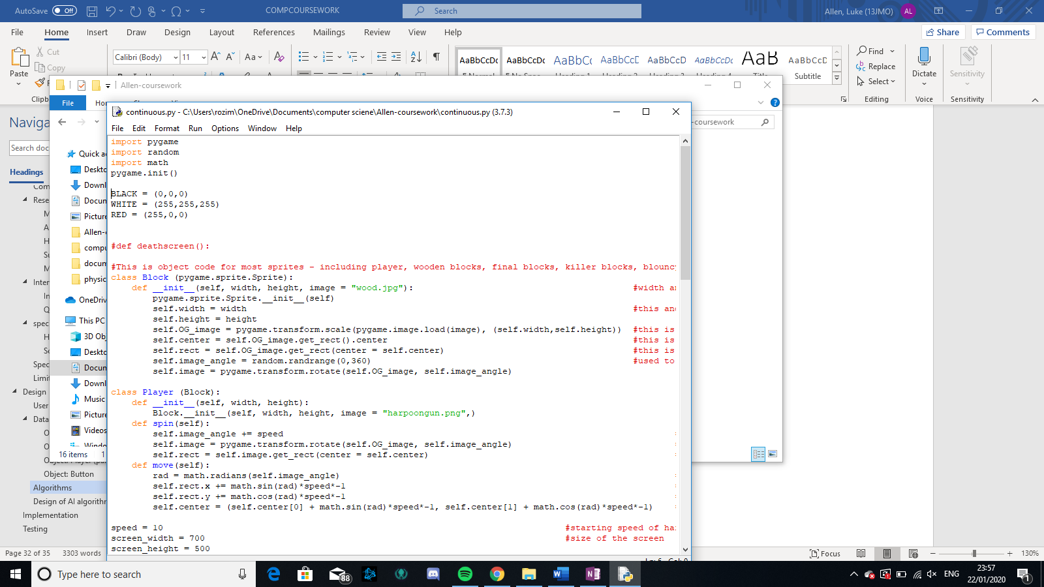

### Class Button

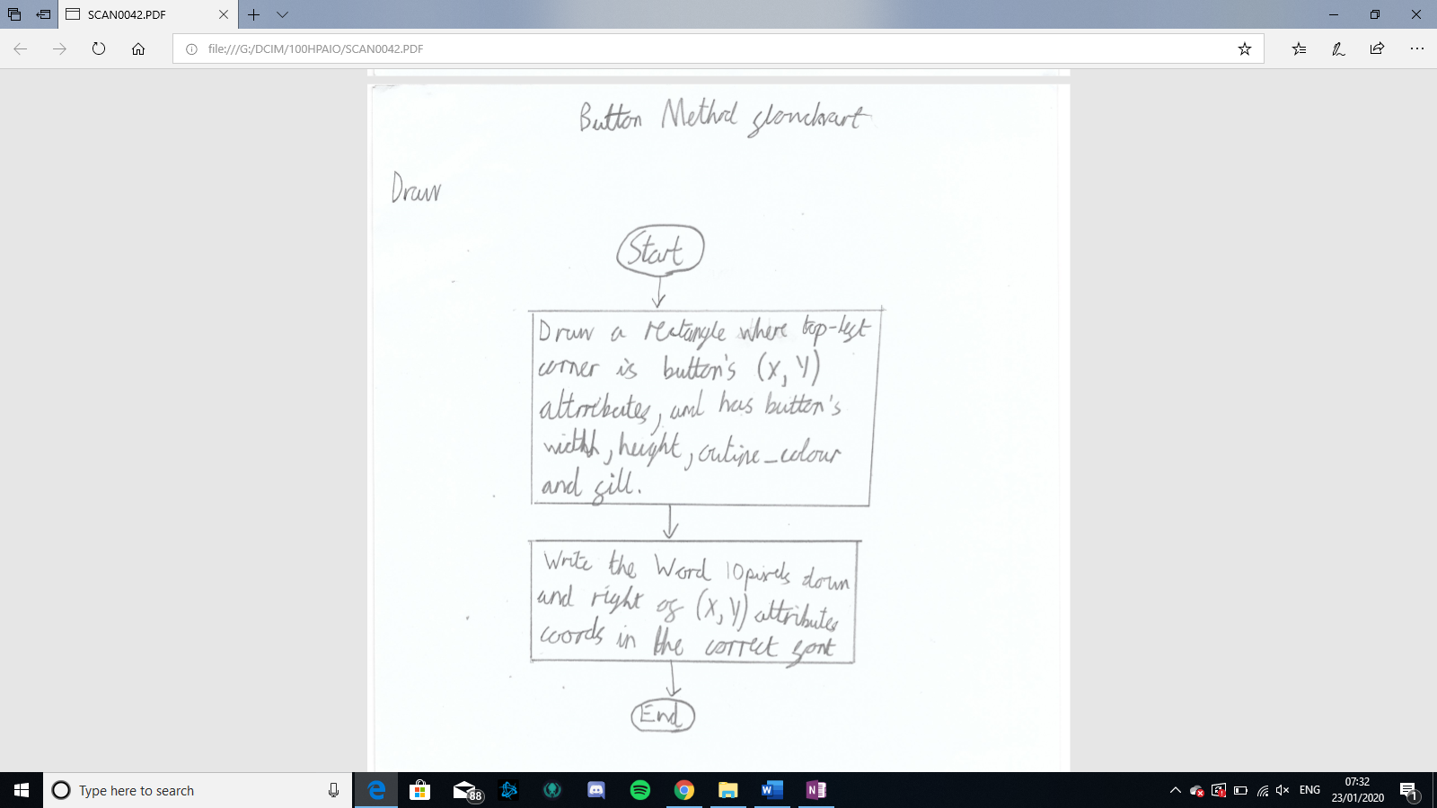

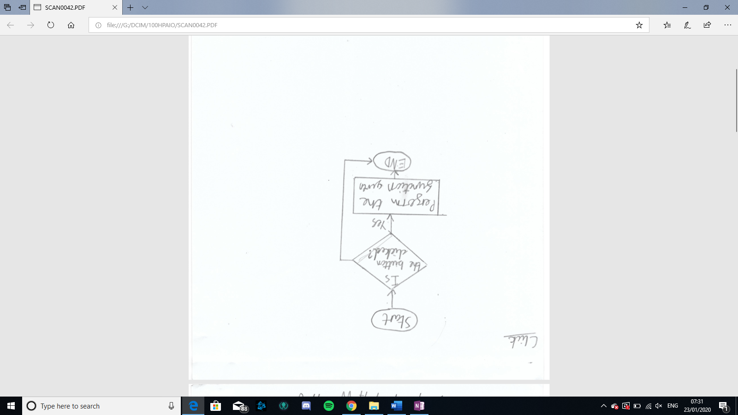

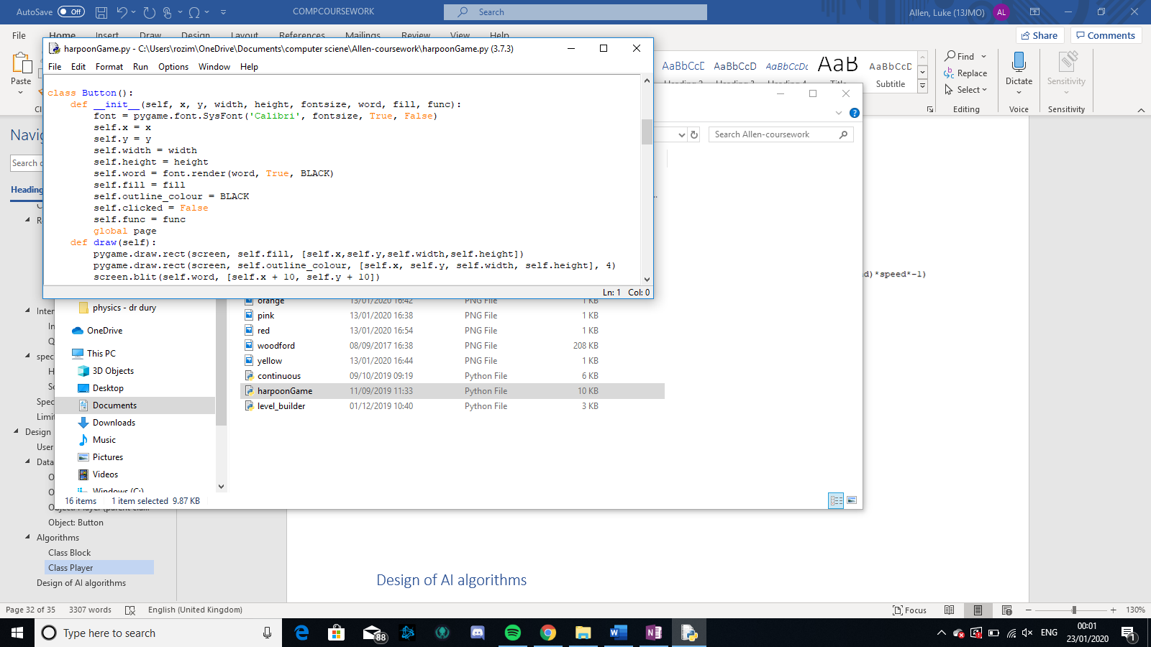

### Class Player

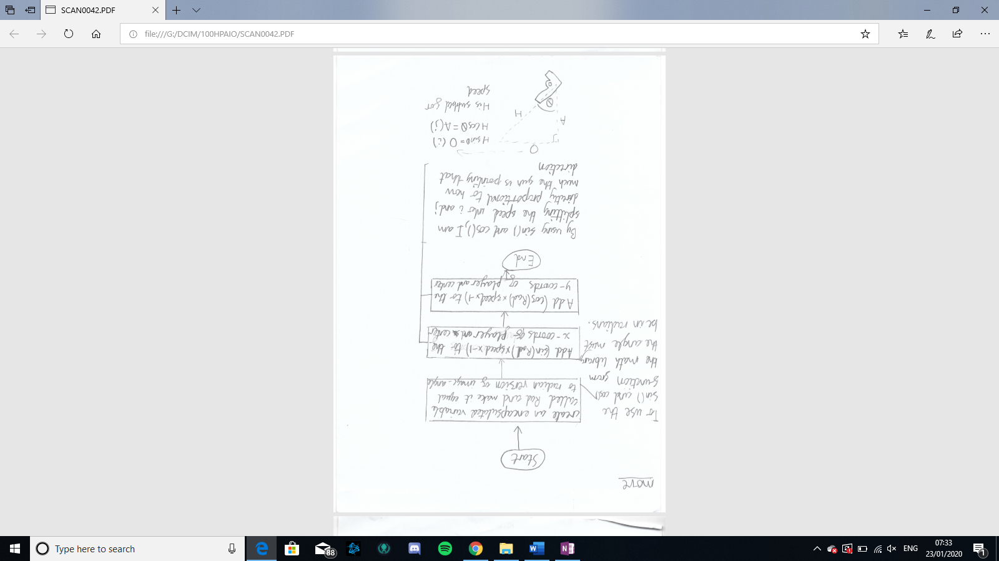

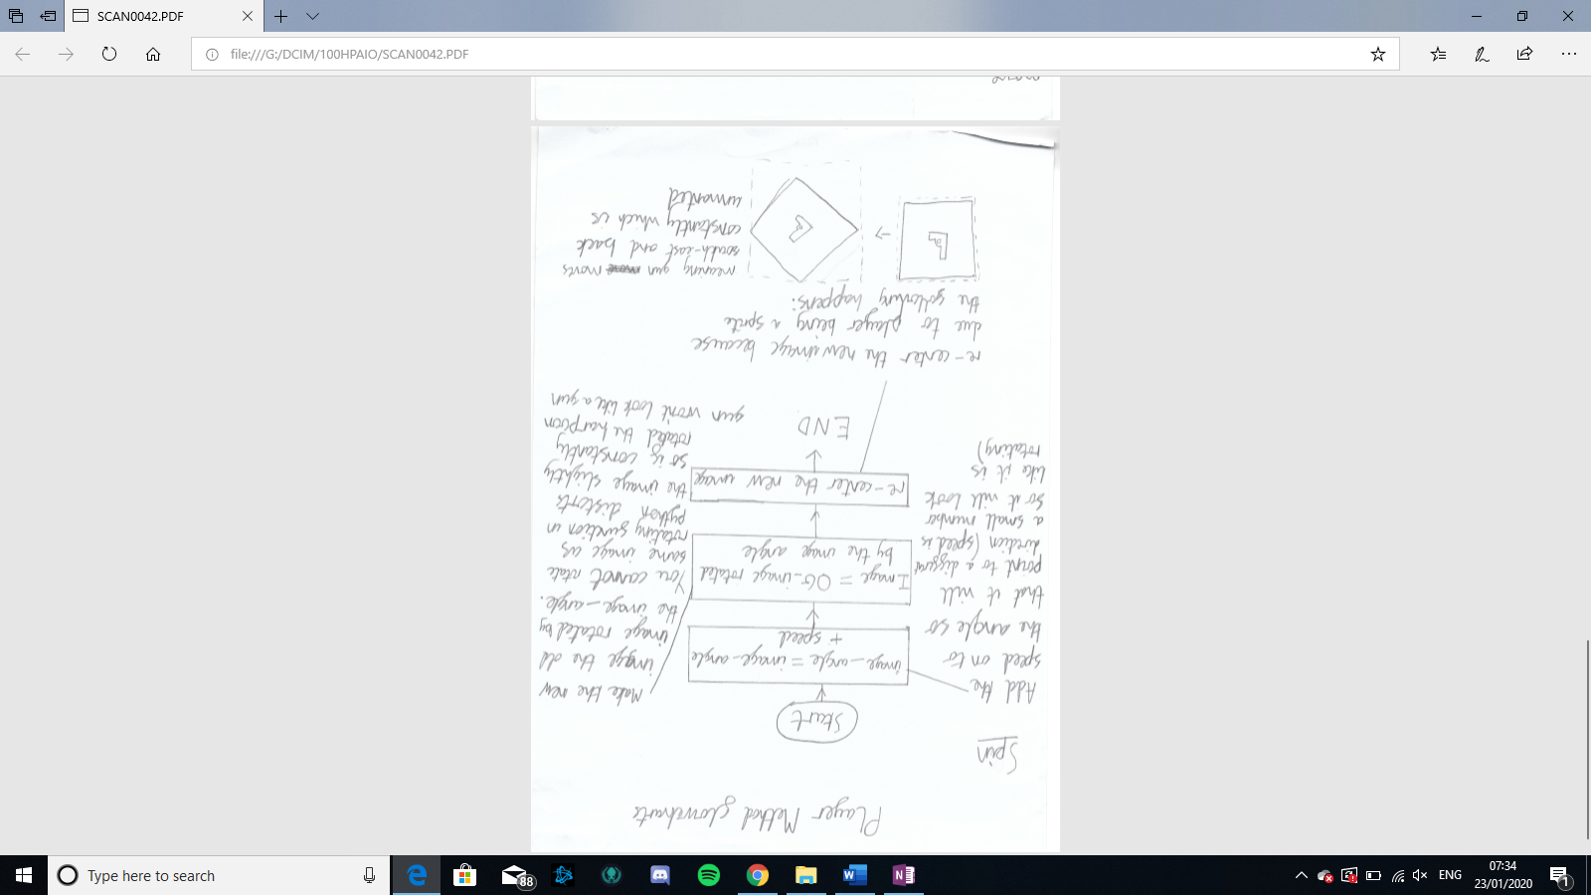

## Design of AI algorithms

## Test Plan

|  |  |  |
| --- | --- | --- |
| **Test** | **Description** | **Exp out** |
| 1 | Screen has area 500 by 700 pixels | Screen displayed |
| 2 | When the game starts, the user will start on the home page | Home page shown |
| 3 | The home page will Say “harpoon game at top”, have a continuous, levels, level_builder and options buttons. | Home page shown |
| 4 | When the continuous button is clicked, it takes you to a page where name/nickname can be inputted | Something happens when button clicked |
| 5 | When the levels button is clicked, takes you to the levels page | Something happens when button clicked |
| 6 | When the level builder button is clicked, it will take you to the create or edit screen | Create or edit screen appears |
| 7 | When the options page is clicked, it will take you to the options page | Something happens when button clicked |
| 8 | Continuous - When typing, the letters you type appear on the screen (in the box) | Letters typed appears |
| 9 | When a typing box is selected, the outline of the box will become thicker | Outline of box becomes thick |
| 10 | Once enter is pressed, the box will disappear, and game will begin | Box disappears |
| 11 | Gun appear on screen at position | Gun appears |
| 12 | “press space to start” appears on screen | “press space to start” appears on screen |
| 13 | The gun is pointing at a random direction | The gun is pointing at a random direction |
| 14 | There are wooden blocks on the screen | Wooden blocks appear |
| 15 | The blocks appear in a random x coordinate on the screen | The blocks appear in a random x coordinate on the screen |
| 16 | There is a score on the top-right of the score | Word “score:” appears |
| 17 | “press space to start” disappears when space is pressed | “press space to start” disappears |
| 18 | Gun spins when space bar is pressed | Gun spins |
| 19 | Gun spins around its center | Gun spins around center |
| 20 | Gun moves, in direction it is pointing when space bar release | Gun moves in direction it is pointing |
| 21 | All objects on the screen moves down | All objects on the screen moves down |
| 22 | If the gun hits a block, the gun replaces the block | Gun replaces block |
| 23 | The score goes up once, every time the gun hits a wooden block | Score goes up |
| 24 | Every time the score goes up by 5, the screen changes colour | Screen colour changes |
| 25 | If the gun hits the sides, the game ends. | Continuous game end |
| 26 | When the player dies, the screen fades | Screen fades |
| 27 | After death, there is a death screen with replay, home and leader board buttons and shows your best and current score and a settings button in top right corner | Death screen appears |
| 28 | When settings buttons are clicked they will go to settings | Settings appear |
| 29 | If the replay button is pressed, continuous game restarts | Continuous game reappears |
| 30 | If the home button is pressed, the player is taken back to the home screen | Home screen appears |
| 31 | If the leader board button is pressed, a leader board of top ten will come up with the rank, name and score. There will also be a back button | Leaderboard appears |
| 32 | If a back button is pressed, then the player will be taken back to the previous page | Previous page appears |
| 33 | Levels – The levels page loads, with the 3 continuous levels and 3 speed trial levels and a button to play self-created levels | Levels page appears |
| 34 | When a level is clicked the user is taken to the level and the wooden blocks, kl blocks and blocks and final block appears | Level appears |
| 35 | the blocks appear in correct positions | Blocks appear correctly |
| 36 | The blocks do not go down | Blocks don’t move down |
| 37 | The screen always has the player at the center of the screen | Centre of gun doesn’t move |
| 38 | There is a kl at the edge of the levels so that the player can know where the maps ends. | 🡪 |
| 39 | when the player dies on a level, the deathscreen also has another levels button. | Deathscreen appears |
| 40 | When the self built levels button is clicked then a list of the levels | List of levels appears |
| 41 | The self built list will have the levels name, creator, date modified. | List is detailed |
| 42 | When a locked level is clicked, a large lock sign will appear for a second, then go away | Sign appears |
| 43 | If someone hovers of their mouse over a lock, a message will appear saying what you have to do to play this feature. | Message appears where top left corner is where mouse is |
| 44 | In level builder – once button is clicked a screen with only two buttons will appear, one saying “create new” and the other saying “edit” | Blank screen with only 2 boxes saying “create new” and “edit” |
| 45 | The edit button will not work if there are no existing levels | Edit button looks greyer |
| 46 | If the create new button is hit user will be taken to a page where they input name of level, name of creator, and difficulty out of 3 they would find it. Then there will be a be a button saying start creation | Blank page with input boxes for name of level and creator and a drag key for level of difficulty |
| 47 | When start creation is pressed, you will be taken to a blank screen with only the options buttons and a save and quit button | Blank screen with options button on top right and save and quit on top left |
| 48 | On the blank screen if the kl key is pressed, a killer line will appear | Killer coloured block top left of screen |
| 49 | If bl key is pressed, bouncy line will appear | bouncy block top left |
| 50 | If checkpoint key is pressed, checkpoint will appear | Wooden block top left appears |
| 51 | If final block button is pressed, final block will appear. | Golden wooden block top left appears |
| 52 | if a block is clicked on, it will be “selected”, a dotted line will appear around it, it will have small circle at corners and sides and there will be a drag bar at the bottom of screen | Box with circles on edges appears around block |
| 53 | If one of the small circles are clicked and pulled, then the shape of block will change | lock on level builder button |
| 54 | If the drag bar is pulled, then the object will rotate | Object rotates |
| 55 | If the main area of the object is clicked, then it will be dragged wherever the mouse goes | Block follows mouse |
| 56 | The outline of area can be selected and grown | Box appears around large red lined box |
| 57 | A harpoon starts in middle of screen | Green area appears |
| 58 | If you scroll your mouse the entire screen zooms in or out | Zoom out or in |
| 59 | If blank area is dragged, then all the object go in direction of mouse movement | All objects move in direction of mouse |
| 60 | Settings – if settings is clicked, the settings page will appear | Settings appears |
| 61 | If the coloured box is clicked a new page with that colour and other colours appear. | New page appears with other colours |
| 62 | The colours that are already being used have non-black rims around it saying that this cannot be selected | Different coloured rims on different colours |
| 63 | If a black rimed colour is selected than the coloured rim is transferred to the new colour | The coloured rim is transferred to the new colour |
| 64 | If a coloured rimed colour is selected, nothing happens | Nothing happens |
| 65 | if back button is selected, the colour changer page is removed, and new colour replaces old colour | the colour changer page is removed, and new colour replaces old colour |
| 66 | If view controls is clicked then the blank page with different buttons for different controls appear | Blank page with boxes with a letter/key in each box and what they do next to the boxes |
| 67 | If box clicked “click key wanted” appears | “click key wanted” appears |
| 68 | If already used key is clicked, then nothing happens | Nothing happens |
| 69 | If not already used key is clicked, button pressed replaces previous button on the controls | Previous key is replaced by new key |

# Implementation

Development model is an agile model … consisting of several iterations. Each iteration will have an implementation and then testing and devaluation which will inform the next level

## Iteration 1 – Continuous

Explain what bit of development this is – puts objects on screen and fires etc

### Constants and Imports

1. **import** pygame
2. **import** random
3. **import** math
4. # initilaise pygame
5. pygame.init()

here I have imported pygame random and math. Pygame is used for most features e.g. turning an image, sprites, screen and other things. Random is used to create random numbers between certain points and the math library will be used for mathematical features like sin/cos/radian conversion and will allow me to incorporate maths into my game to allow me to do certain things like trigonometry so that I am able to split the peed into I and j, and then be able to add that individually to the x and y cords.

1. # Define colors
2. BLACK = (0,0,0)
3. WHITE = (255,255,255)
4. RED = (255,0,0)

I have implemented a few colours for things like the background and so forth

1. spin = False
2. move = False
3. done = False
4. spinable = True
5. start = False
6. clock = pygame.time.Clock()
7. score = 0

these are a few variables that I have implemented so that you can hold down on space. As when the computer only detects when you initially push down on space, these constants are able to tell if you are spinning, moving, if game is still running, if user is allowed to spin and finally if game has started yet.

### Player class

Spinning movement

1. **def** spin(self):
2. self.image = pygame.transform.rotate(self.image, speed)

In this first iteration for movement I have been creating the spinning function of the player. Here, what I have done is every time I call this function it spins the image by speed which is a small number. Although through testing I have discovered that the image becomes distorted by using the method as shown below:

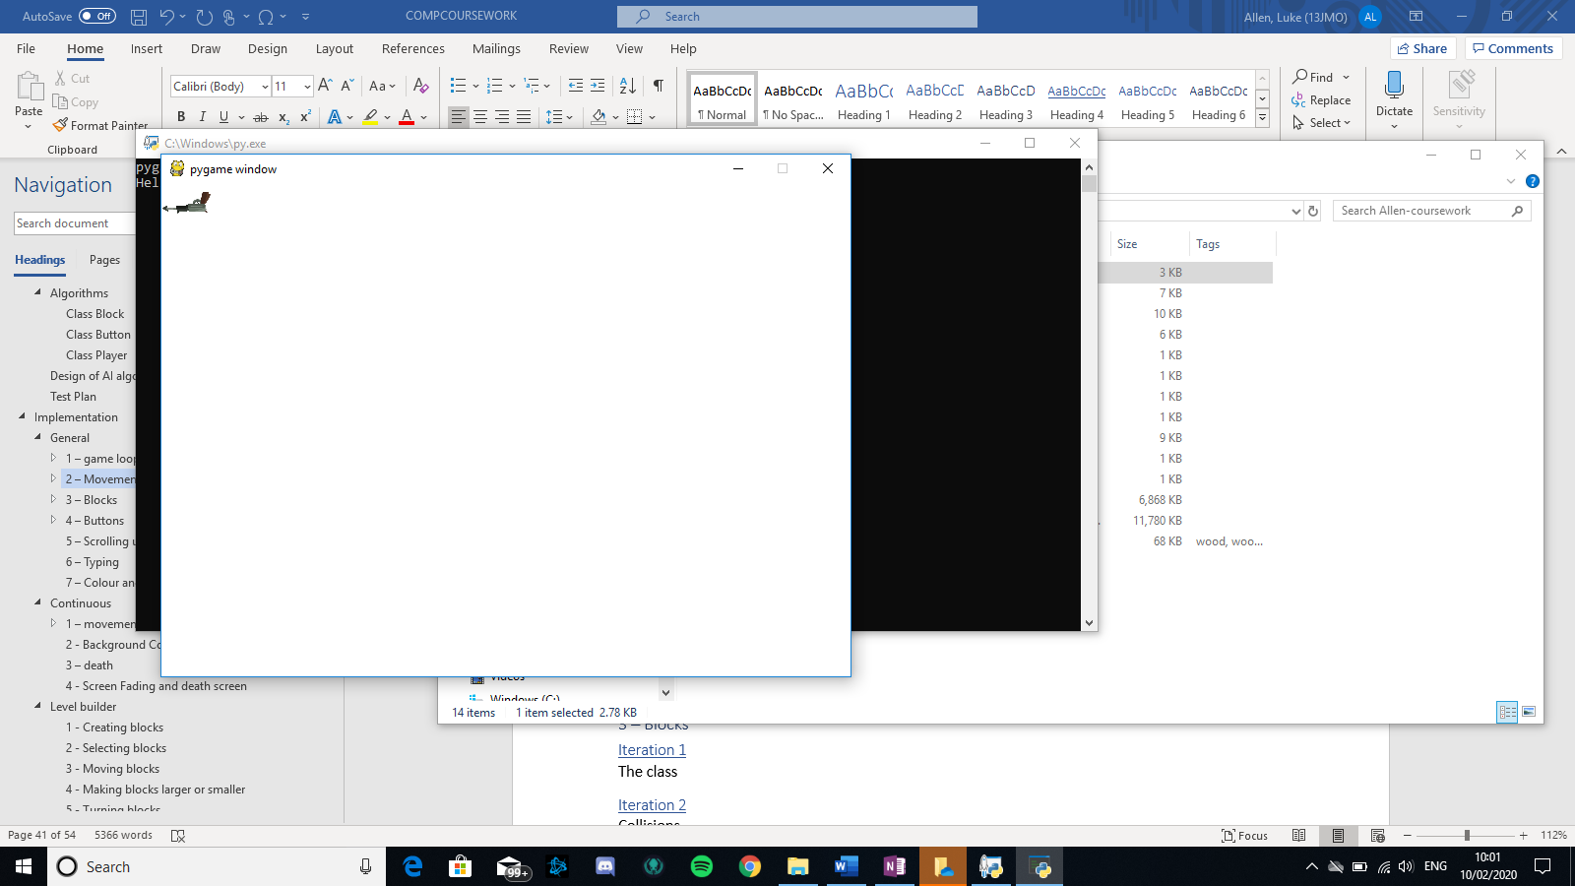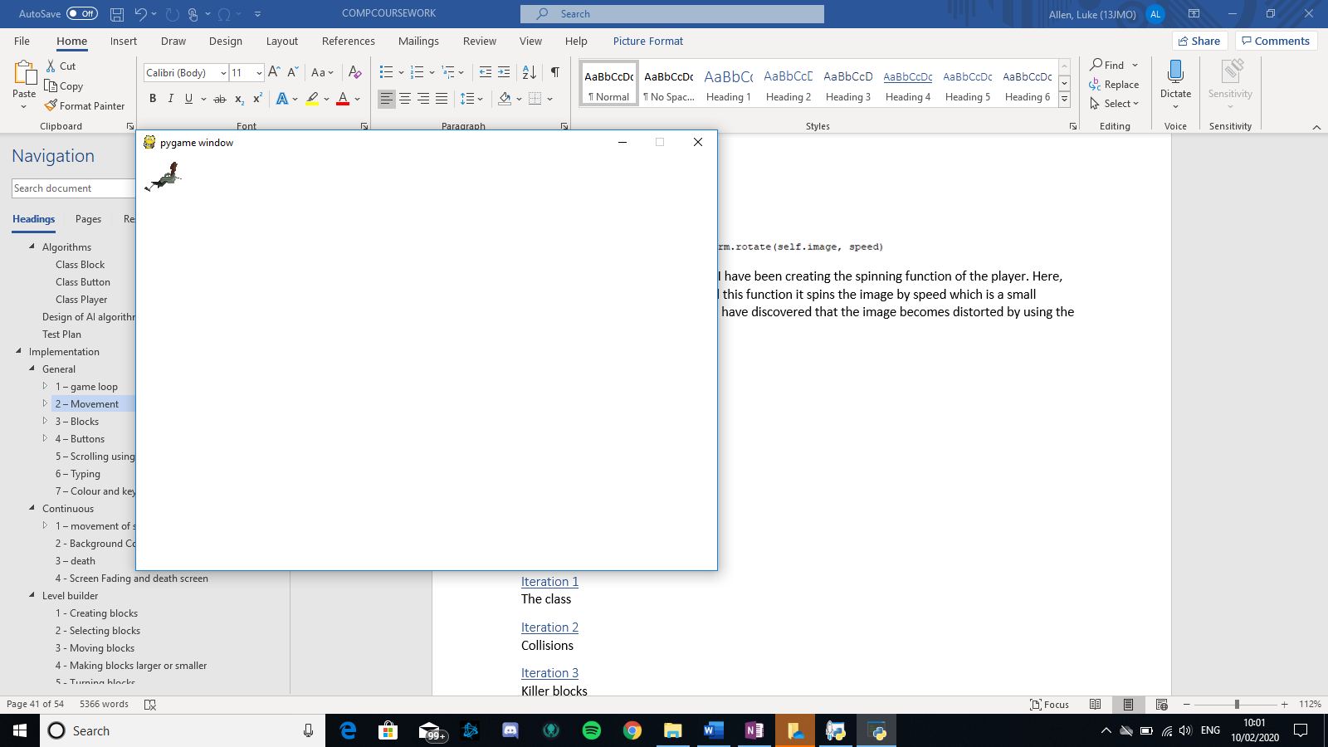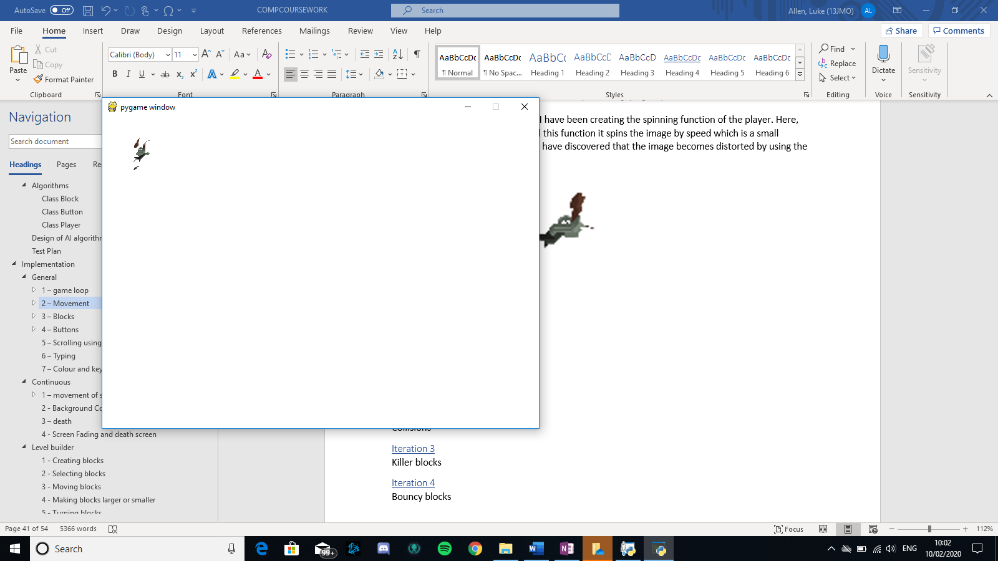

This is because everytime the image is rotated, it becomes slightly distorted therefore if the same image is rotated multiple times then it will become distorted

2nd attempt – error Fix

1. **def** spin(self):
2. self.image_angle += 2
3. self.image = pygame.transform.rotate(self.OG_image, self.image_angle)
4. 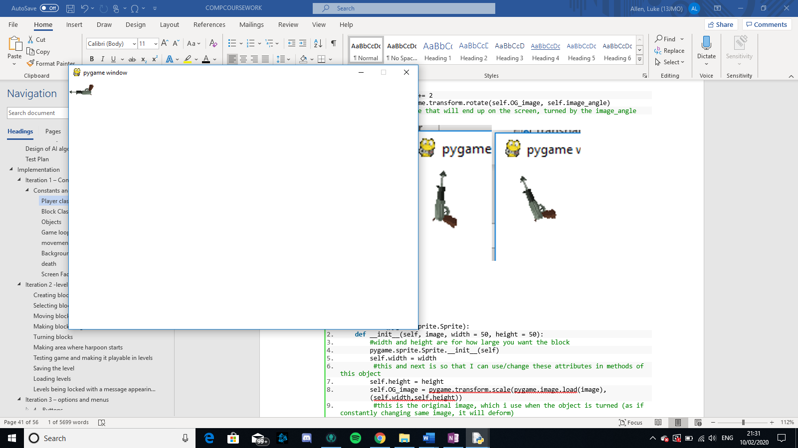    #this is the image that will end up on the screen, turned by the image_angle

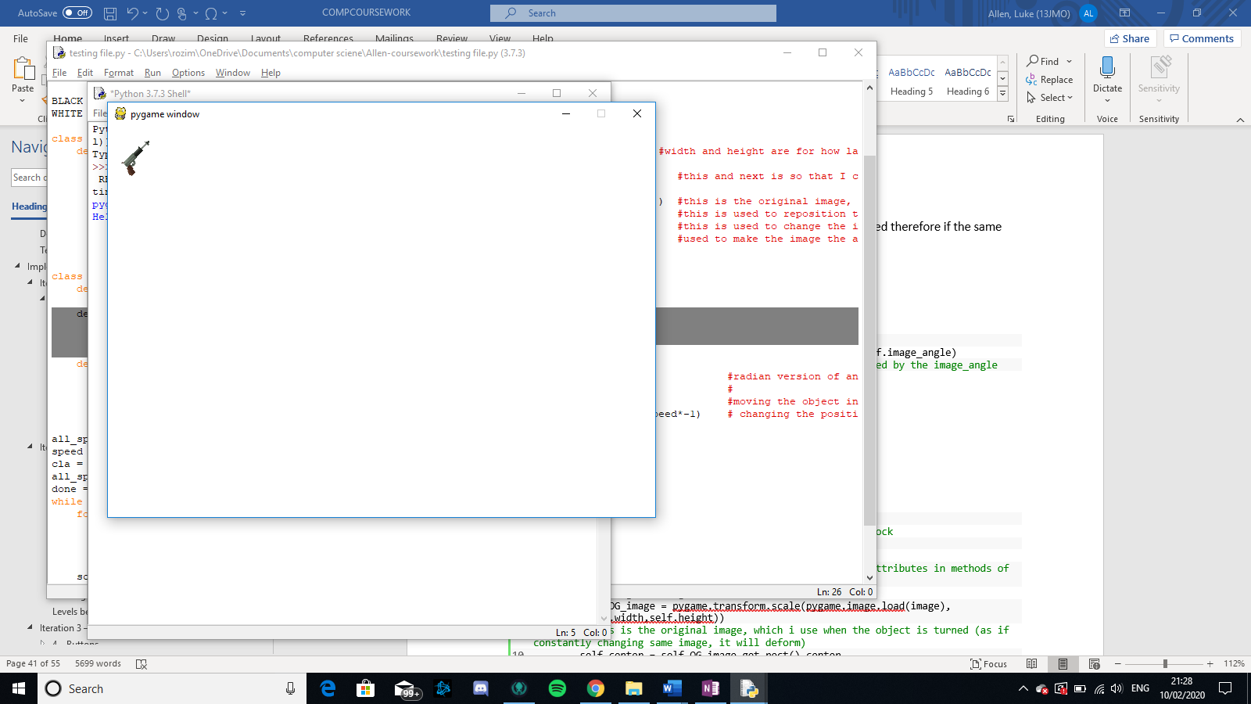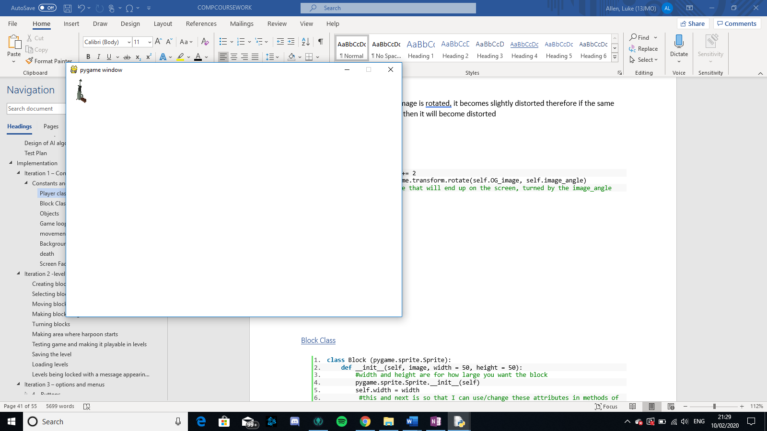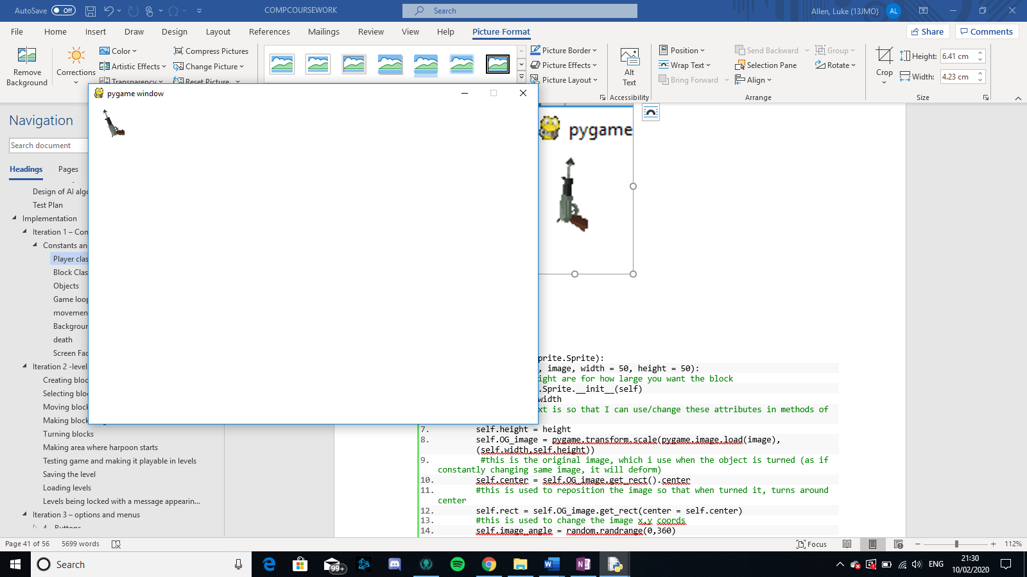

What I have done now is instead of rotating the same image constantly, I am rotating the first image by an increasing angle. Therefore, there is only one mini distortion. Although no there is a new problem – the gun is not rotating around its centre, it is trying to be closest to the top left corner without going behind the (x,y) cords.

3rd attempt - refinement

1. **def** spin(self):
2. self.image_angle += speed
3. #this adds the variable speed onto image_angle, speed will increase
4. self.image = pygame.transform.rotate(self.OG_image, self.image_angle)
5. #this is the image that will end up on the screen, (turned by the image_angle)
6. self.rect = self.image.get_rect(center = self.center)
7. #this is what makes the image look like it is turning via its center

To fix the previous problem, what I have done is every time the image is rotated, I have re-centred the image

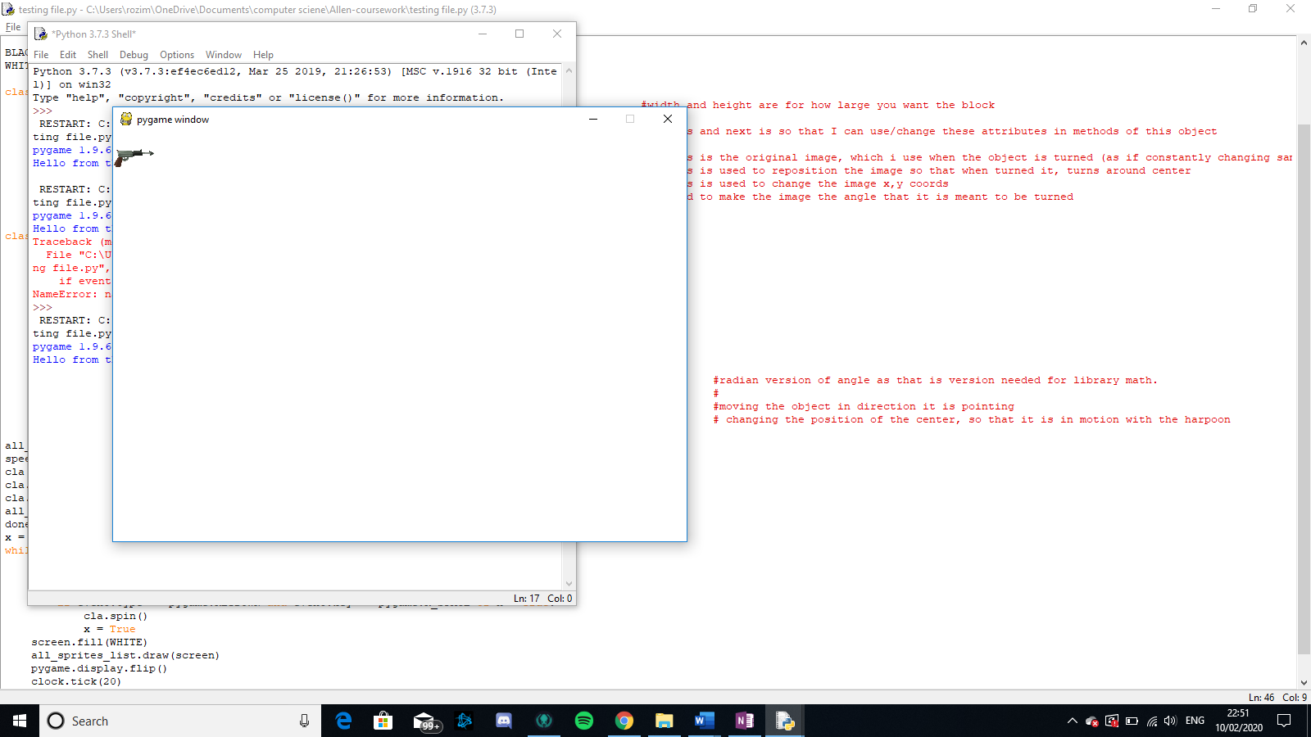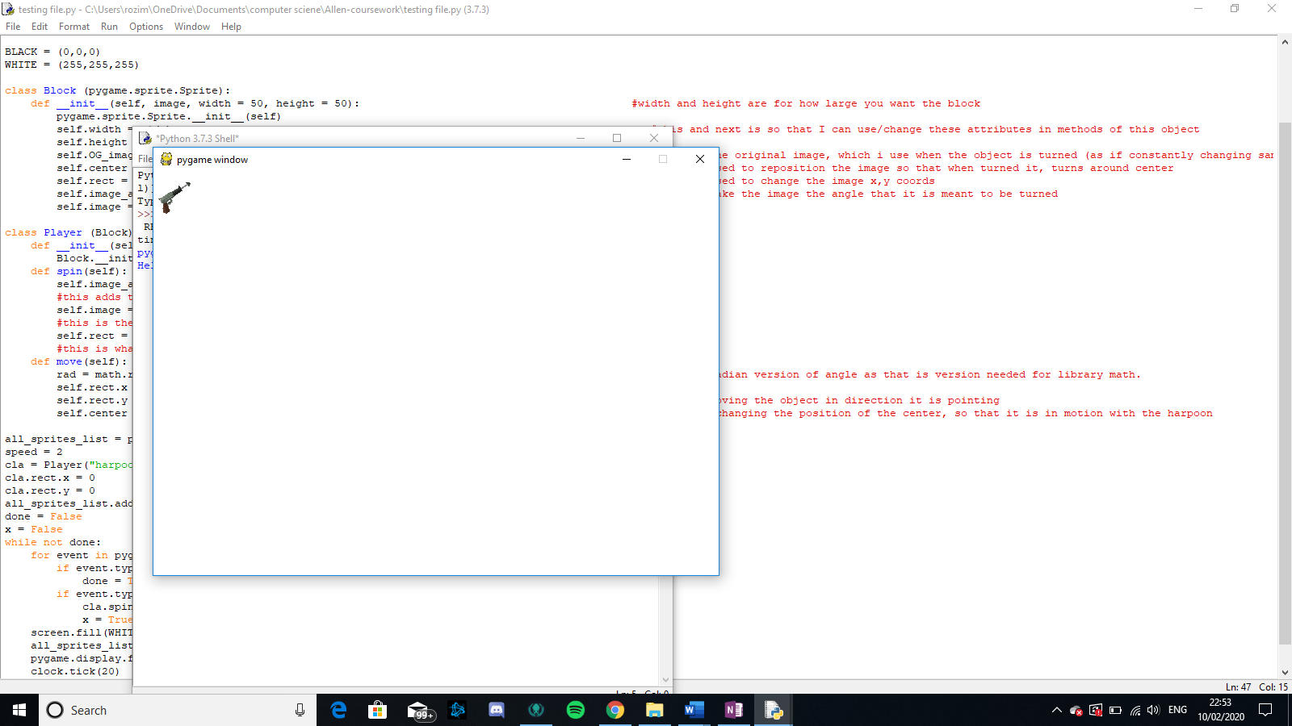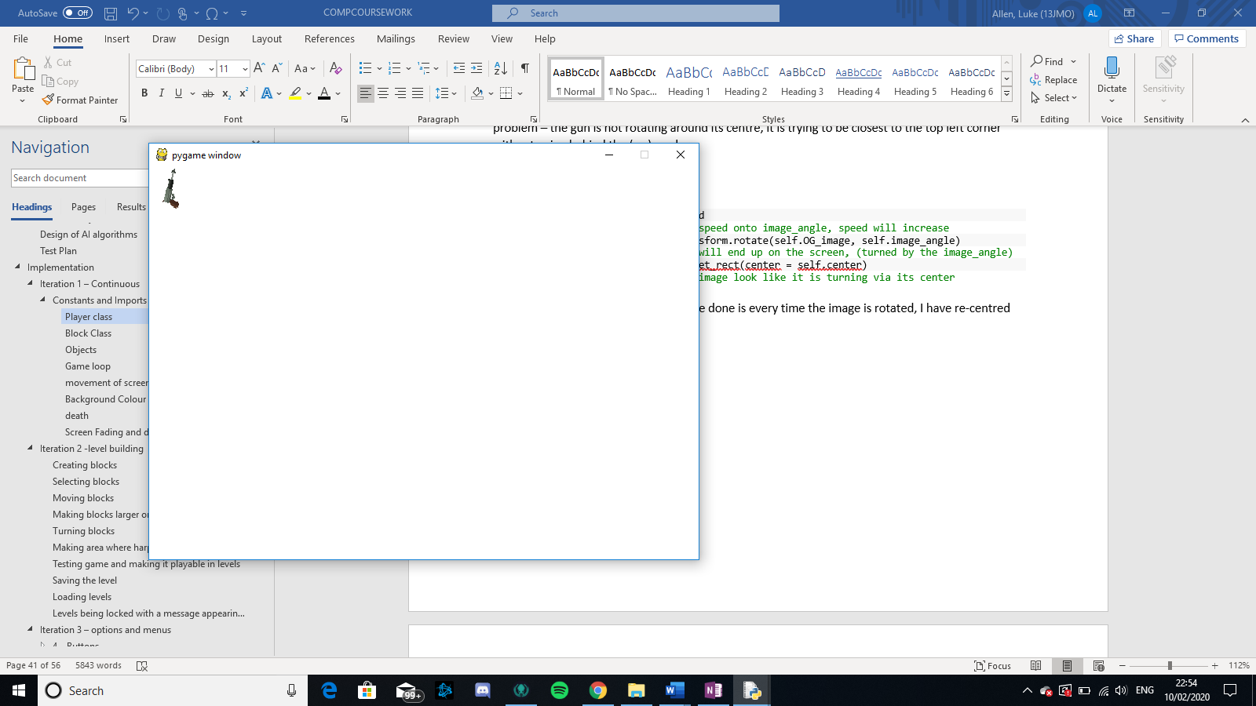

The spinning now works as it should.

Movement in direction pointing

1. **def** move(self):
2. self.rect.x += math.sin(self.image_angle)*speed*-1
3. self.rect.y += math.cos(self.image_angle)*speed*-1
4. #moving the object in direction it is pointing
5. self.center = (self.center[0] + math.sin(self.image_angle)*speed-1, self.center[1] + math.cos(self.image_angle)*speed*-1)
6. # changing the position of the center, so that it is in motion with the harpoon

For the first attempt at movement in direction pointing, what I did was first change the image so that it was originally pointing up, therefore allowing the up direction to be mentally set as 0, the what I have done is sin(angle) should equal the x component and cos(angle) the y component but for some reason the player seems to be moving in a completely random direction:

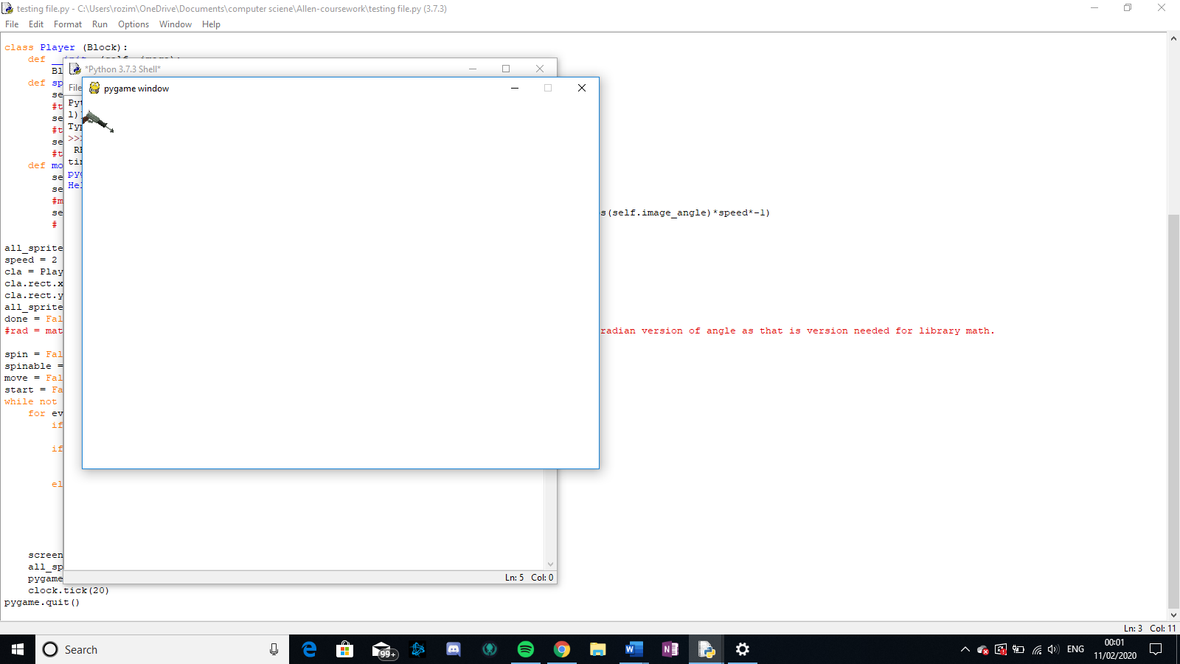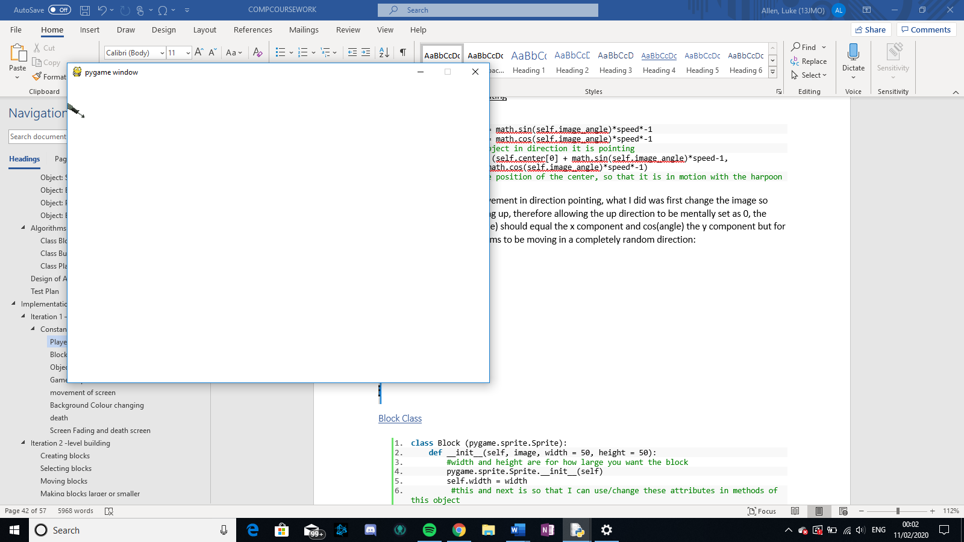

Here it is clearly not going in the direction, it is pointing.

Attempt 2

1. **def** move(self):
2. rad = math.radians(self.image_angle)
3. #radian version of angle as that is version needed for library math.
4. self.rect.x += math.sin(rad)*speed*-1
5. self.rect.y += math.cos(rad)*speed*-1
6. #moving the object in direction it is pointing
7. self.center = (self.center[0] + math.sin(rad)*speed*-1, self.center[1] + math.cos(rad)*speed*-1)
8. # changing the position of the center, so that it is in motion with the harpoon

After much research I have come to the realisation that the sin and cos() functions within math both use radians instead of degrees, therefore I have converted from degrees to radians for this method

Now the movement is as follows:

### Block Class

1. **class** Block (pygame.sprite.Sprite):
2. **def** __init__(self, image, width = 50, height = 50):
3. #width and height are for how large you want the block
4. pygame.sprite.Sprite.__init__(self)
5. self.width = width
6. #this and next is so that I can use/change these attributes in methods of this object
7. self.height = height
8. self.OG_image = pygame.transform.scale(pygame.image.load(image),  (self.width,self.height))
9. #this is the original image, which i use when the object is turned (as if constantly changing same image, it will deform)
10. self.center = self.OG_image.get_rect().center
11. #this is used to reposition the image so that when turned it, turns around center
12. self.rect = self.OG_image.get_rect(center = self.center)
13. #this is used to change the image x,y coords
14. self.image_angle = random.randrange(0,360)
15. #used to make the image the angle that it is meant to be turned
16. self.image = pygame.transform.rotate(self.OG_image, self.image_angle)

To help with the spinning method in player, I created the OG_image and the image_angle attributes.

### Objects

1. #creating sprite groups so that we can use group collide
2. blocks = pygame.sprite.Group()
3. block_list = [] #used to tell which the next block is that the haropoon should be hitting
4. trail = []
5. all_sprites_list = pygame.sprite.Group()
7. #creates wooden blocks
8. **for** i **in** range(4):
9. block = Block("wood.jpg")
10. block.rect.x = random.randrange(0,650) #this makes the blocks appear in a random x- coord  that is on-screen
11. block.rect.y = (i*200) - 400 #evenly place them out
12. block.OG_image = pygame.transform.scale(pygame.image.load("wood.jpg"), (20, 20))  #changes the image to the wood image
13. blocks.add(block)             #adds this block to blocks, block_list and all_sprites_list
14. block_list.append(block)
15. all_sprites_list.add(block)
17. #creates player
18. target = 3                    #makes the target the 4th one in blocks (0 to 3 as index)
19. player = Player("harpoongun.png")     #creates the player and call it
20. player.rect.x = 325
21. player.rect.y = 300                  #changes the player's x and y coords
22. player.center = (325,300)           #records center of the player so that when rotating or moving, the image rotates about center.
23. player.OG_image = pygame.transform.scale(pygame.image.load("harpoongun.png"), (50,50))
24. all_sprites_list.add(player)

As you can see below these are the separate objects on the screen created from this:

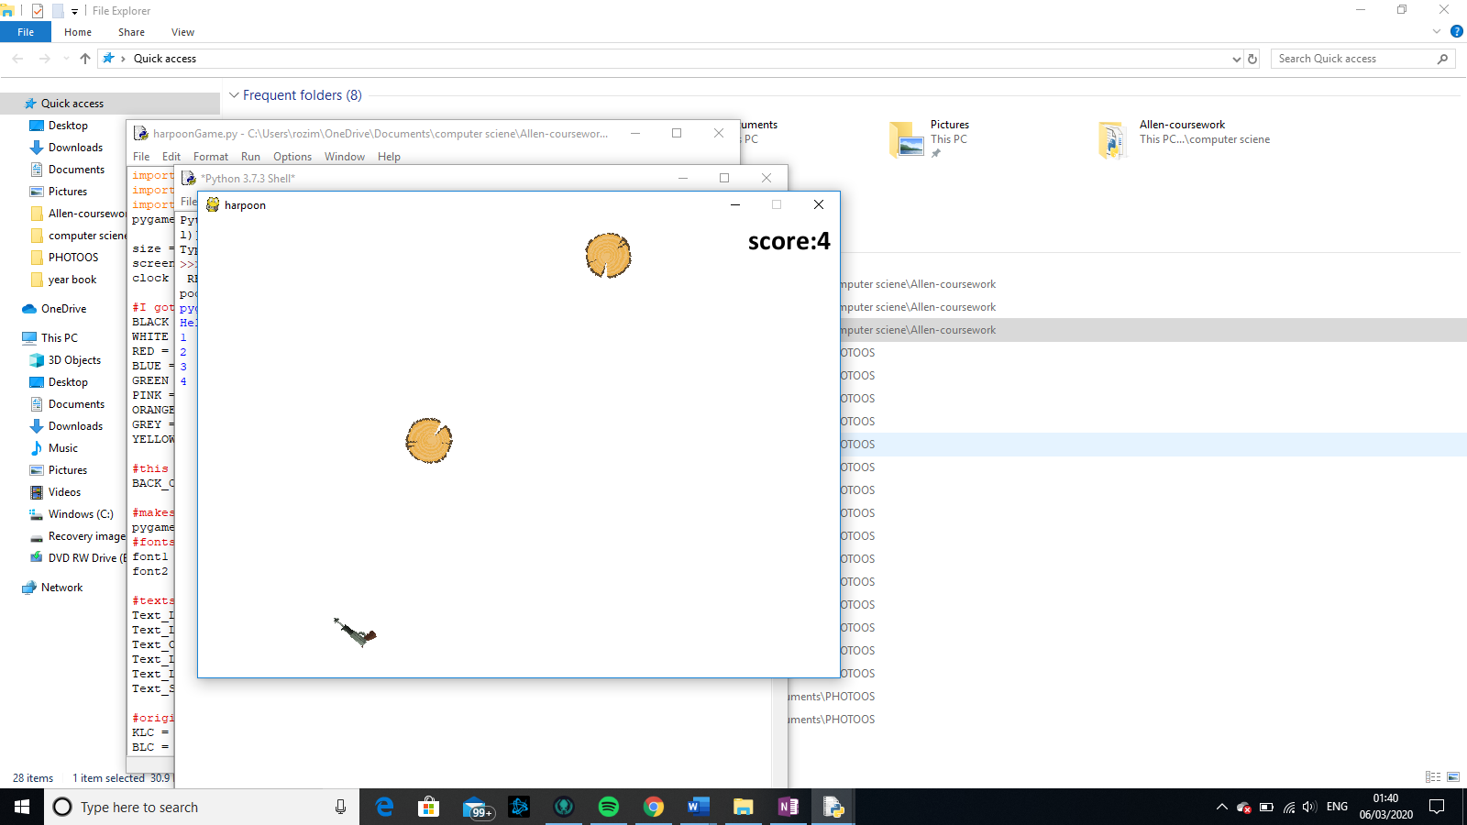

The other 2 wooden block are in imaginary space above,

this piece of programming runs everytime the game is just about to be played. It creates a new instance of player and creates 4 instances of a wooden block.

### movement of screen

attempt 1 - constant moving of scree

1. If start == True:                     #only when game has started
2. **for** sprite **in** all_sprites_list:  #adds 4 to all y coords of all objects
3. sprite.rect.y += 4

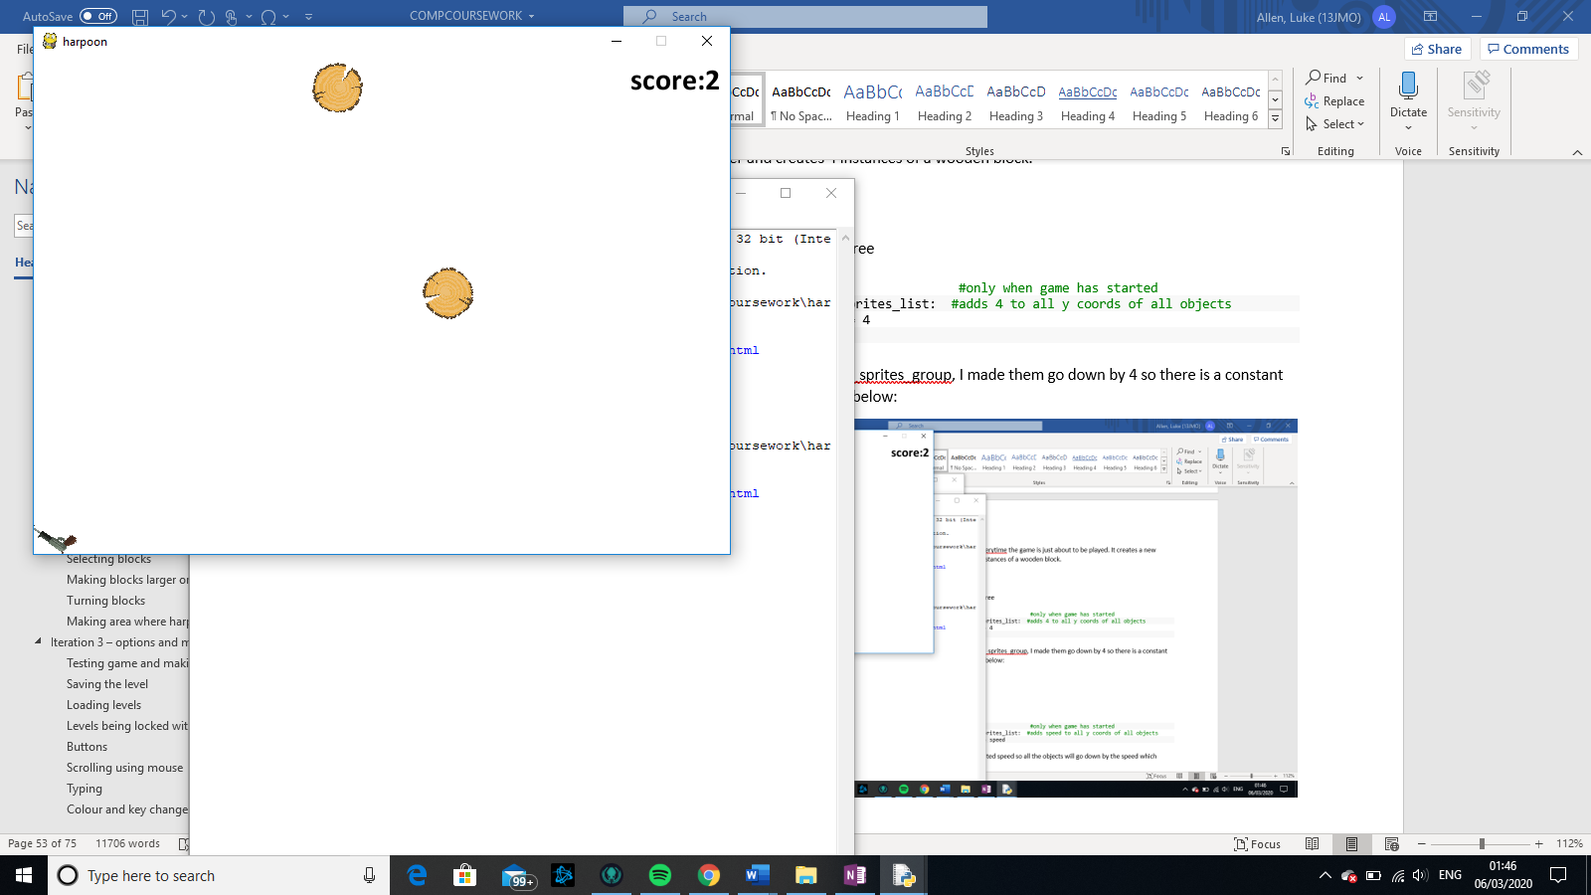Here for every sprite in all_sprites_group, I made them go down by 4 so there is a constant scrolling, this can be seen below:

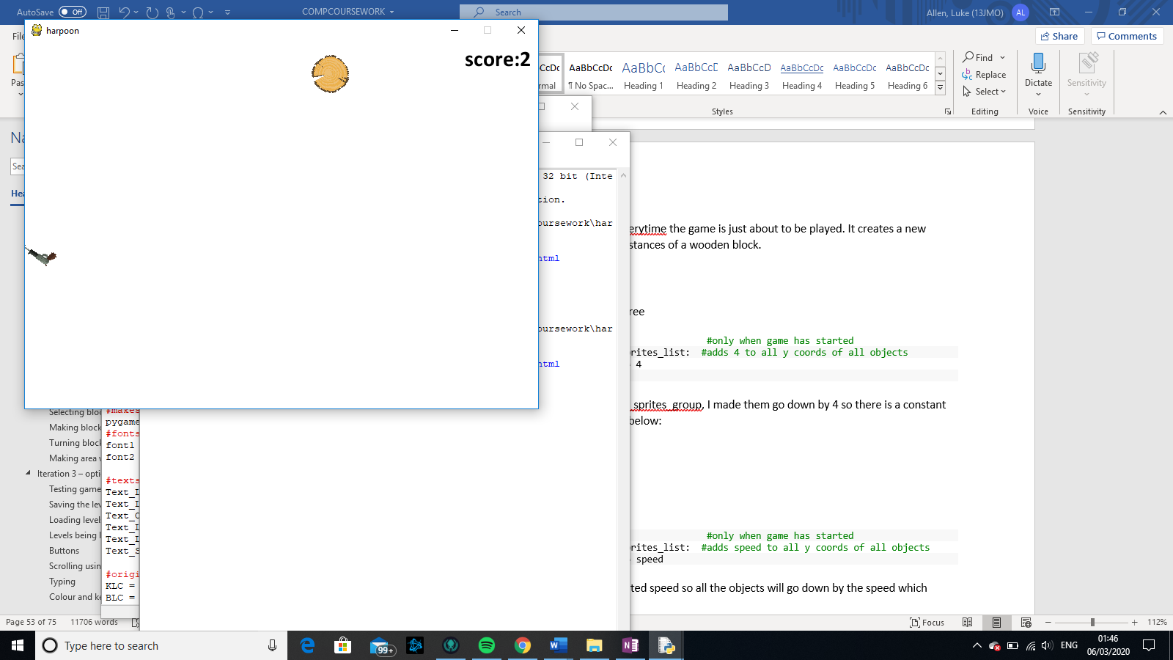

Speeding up

1. speed = score/3
2. If start == True:                     #only when game has started
3. **for** sprite **in** all_sprites_list:  #adds speed to all y coords of all objects
4. sprite.rect.y += speed

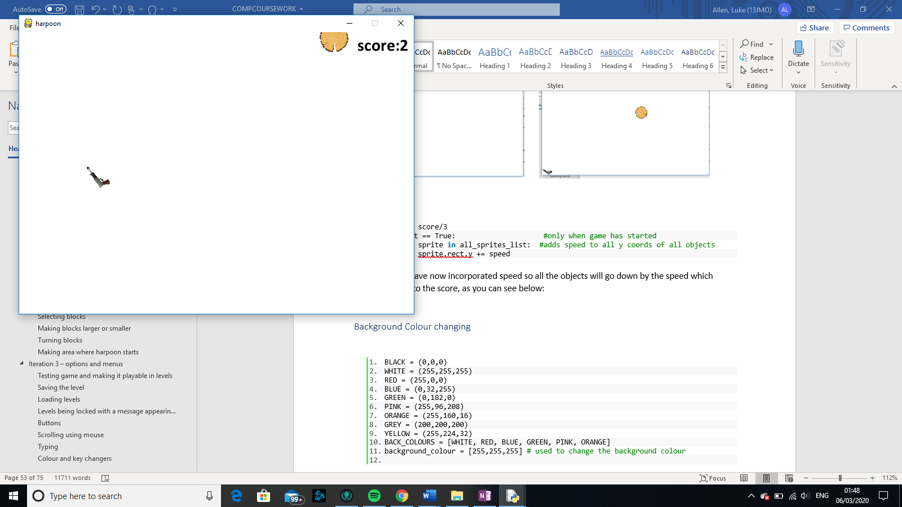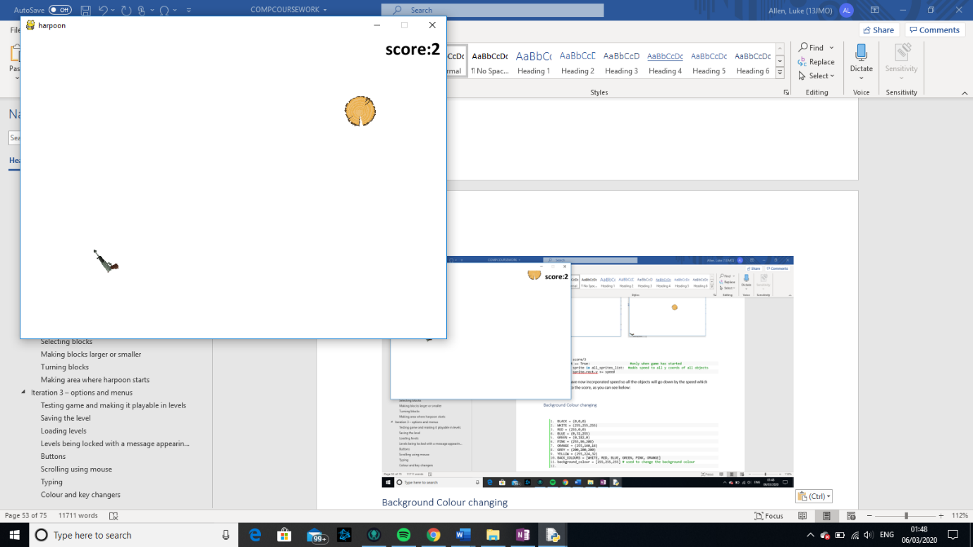Here I have now incorporated speed so all the objects will go down by the speed which relates to the score, as you can see below:

Here, when the score is 2, the screen is moving down the screen rather slowly …

… but here when the score is 9, the screen is moving a lot faster

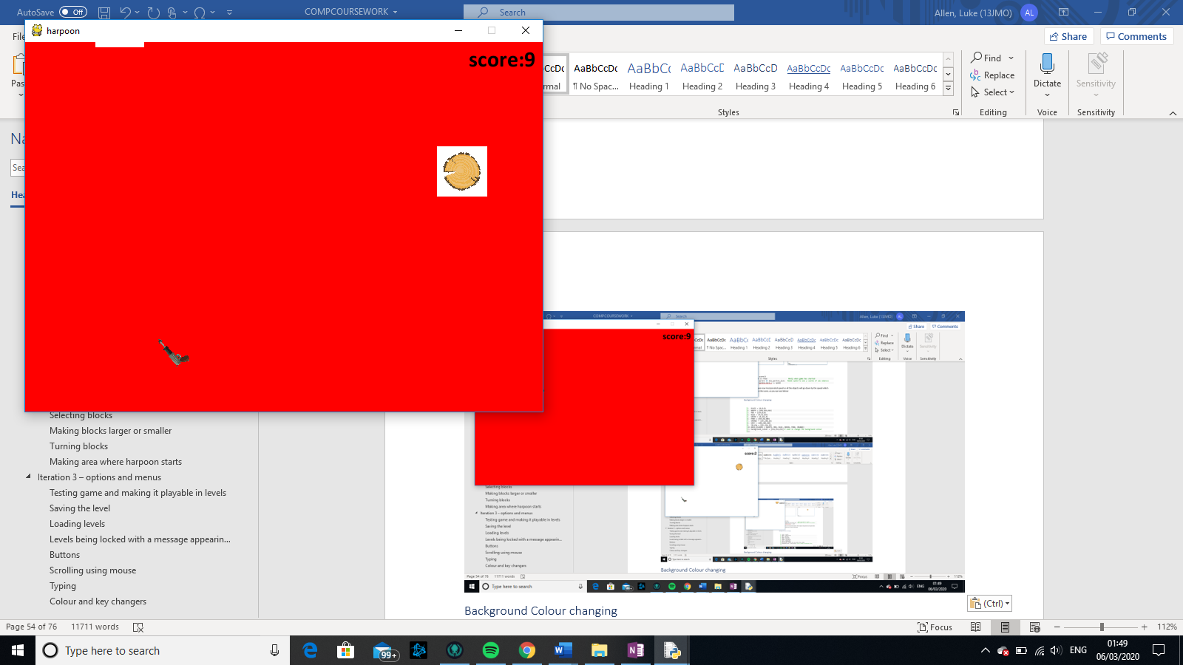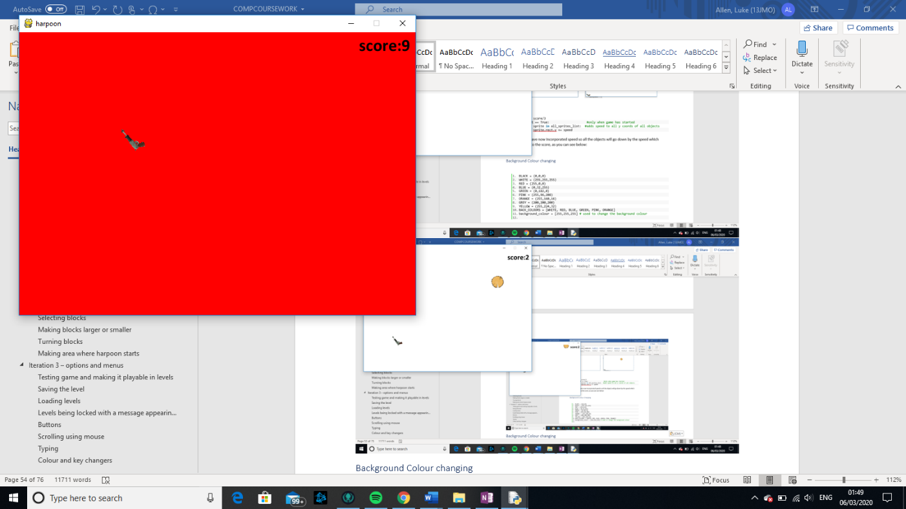

### Background Colour changing

1. BLACK = (0,0,0)
2. WHITE = (255,255,255)
3. RED = (255,0,0)
4. BLUE = (0,32,255)
5. GREEN = (0,182,0)
6. PINK = (255,96,208)
7. ORANGE = (255,160,16)
8. GREY = (200,200,200)
9. YELLOW = (255,224,32)
10. BACK_COLOURS = [WHITE, RED, BLUE, GREEN, PINK, ORANGE]
11. background_colour = [255,255,255] # used to change the background colour
13. **def** transition(x): #where x is the colour to be transitioned to
14. **global** move
15. **if** x == GREY:  #for when transitioning to grey all the objects should shade
16. move = False
17. **for** i **in** all_sprites_list:
18. **for** t **in** range(100):
19. i.image.set_alpha(t)#makes them become more and more shaded quickly
21. **if** background_colour[0] > x[0]:
22. background_colour[0] = background_colour[0] -1
23. **elif** background_colour[0] < x[0]:
24. background_colour[0] = background_colour[0] + 1
25. **if** background_colour[1] > x[1]:
26. background_colour[1] = background_colour[1] -1
27. **elif** background_colour[1] < x[1]:
28. background_colour[1] = background_colour[1] + 1
29. **if** background_colour[2] > x[2]:
30. background_colour[2] = background_colour[2] -1
31. **elif** background_colour[2] < x[2]:
32. background_colour[2] = background_colour[2] + 1
33. #what these do is make the numbers of the background colour closer to that of the new colour,
34. #as it is only changing values by 1 each time it become much more of a gradual effect of over a couple of seconds

In this I have made sure that background_colour is an array and not a tuple so that I am able to change the values within to make the colour gradually different.

Although for some reason when I play the game, a whit box appears around the wooden block like so:

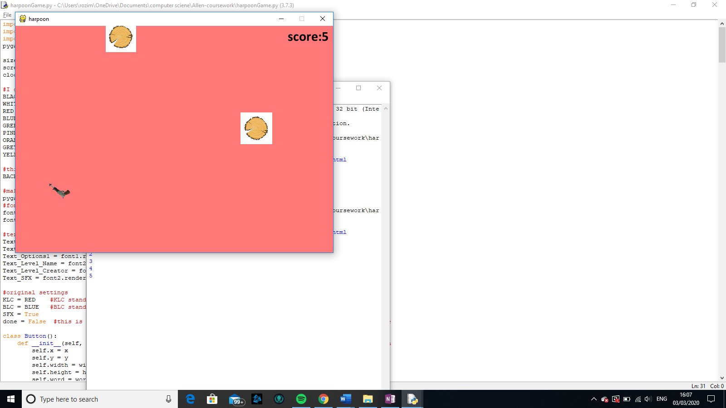

It turned out that this was because there was a white area on the actual image. So that had to be cropped out so that there is only the wood.

2. ...
4. **if** (score/5) == (score//5):
5. background_colour_pointer = background_colour_pointer + 1 #
7. **if** page[-1] == "GACO":
8. transition(BACK_COLOURS[background_colour_pointer]) #makes the background  colour the colour it should be
9. screen.fill(background_colour)

this decides whether the background colour should change or not, which could be when ever the score is a multiple of 5

### Death

1st attempt

1. **if** (player.rect.x > 700 **or** player.rect.x < 0 **or** player.rect.y > 500 **or** player.rect.y < 0):
2. death = True # when the the x coords is outside of the screen, then the player dies

Originally, I made it so that if the gun ever hit the sides then the player would die but due to lots of testing, I discovered that this would not work because if a block was on the very edge and the player hit the block then it would also become on the very edge and if it were to rotate then it would hit sides and player would die like following:

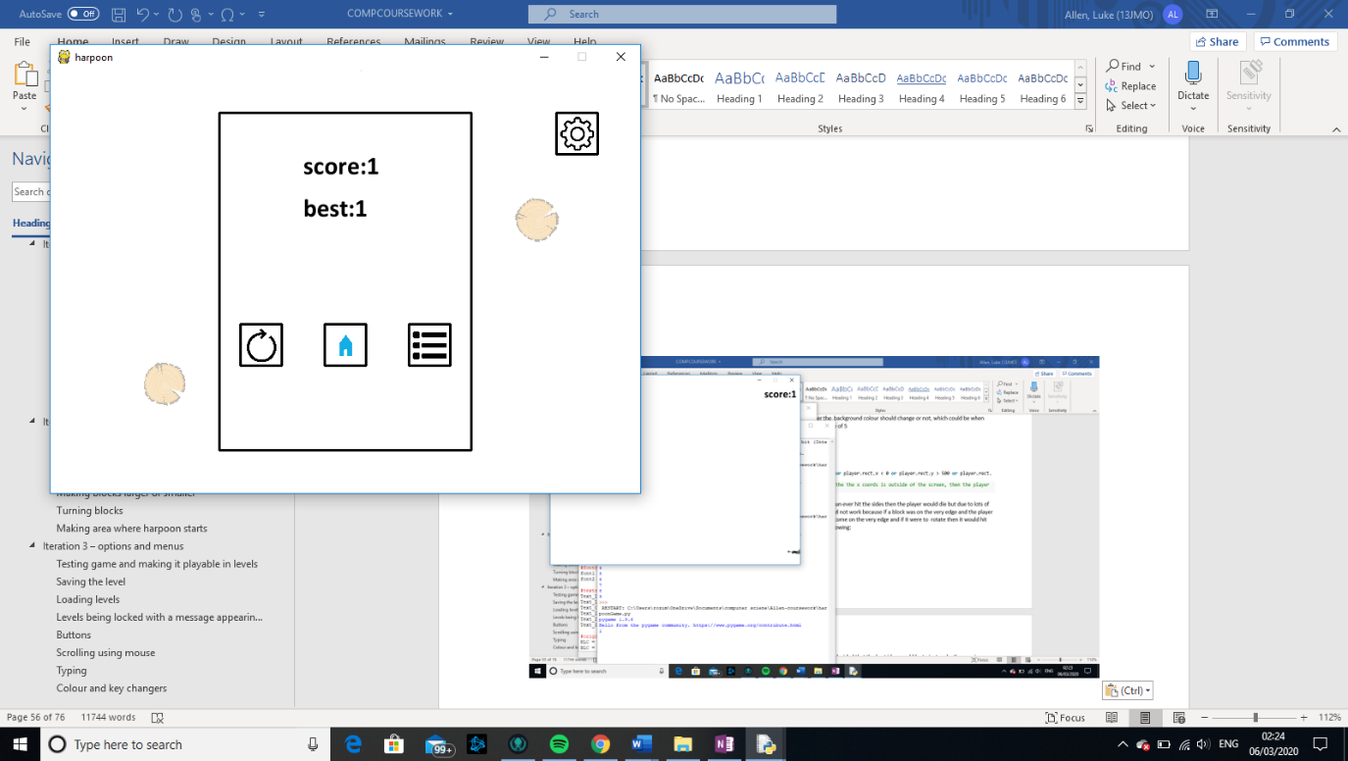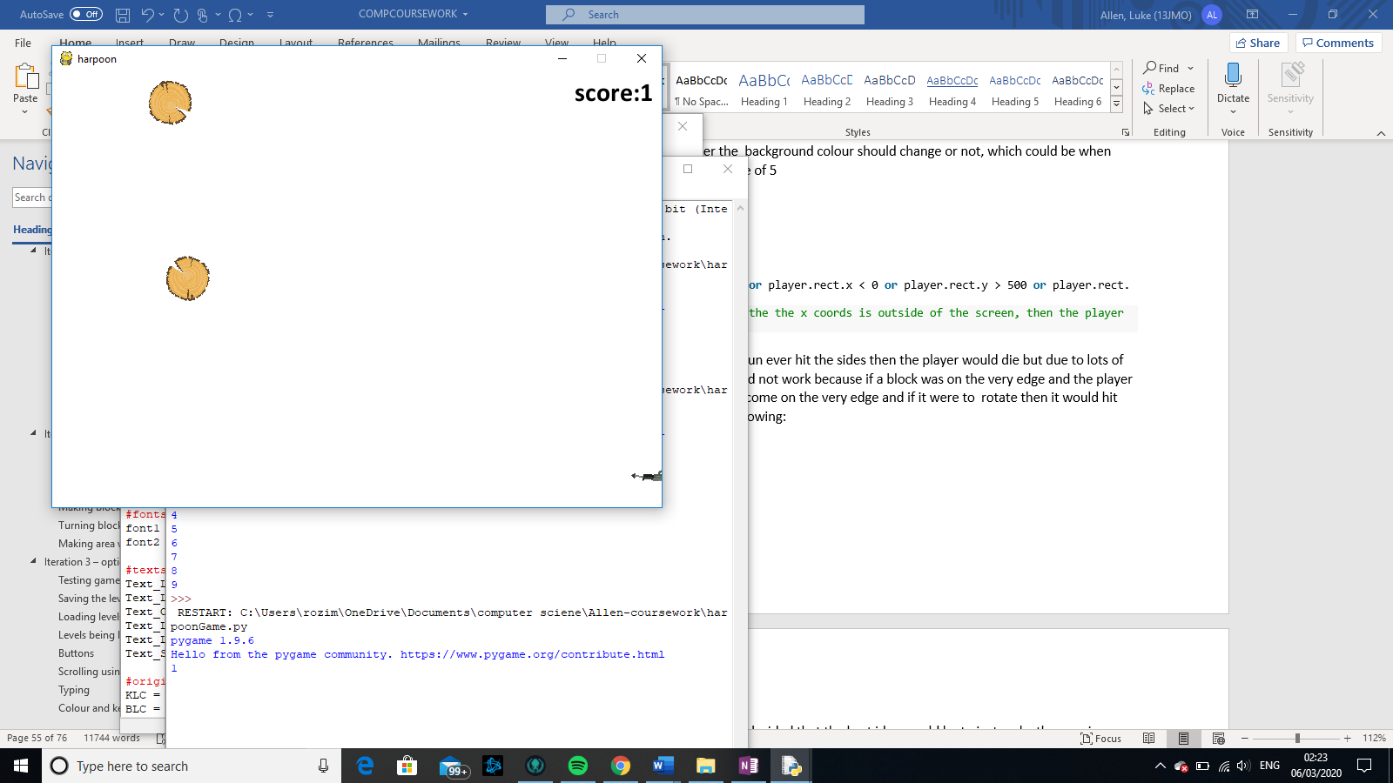



As you can see above, I hit a block which was very close to the side and then due to the harpoon repositioning itself, it died.

2nd attempt

As a solution to my first scenario I decided that the best idea would be to just make the area in which you die in larger so the following code was produced:

1. **if** (player.rect.x > 720 **or** player.rect.x < -20 **or** player.rect.y > 520 **or** player.rect.y < -20):
2. death = True # when the the x coords is at least 20 units outside of the screen, then the player dies

### Screen Fading and death screen

fading

1. **def** transition(x): #where x is the colour to be transitioned to
2. **global** move
3. **if** x == GREY:  #for when transitioning to grey all the objects should shade
4. move = False
5. **for** i **in** all_sprites_list:
6. **for** t **in** range(100):
7. i.image.set_alpha(t)#makes them become more and more shaded quickly
9. **if** background_colour[0] > x[0]:
10. background_colour[0] = background_colour[0] -1
11. **elif** background_colour[0] < x[0]:
12. background_colour[0] = background_colour[0] + 1
13. **if** background_colour[1] > x[1]:
14. background_colour[1] = background_colour[1] -1
15. **elif** background_colour[1] < x[1]:
16. background_colour[1] = background_colour[1] + 1
17. **if** background_colour[2] > x[2]:
18. background_colour[2] = background_colour[2] -1
19. **elif** background_colour[2] < x[2]:
20. background_colour[2] = background_colour[2] + 1

The very first part of this function is for the fading because whenever we use fading it will always be to grey, what is happening is I am setting image + 0.5% roughly transparency each time.

1. #making all the buttons for the deathscreen
2. death_screen = Button(200, 50, 300, 400, 20, "", WHITE, "")
3. REPLAY = image_button(225, 300, 50, 50, 20, "", WHITE, "replay", "replay.png")
4. HOME = image_button(325, 300, 50, 50, 20, "", WHITE, "home", "home.jpg")
5. LEADERBOARD = image_button(425, 300, 50, 50, 20, "", WHITE, "leaderboard", "list.png")
6. background_colour_pointer = 0
7. scores = [0] #this is used to keep track of the top scores for the leaderboard
8. scores_added = False #this is used to check wheter the score has been added to the leaderboards
10. **def** deathscreen(): #draws all button for deathscreen and checks if they have been clicked
11. death_screen.draw()
12. SETTINGS.draw()
13. SETTINGS.click()
14. REPLAY.draw()
15. REPLAY.click()
16. HOME.draw()
17. HOME.click()
18. LEADERBOARD.draw()
19. LEADERBOARD.click()
20. screen.blit(score_word, (300,100))
21. screen.blit(bestScore_word, (300, 150))
22. #draws on deathscreen the score and the best score
24. ... #in loop
26. **elif** death == True: # if death is true writes score and best score on the centre of the screen
27. move = False
28. **if** score > bestscore: #checks to see if most recent score is the best score
29. bestscore = score
30. **if** scores_added == False:
31. add_to_scores(score, Player_name)  # add score to the scores list in order of greatest to smallest
32. scores_added = True #make sure that the same score isnt being constantly added
33. bestScore_word = font.render("best:" + str(bestscore), True, BLACK) #writing best score on deathscreen
34. transition(GREY) #turns game area grey and makes objects fade
35. deathscreen() #loads deathscreen

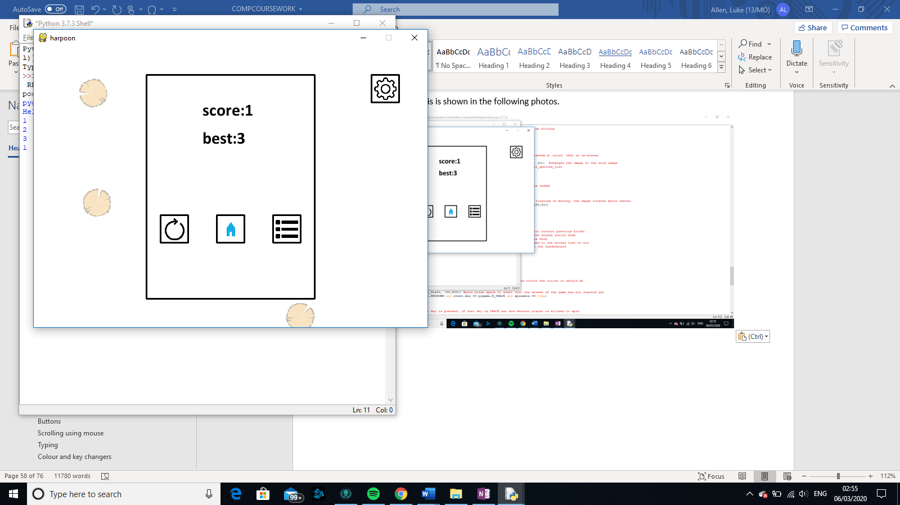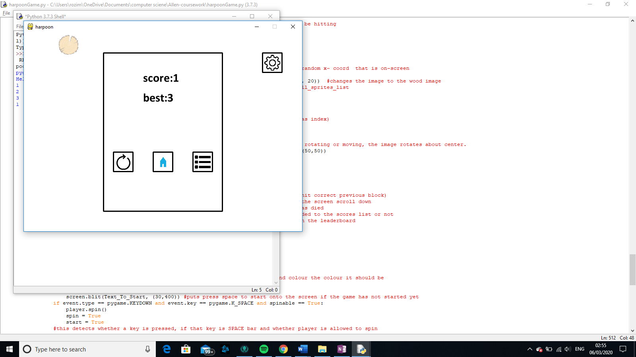The end result of this is shown in the following photos.

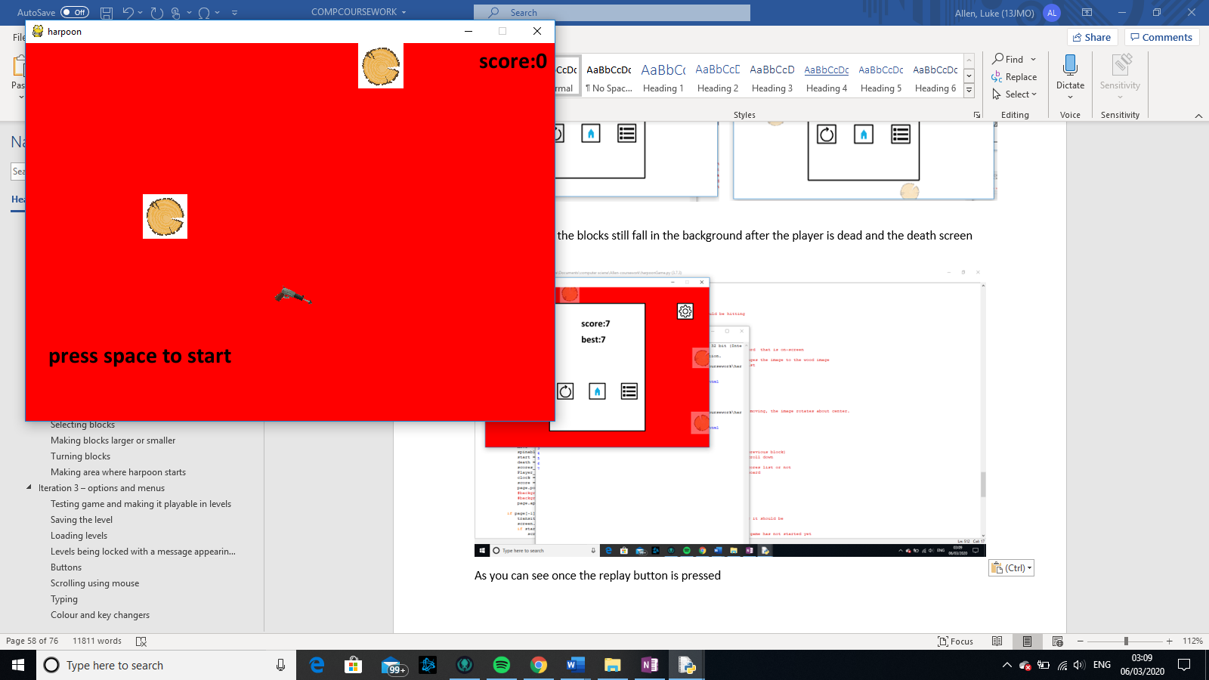This shows how the blocks still fall in the background after the player is dead and the death screen has appeared.

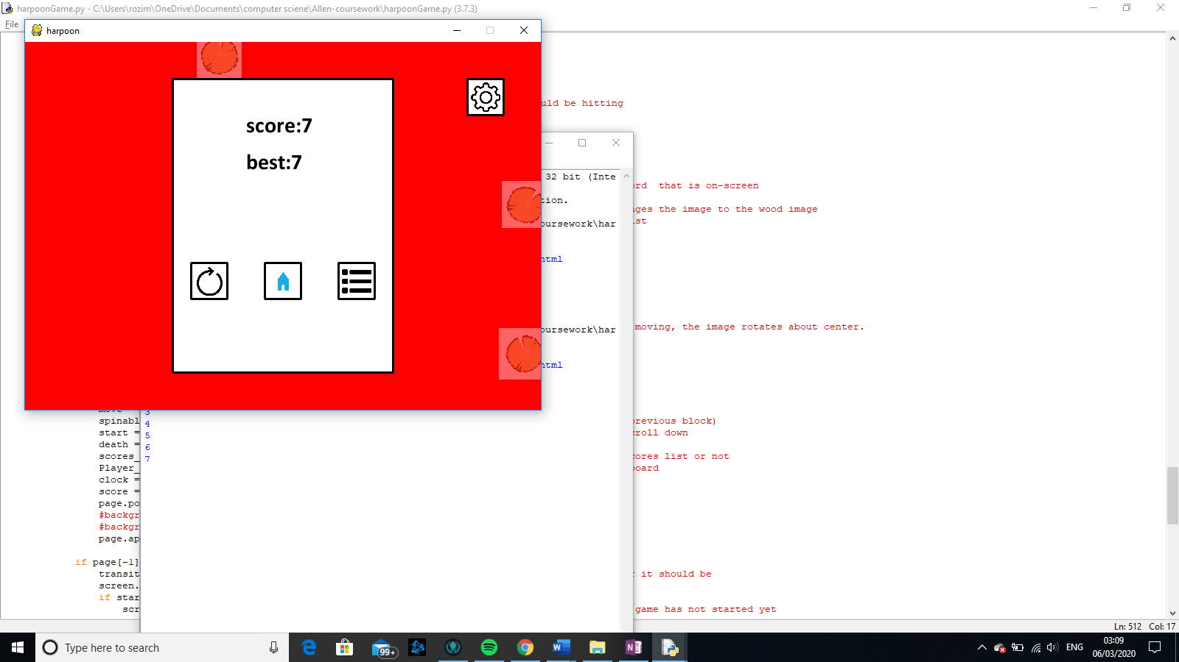

As you can see once the replay button is pressed, there is a problem in the sense that the screen does not turn back to white, therefore, I added the following piece of code in the initiating area of the game, where the objects are created.

1. background_colour_pointer = 0
2. background_colour = [255,255,255]

the first line resets the pointer so that the order of colour change should be the same, and the second line is so that the background is white straight away and does not transition into white. So now when I try it, I get the following:

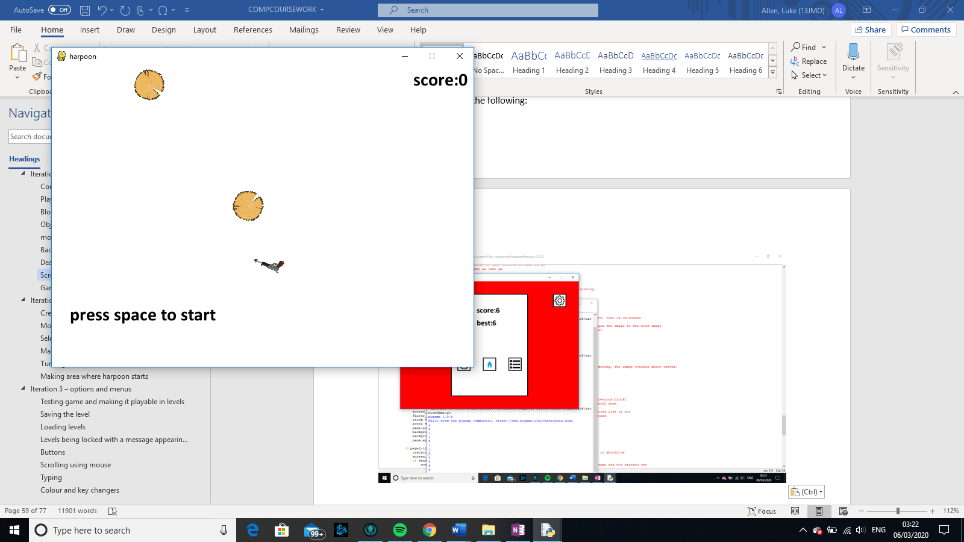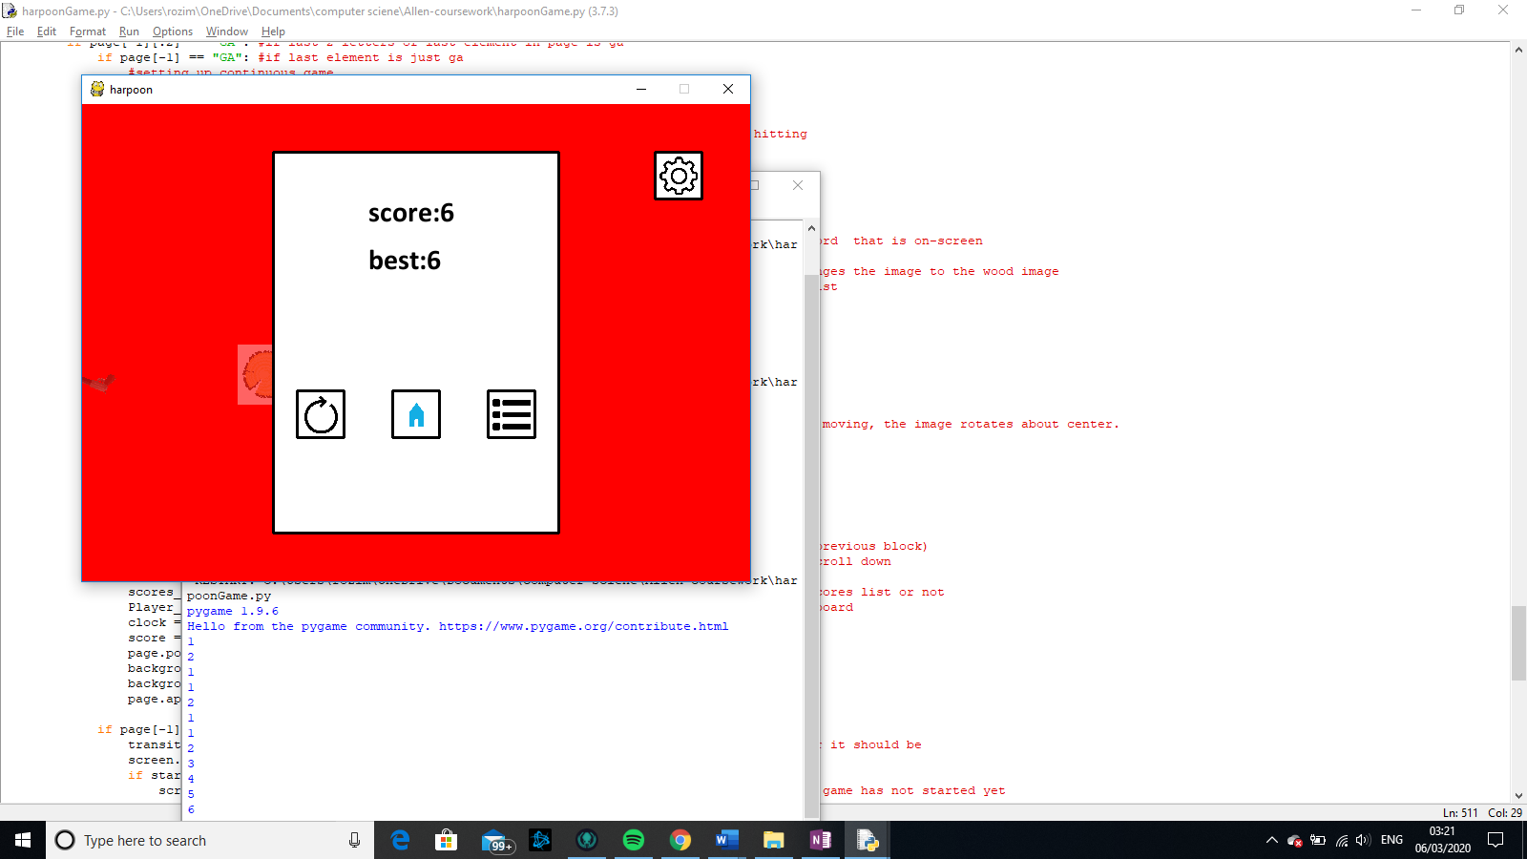As you can se now when the replay button is pressed the colour goes back to white at the beginning.

### Game loop

1. **while** done == False:
2. #this makes a continuous loop until done equals True
3. **for** event **in** pygame.event.get():
4. **if** event.type == pygame.QUIT:
5. done = True
6. #this sees what all the inputs are and if one is to close window then stops loop
7. **if** event.type == pygame.KEYDOWN **and** event.key == pygame.K_SPACE **and** spinable == True:
8. player.spin()
9. spin = True
10. #this detects whether a key is pressed, if that key is SPACE bar and whether player is allowed to spin

When the space is first pressed it checks if the player is allowed to spin through the variable name spinable (if the player was constantly allowed to spin then it would be able to change direction whilst moving and in effect cheat) . If it is allowed then we make the player spin, we make spin = true so that we know that the player is spinning

1. **elif** (spin == True **and** event.type != pygame.KEYDOWN) **or** (move == True):
2. spin = False
3. move = True
4. spinable = False
5. start = True
6. player.move()
7. #this detects if no key is pressed and spin = True, or it was moving last loop

This first part of the if statement asks if it has just been spinning and has stopped pressing space button meaning that the user wants the player to now move in the direction that it is pointing. The next part of the if statement asks if the player was previously moving, and due to it having move = True in the if statement the player would constantly move in a straight line and forever if not for the next section of code

1. speed = score//5 + 5
2. #increases speed
3. screen.fill(WHITE)
5. blocks_hit = pygame.sprite.spritecollide(player,blocks,False)
6. #adds any blocks that have been hit by the player to blocks_hit
7. **if** len(blocks_hit) > 0:
8. #checks if anything has been hit
9. **if** blocks_hit[-1] == block_list[target]:
10. #checks if the last block entered was the targeted block
11. block_list[target].rect.x = random.randrange(0, 650)
12. block_list[target].rect.y -= 800
13. #puts the block higher that it looks like a constant stream of blocks
14. target -= 1
15. **if** target == -1:
16. target = 3
17. #changes target to next one
18. score += 1
19. #add 1 to score
20. **print**(score)
21. spinable = True
22. #allow player to spin again
23. move = False
24. #stops player from moving
25. **else**:
26. death = True
27. # for moment this stops game if wrong block hit

What this code does is check if a block has been hit, if so, it then checks whether the block that has been hit is the correct block, if so then it will add 1 to the score, make the block’s y coordinates much higher above with a random x coordinates, stop the player from moving, and allow the player to spin again. If the block that is hit is not the block that is meant to be hit then the player would count as being dead.

1. **if** start == True:
2. **for** sprite **in** all_sprites_list:
3. sprite.rect.y += (speed-4)
4. sprite.center = (sprite.center[0], sprite.center[1] + (speed-4))
5. #makes all srites move down screen by spped
6. **if** (player.rect.x > 720 **or** player.rect.x < -20 **or** player.rect.y > 520 **or** player.rect.y < -20):
7. done = True
8. #if player hits side of screen they dead
9. all_sprites_list.draw(screen)
10. #shows all sprites
11. word = font.render("score:" + str(score), True, BLACK)
12. #writes score on top right corner
13. screen.blit(word, (600, 10))
14. #makes word appear there
15. clock.tick(20)
16. pygame.display.flip()
18. pygame.quit()

## Iteration 2 -level building

Moving the objects and dealing with collisions

### Creating blocks

1. **class** Create(Block):
2. **def** __init__(self, image):
3. super().__init__(image)
4. self.image_angle = 0
5. self.image = pygame.transform.rotate(self.OG_image, self.image_angle)
6. self.image_file = image
7. self.rect.x = 100      #start x position
8. self.rect.y = 100      #start y position
9. self.select = False    #this attribute is to help know if the object has  been selected.
10. self.dragstart = False  #this attribute is to help know if the object is  being dragged.
11. self.og_x = 0  #position of top left x coord of object when object is  starting to get dragged
12. self.og_y = 0  #position of top left y coord of object when object is  starting to get dragged
13. self.drag_og_x = 0  #position of mouse x coord of object when object is  starting to get dragged
14. self.drag_og_y = 0  #position of mouse y coord of object when object is  starting to get dragged
15. self.bottom_right = False  #tells us whether the oject is being enlarged
16. self.bar_position = [170,430]  #it is the position of the rotation bar to  mark what angle the image is turned at
17. self.bar_drag = False  #tells us whether the rotation bar is being dragged
18. self.center = [0.5*self.width + self.rect.x,0.5*self.height + self.rect.y]
20. **if** event.type == pygame.KEYDOWN **and** event.key == KillerBlockKey: #when the key that is assigned to making a killer line is pressed, originally k is pressed
21. killer = Create(klc_image)  #a object called killer is created, with image of  kl
22. all_blocks_list.add(killer)
23. all_sprites_list.add(killer)   #killer is added to all_blocks_list and all_sprites_list
24. **elif** event.type == pygame.KEYDOWN **and** event.key == BouncyBlockKey:  #when the key that is assigned to making a killer line is pressed, originally k is pressed
25. bouncy = Create(blc_image)   #a object called bouncy is created, with image of bl
26. all_blocks_list.add(bouncy)
27. all_sprites_list.add(bouncy)   #bouncy is added to all_blocks_list and  all_sprites_list
28. **elif** event.type == pygame.KEYDOWN **and** event.key == CheckpointBlockKey:  #when the  key that is assigned to making a killer line is pressed, originally k is pressed
29. checkpoint = Create("wood.jpg")  #a object called checkpoint is created, with  image of wooden block
30. all_blocks_list.add(checkpoint)
31. all_sprites_list.add(checkpoint)   #checkpoint is added to all_blocks_list and all_sprites_list
32. **elif** event.type == pygame.KEYDOWN **and** event.key == FinalBlockKey:  #when the key  that is assigned to making a killer line is pressed, originally k is pressed
33. final = Create("wood.jpg")   #a object called final is created, with image of a final wooden block
34. all_blocks_list.add(final)
35. all_sprites_list.add(final)   #final is added to all_blocks_list and all_sprites_list

### Selecting blocks

1. **def** selecter(self):
2. pos = pygame.mouse.get_pos()
3. **if** (event.type == pygame.MOUSEBUTTONDOWN):
4. **if** (pos[0] > self.rect.x - 10) **and** (pos[0] <(self.rect.x + self.width + 10)) **and** ((pos[1] > self.rect.y - 10) **and** (pos[1] < (self.rect.y + self.height + 10))): #if this object is clicked on
5. **for** i **in** all_sprites_list: #deselects all objects
6. i.select = False
7. self.select = True #selects this singular object
8. **else**:
9. self.select = False #as mouse has clicked elswhere, deselects object
10. **if** self.select == True:
11. pygame.draw.rect(screen, BLACK, [self.rect.x - 5, self.rect.y - 5, self.width + 10, self.height + 10], 2)   #draws box around it
12. pygame.draw.circle(screen, WHITE, (self.rect.x + self.width + 5, self.rect.y + self.height + 5), 5)       #
13. pygame.draw.circle(screen, BLACK, (self.rect.x + self.width + 5, self.rect.y + self.height + 5), 5, 1)    # draws a a hollow black circle on bottom right of  box for object to be enlarged.

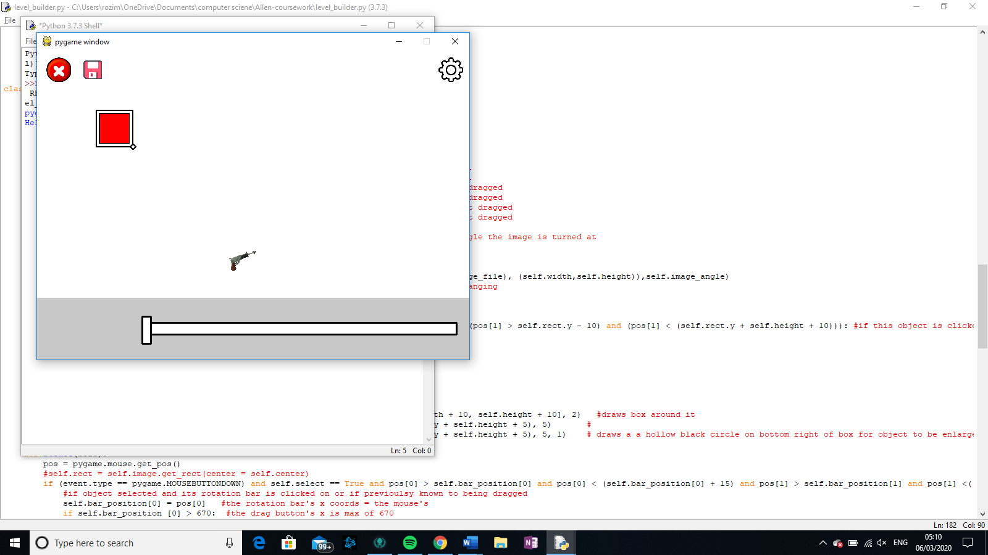For this method, there were little to no problems. As explained above, when button is clicked all objects are deselected and the one that is touching the mouse is selected; then if selected, a box appears around it with a small circle at the bottom right corner which is for enlarging the object. Therefore, the following image occurs as described before:

### Moving blocks

1st attempt

1. **def** selecter(self):
2. **if** (event.type == pygame.MOUSEBUTTONDOWN):  #checks if mouse leftclick has  occured
3. **for** i **in** all_sprites_list:      #deselects all objects
4. i.select = False
5. **if** (pygame.mouse.get_pos()[0] > self.rect.x) **and** (pygame.mouse.get_pos()[0] <(self.rect.x + self.width)) **and** ((pygame.mouse.get_pos()[1] > self.rect.y) **and** (pygame.mouse.get_pos()[1] < (self.rect.y + self.height))):
6. self.select = True  #selects object if click is within area of object
7. **if** self.select == True:  #draw a box around selected object with a small circle at bottom right corner.
8. pygame.draw.rect(screen, BLACK, [self.rect.x - 5, self.rect.y - 5, self.width + 10, self.height + 10], 2)
9. pygame.draw.circle(screen, WHITE, (self.rect.x + self.width + 5, self.rect.y + self.height + 5), 5)       #
10. pygame.draw.circle(screen, BLACK, (self.rect.x + self.width + 5, self.rect.y + self.height + 5), 5, 1)
11. ...
13. **for** i **in** all_sprites_list:
14. i.selecter()          #runs selecter function
15. i.drag()              #runs drag function
16. all_sprites_list.draw(screen)
17. clock.tick(20)

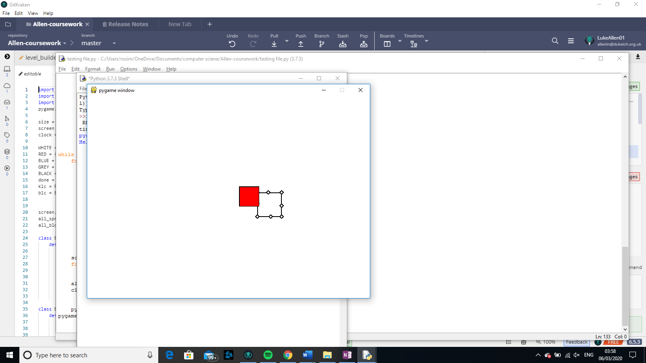As it says above, how the program works, it takes in input, checks if it is a mouse click, if so it deselects all objects and selects one that the click is on; then if it is selected a black box is drawn around it and a small white circle at the bottom right of it. Although after some testing, the box and small circle around it seems to lag behind the actual objects itself, as shown in the following images:

After looking into the problem some more, I realised that because the i.selecter() was before the i.drag(0), the box would be drawn and then the object would be moved due to the drag method.

1. **def** drag(self):
2. pos = pygame.mouse.get_pos()
3. **if** event.type == pygame.MOUSEBUTTONDOWN **and** self.select == True **and** self.dragstart == False **and** (pos[0] > self.rect.x + 5) **and** (pos[0] <(self.rect.x + self.width - 5)) **and** ((pos[1] > self.rect.y + 5) **and** (pos[1] < (self.rect.y + self.height - 5))):
4. #this checks if object is selected, clicked on and not started dragging yet
5. self.dragstart = True   #tells us it has started dragging
6. self.drag_og_x = pos[0]   #position of mouse x coord of object when object is starting to get dragged
7. self.drag_og_y = pos[1]   #position of mouse y coord of object when object is starting to get dragged
8. self.og_x = self.rect.x   #position of top left x coord of object when  object is starting to get dragged
9. self.og_y = self.rect.y   #position of top left y coord of object when  object is starting to get dragged
10. **if** self.dragstart == True:    #checks if the object has started to be dragged
11. self.rect.x = self.og_x + (pos[0] - self.drag_og_x) #changes the position  of object to that of original x coord + change in x mouse position
12. self.rect.y = self.og_y + (pos[1] - self.drag_og_y) #changes the position  of object to that of original y coord + change in y mouse position
13. **if** event.type == pygame.MOUSEBUTTONUP: #if mouse leftclick is released
14. self.dragstart = False      #drag is stopped

Now for this next part- the screen drag function – which is used to move the screen around so that you are able to access other objects

1. **def** screen_drag():
2. **global** screen_drag_start  #this allows screen_drag_start to be used inside and out of the function##this is good because then it can be set to a singular value  beforehand and not changed everytime the funciton is called
3. **global** screen_drag_start_x  #this allows screen_drag_start_x to be used inside and out of the function
4. **global** screen_drag_start_y  #this allows screen_drag_start_y to be used inside and out of the function
5. x = 0
6. **for** i **in** all_blocks_list:
7. **if** i.select == True:
8. x = x + 1   #x is number of selected blocks
9. pos = pygame.mouse.get_pos()
10. **if** x == 0 **and** event.type == pygame.MOUSEBUTTONDOWN :   #checks that no items  are selected and the mouse left-click has been pressed down
11. screen_drag_start = True      #tells us the screen(i.e. all the objects)  are starting to be dragged
12. screen_drag_start_x = pos[0]  #tells us the start x for when the screen is begging to be dragged
13. screen_drag_start_y = pos[1]  #tells us the start x for when the screen is begging to be dragged
14. **for** i **in** all_sprites_list:
15. i.og_x = i.rect.x     #procreates drag function but for every  individual block
16. i.og_y = i.rect.y
17. **elif** event.type == pygame.MOUSEBUTTONUP **and** screen_drag_start == True:
18. screen_drag_start = False
19. **if** screen_drag_start == True:
20. **for** i **in** all_sprites_list:
21. i.rect.x = i.og_x + (pos[0] - screen_drag_start_x)
22. i.rect.y = i.og_y + (pos[1] - screen_drag_start_y)

As stated in the comment, I have checked to see if there are any selected block, if not, then I check to see if mouse has clicked, if so then I have recorded the start x, y cords of where the mouse was and the x,y coord of where each objects started, and from then on unless event is the release of the leftclick, the x coord of each object is equal to the starting x coord of object + difference in values of current mouse x and starting mouse x coord. Therefore the following happens:

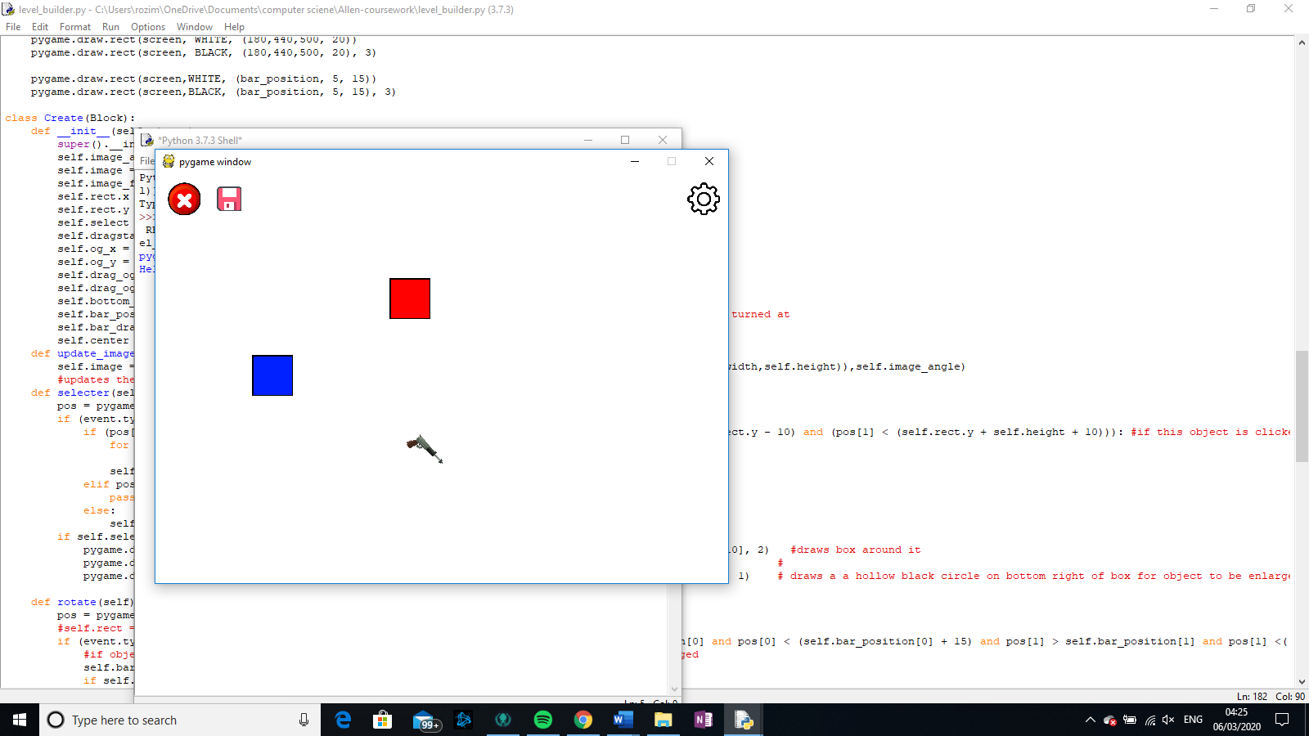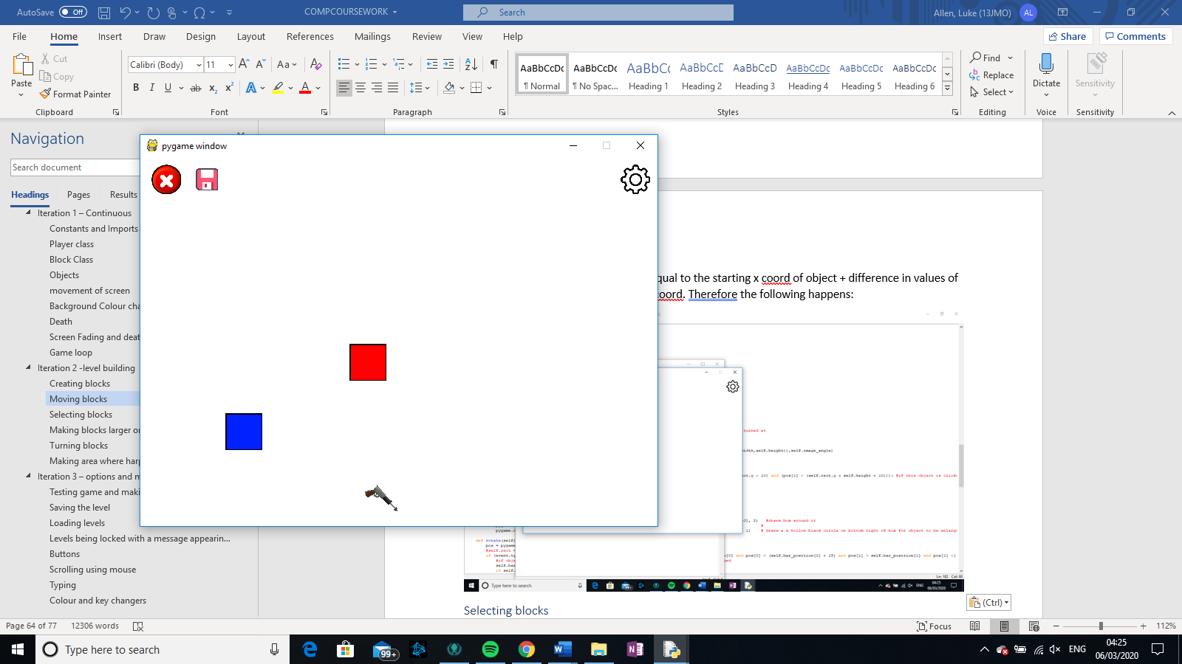

As you can see I have dragged all the objects down but I have kept the buttons in the same place (because they do not belong to the all_blocks_list.

### Making blocks larger or smaller

Here, what did is checked to see if the click was in the mini circle and then changed the width and height accordingly…

1. **def** size(self):
2. pos = pygame.mouse.get_pos()
3. pressed = pygame.mouse.get_pressed()
4. bottom_right_pos = (self.rect.x + self.width + 5, self.rect.y + self.height + 5)
6. **if** pressed[0] == 1 **and** self.select == True:
7. **elif** math.sqrt((bottom_right_pos[0] - pos[0])**2 + (bottom_right_pos[1] - pos[1])**2) < 5:           #uses equation of a circle to find out if mouse coords in circle
8. self.width = pos[0] - self.rect.x     # new width is difference between x coords of it and top left corner which stays constant
9. self.height = pos[1] - self.rect.y    # new height is difference between y coords of it and top left corner which stays constant

  …but for some reason, it would only allow me to increase the size of the code for a small amount of space and then would stop growing or shrinking. After multiple tests, I realised that the mouse had to constantly be in the area of circle and as the refresh rate is not too quick, when mouse appeared outside of circle, it would not move.

Attempt 2

1. **def** size(self):
2. pos = pygame.mouse.get_pos()   #this is just so that I do not have to say  pygame.mouse.get_pos() every time it is used
3. pressed = pygame.mouse.get_pressed()    #this is just so that I do not have to say pygame.mouse.get_pressed() every time it is used
4. bottom_right_pos = (self.rect.x + self.width + 5, self.rect.y + self.height + 5) #position of the bottom right corner (of selected circle)
6. **if** pressed[0] == 1 **and** self.select == True:
7. **if** math.sqrt((bottom_right_pos[0] - pos[0])**2 + (bottom_right_pos[1] - pos[1])**2) < 5 **or** self.bottom_right == True: #this checks the circular area within  the small circular using the equation of the circle
8. self.width = pos[0] - self.rect.x  #changes width to the new width##
9. self.height = pos[1] - self.rect.y  #changes the height to the new  height
10. self.bottom_right = True #tells us that the bottom right corner is  being held down to increase size of object
11. **else**:
12. self.bottom_right = False  #tells us that the bottom right corner is not  being held down to increase size of object

Here, I have created a new attribute called self.bottom_right which records whether or not the bottom right corner is being increased or not. If it is true then next occurrence it will changes size of width to new size by minusing of the top right corner x coords from the mouse x  coords because the mouse x coords where roughly originally the bottom_right x coords no matter what x or y cords the mouse has.

### Turning blocks

### Making area where harpoon starts

## Iteration 3 – options and menus

### Testing game and making it playable in levels

### Saving the level

### Loading levels

### Levels being locked with a message appearing if so

### Buttons

First iteration

How it looks

Second iteration

How it gets clicked

Third iteration

How it works

Forth iteration

Back button

Fifth button

Home button

### Scrolling using mouse

### Typing

### Colour and key changers

## General

### 1 – game loop

#### Iteration 1

While not done

#### Iteration 2

Paging system

## Continuous

## Level builder

## Levels

# Testing

## Test 1

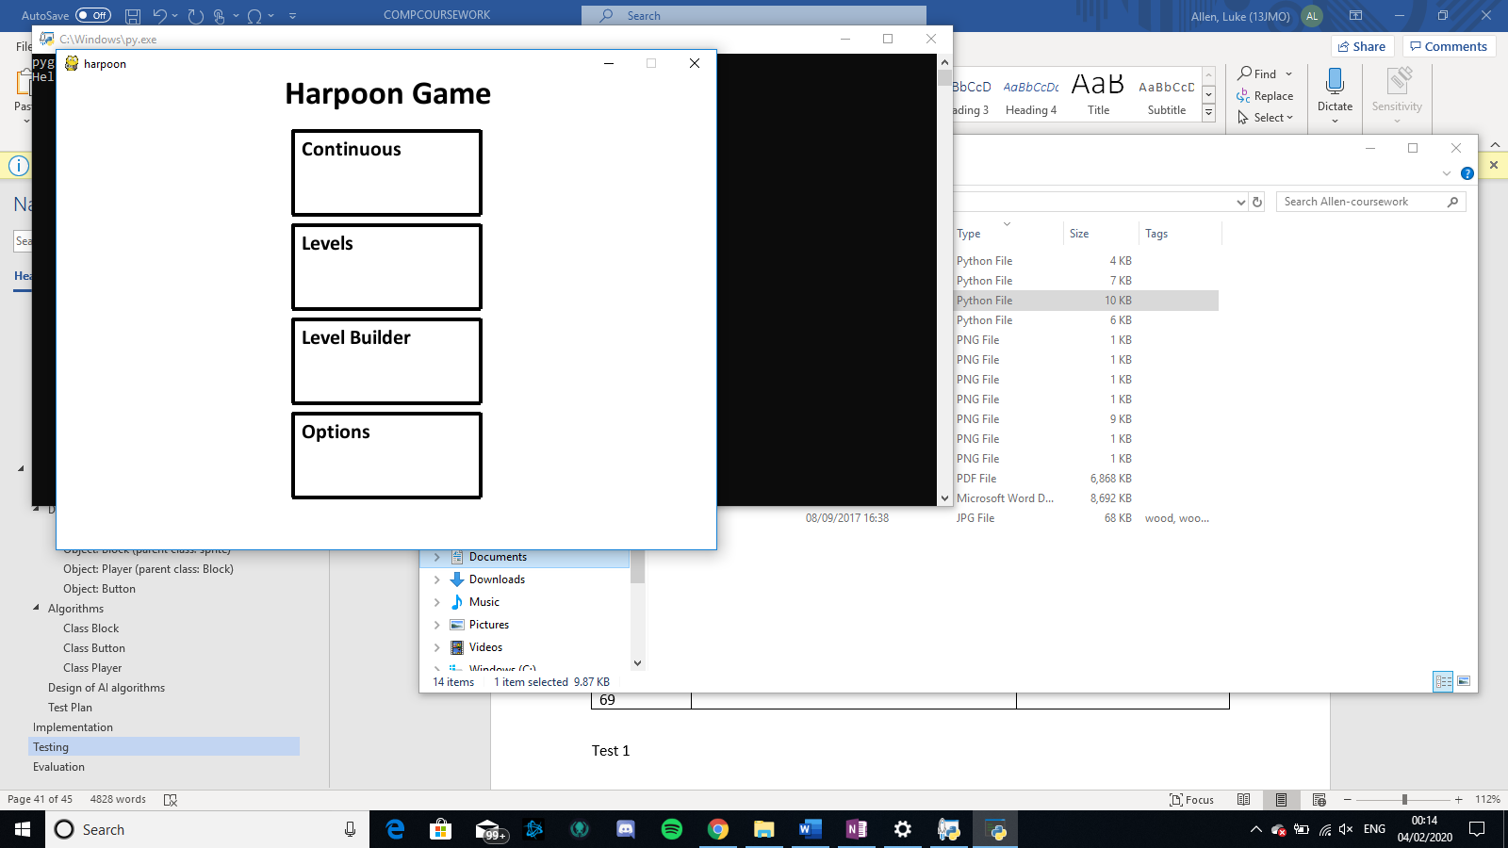Here there is a 500 by 700 pixeled screen.

## Test 2

Here as we started the python program, immediately start on the Harpoon Game page where we will hopefully be able to go to the continuous, levels and level builder parts of the game.

## Test 3

On the Starter page, there are the 4 buttons that are expected: the Continuous, levels, level builder and options buttons.

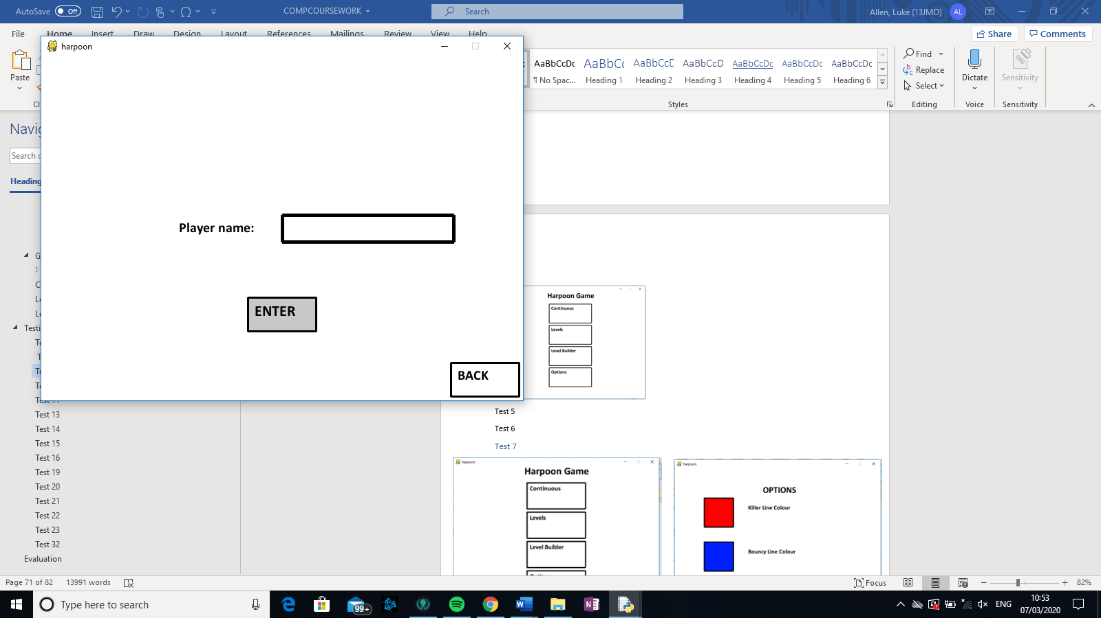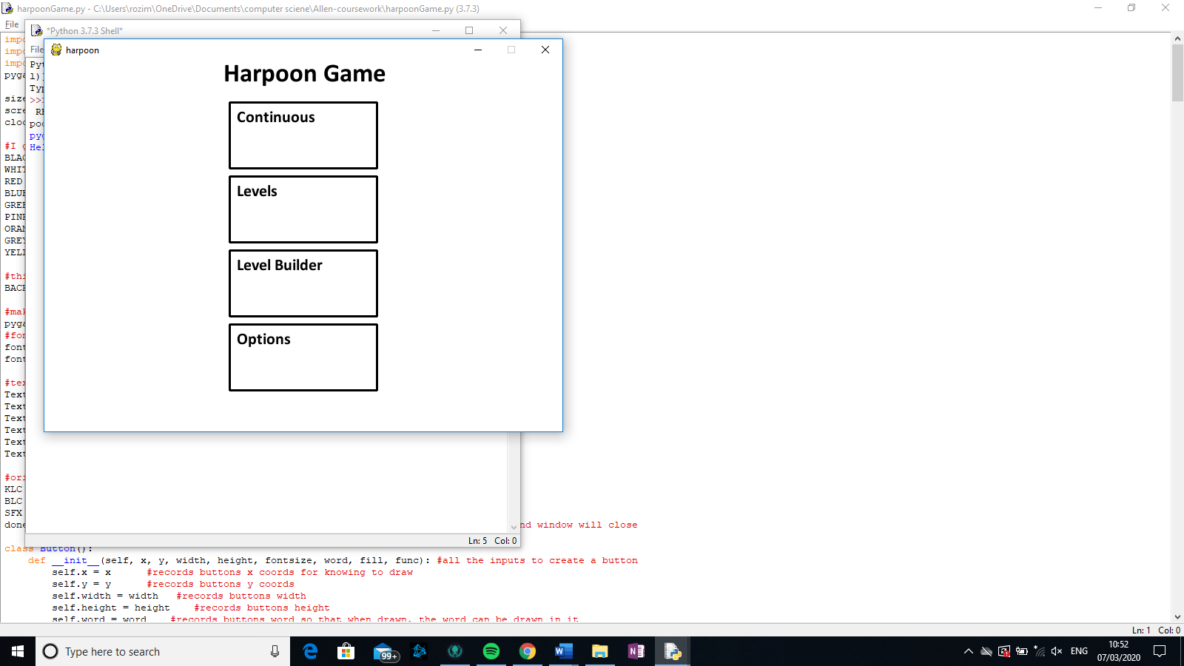Test 4

Test 5

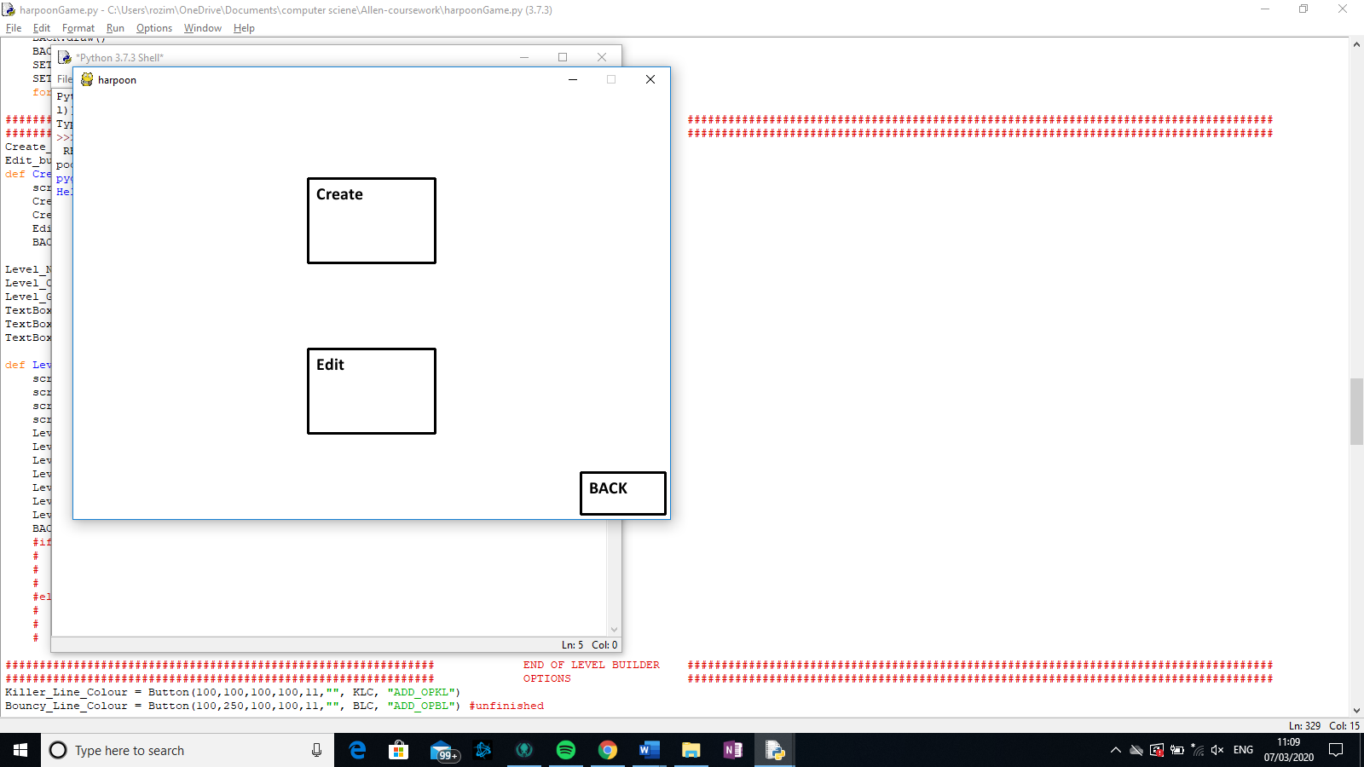Test 6

## Test 7

When the options button on the left is clicked, the screen will transition into the screen on the right, which is the options page

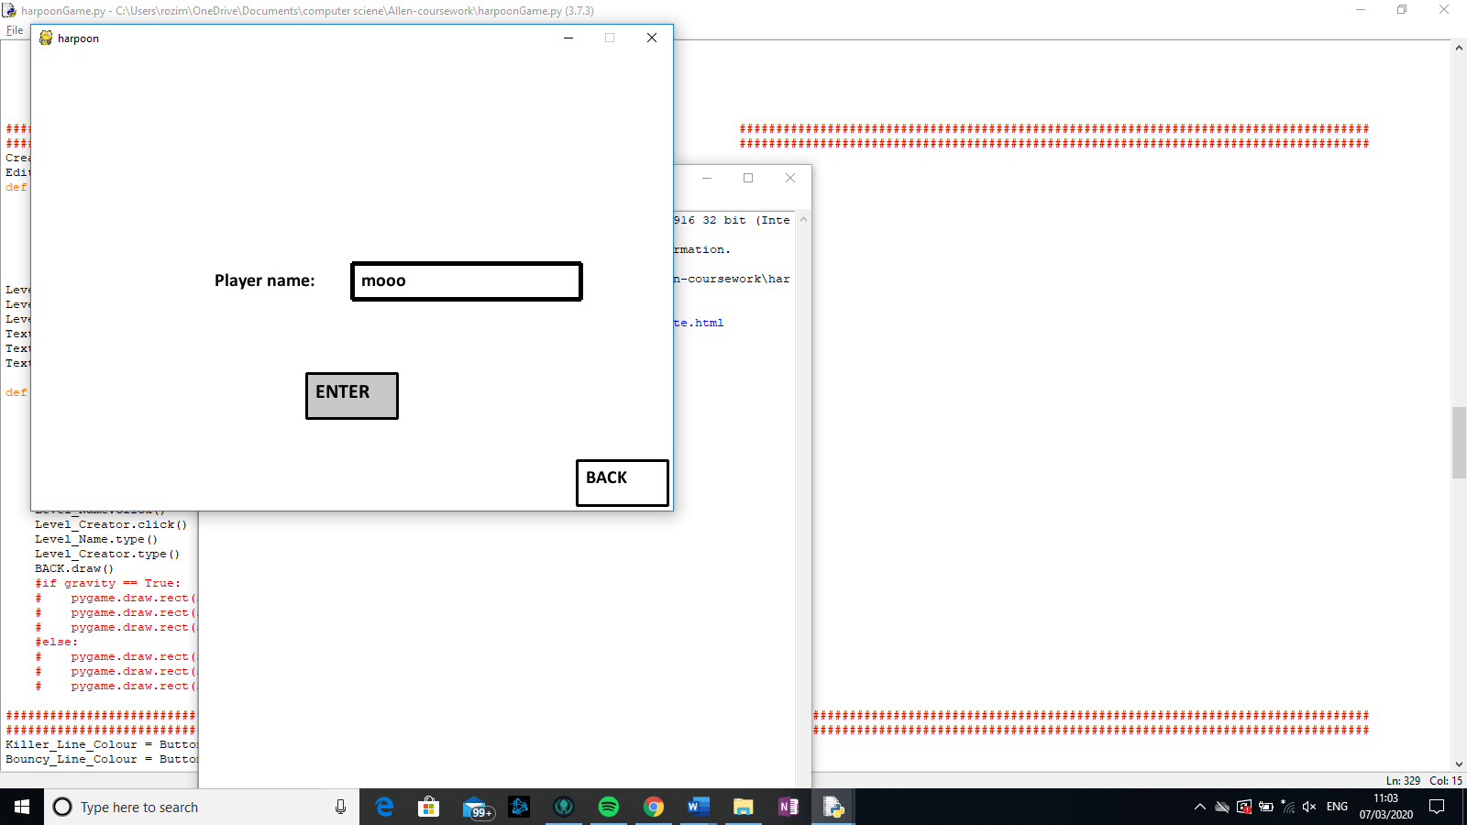Test 8

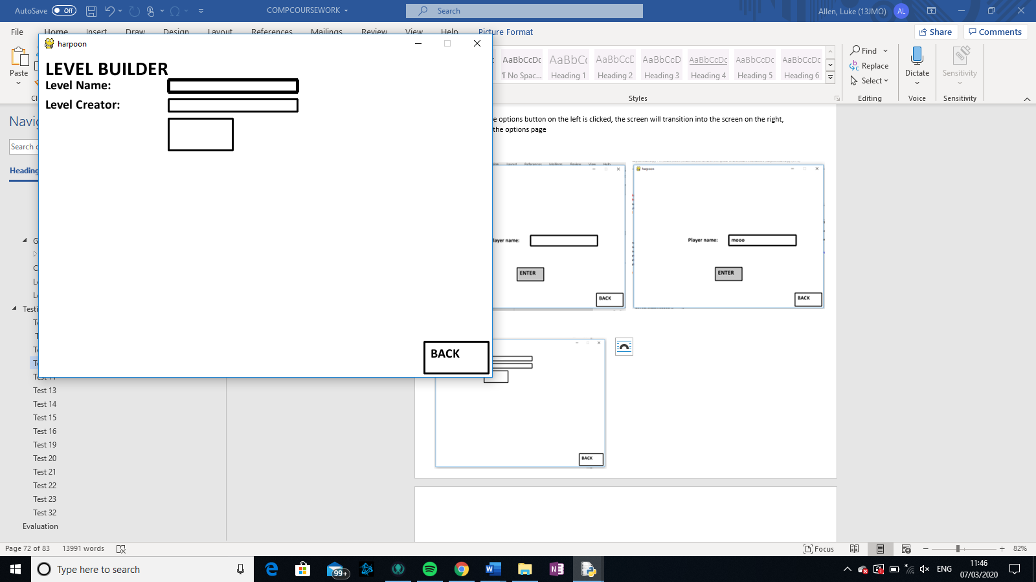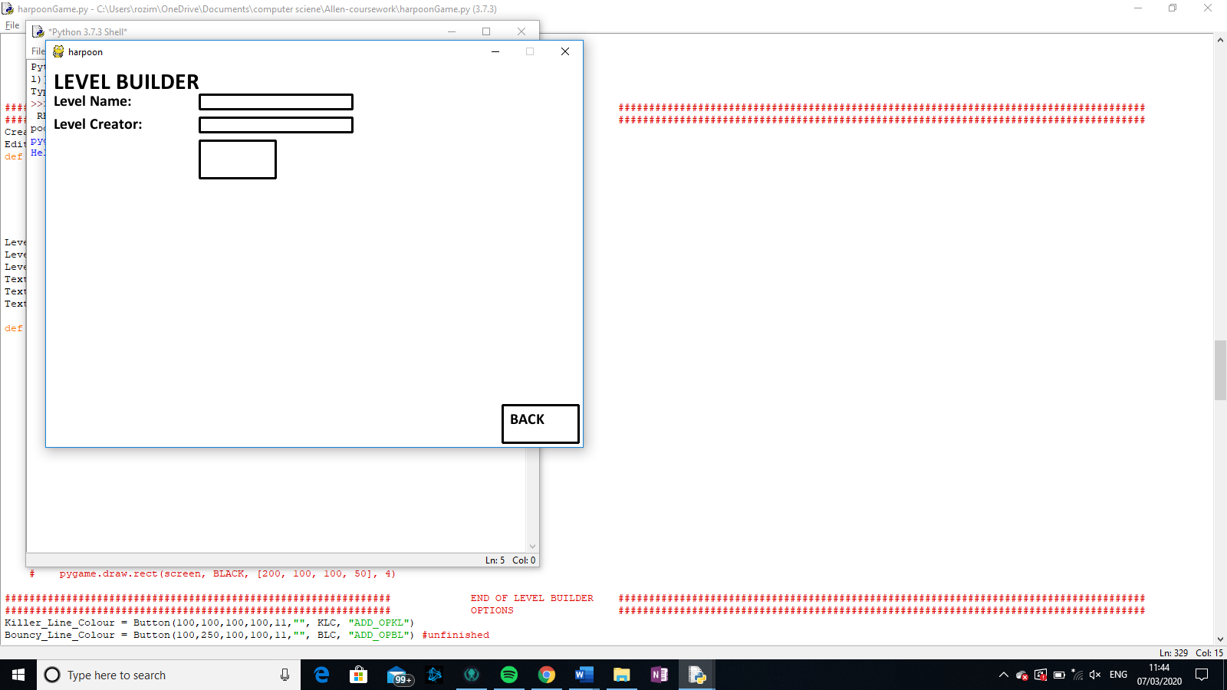Test 9

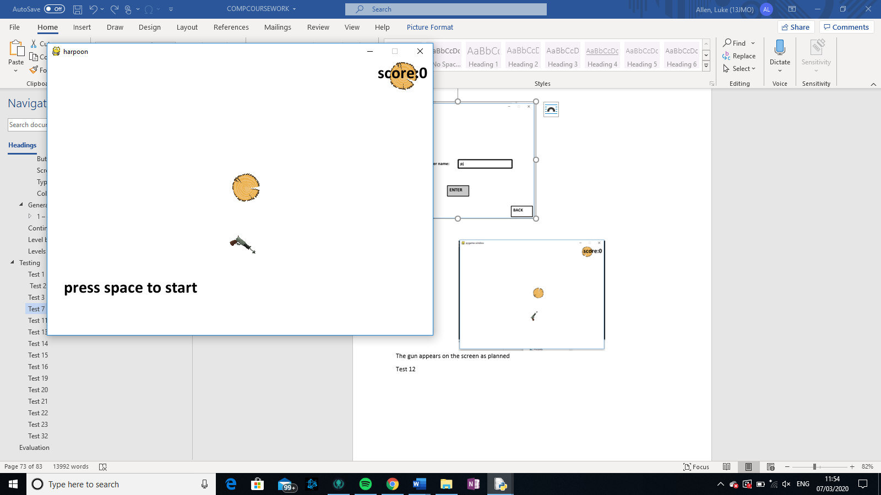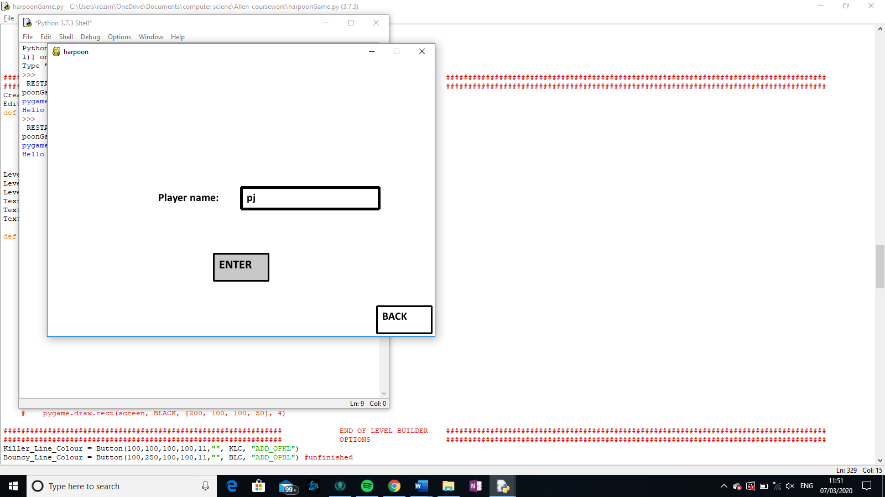Test 10

## Test 11

The gun appears on the screen as planned

Test 12



## Test 13

Here are two starting positions of the continuous part of the game. They both start pointing at different directions showing their randomness.

## Test 14

As you can see, wooden blocks also appear on the screen

## Test 15

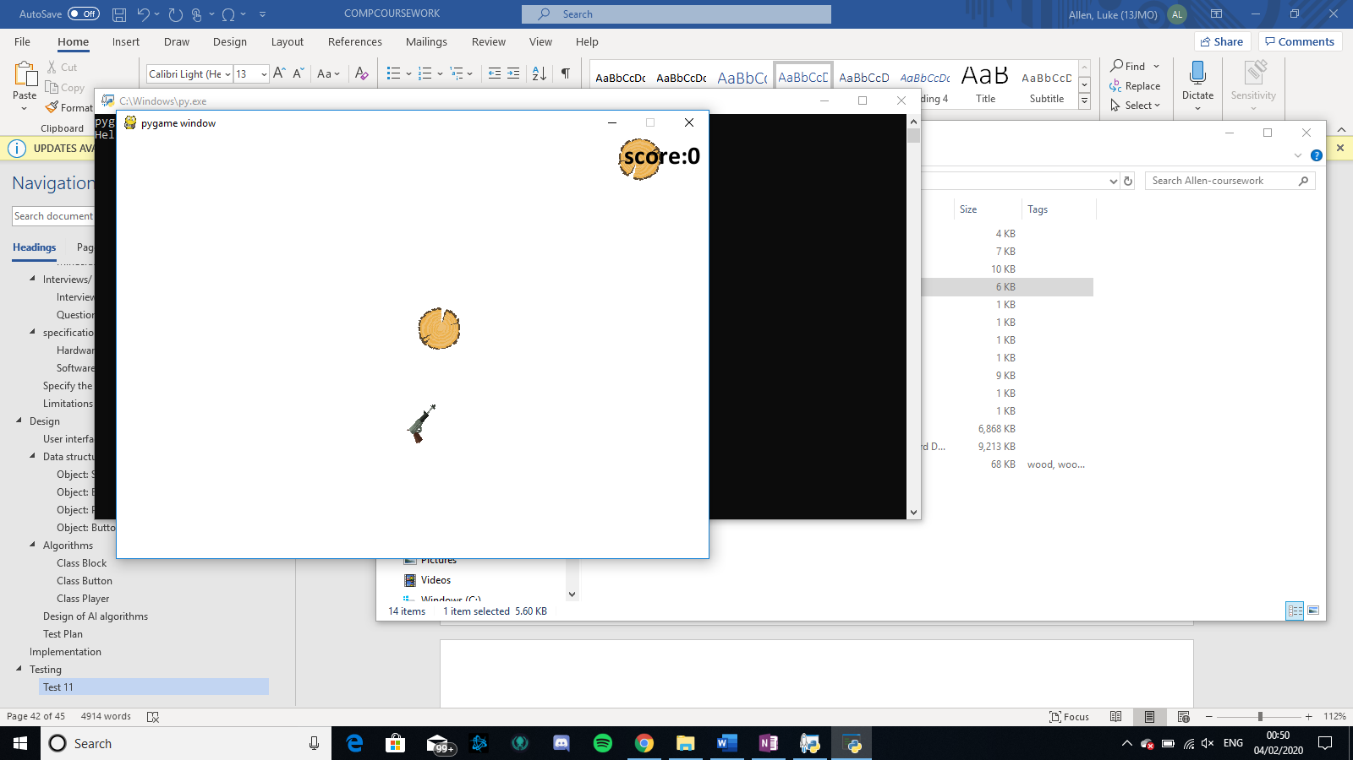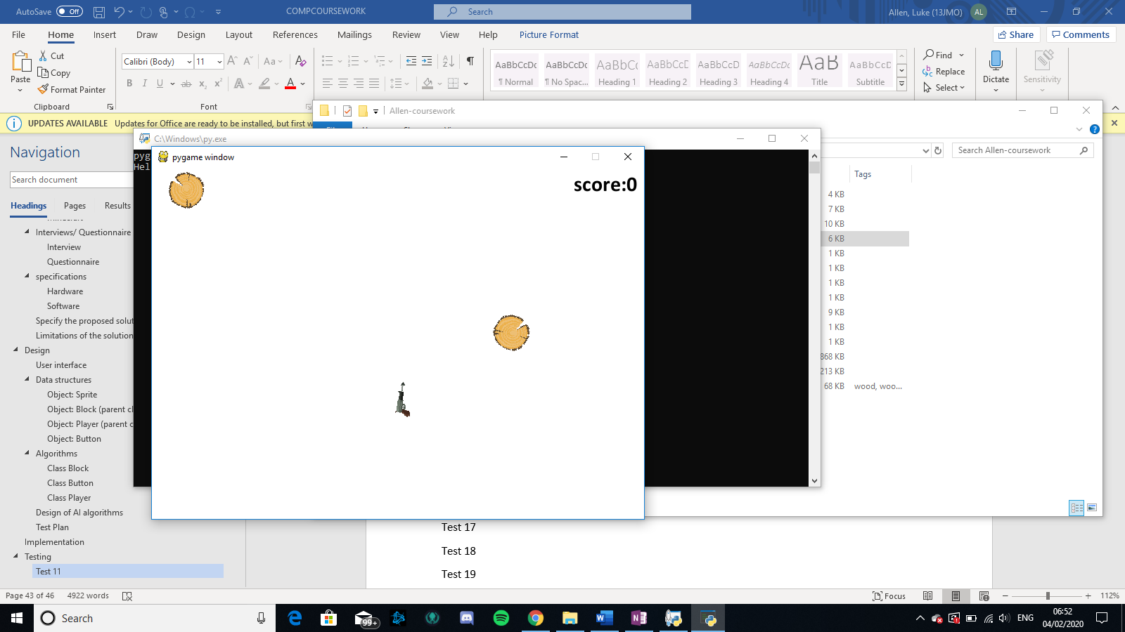

As you can see via the two different beginnings of the page that the wooden blocks spawn with a random x-coordinate.

## Test 16

As you can see there is a score showing at the top right corner

Test 17

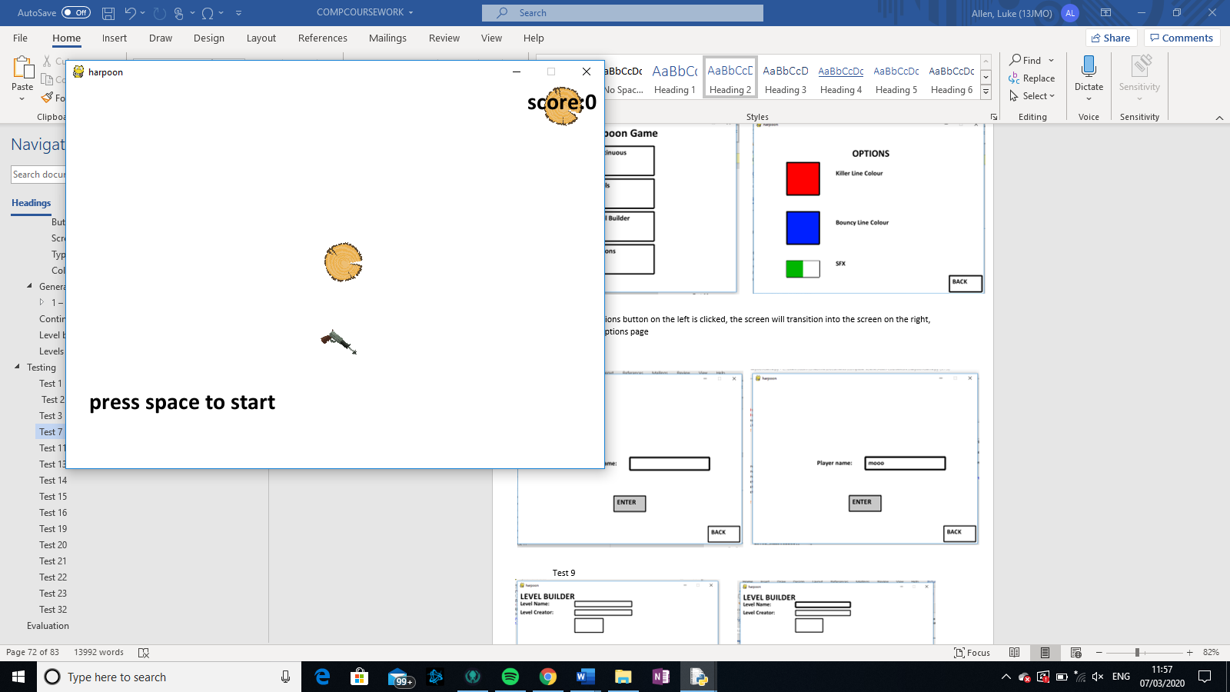

## Test 18

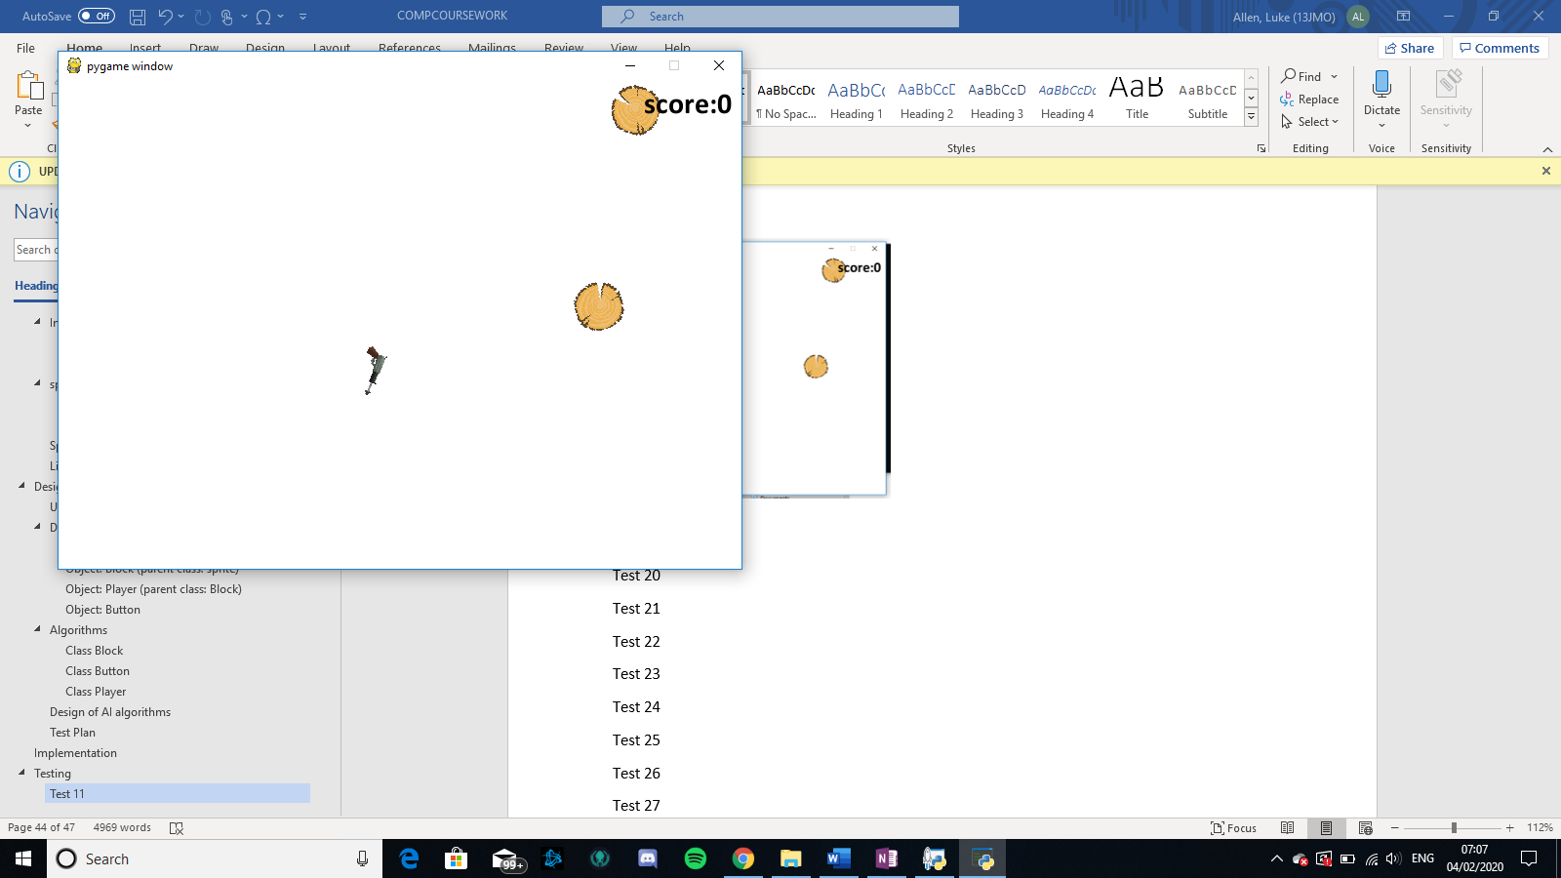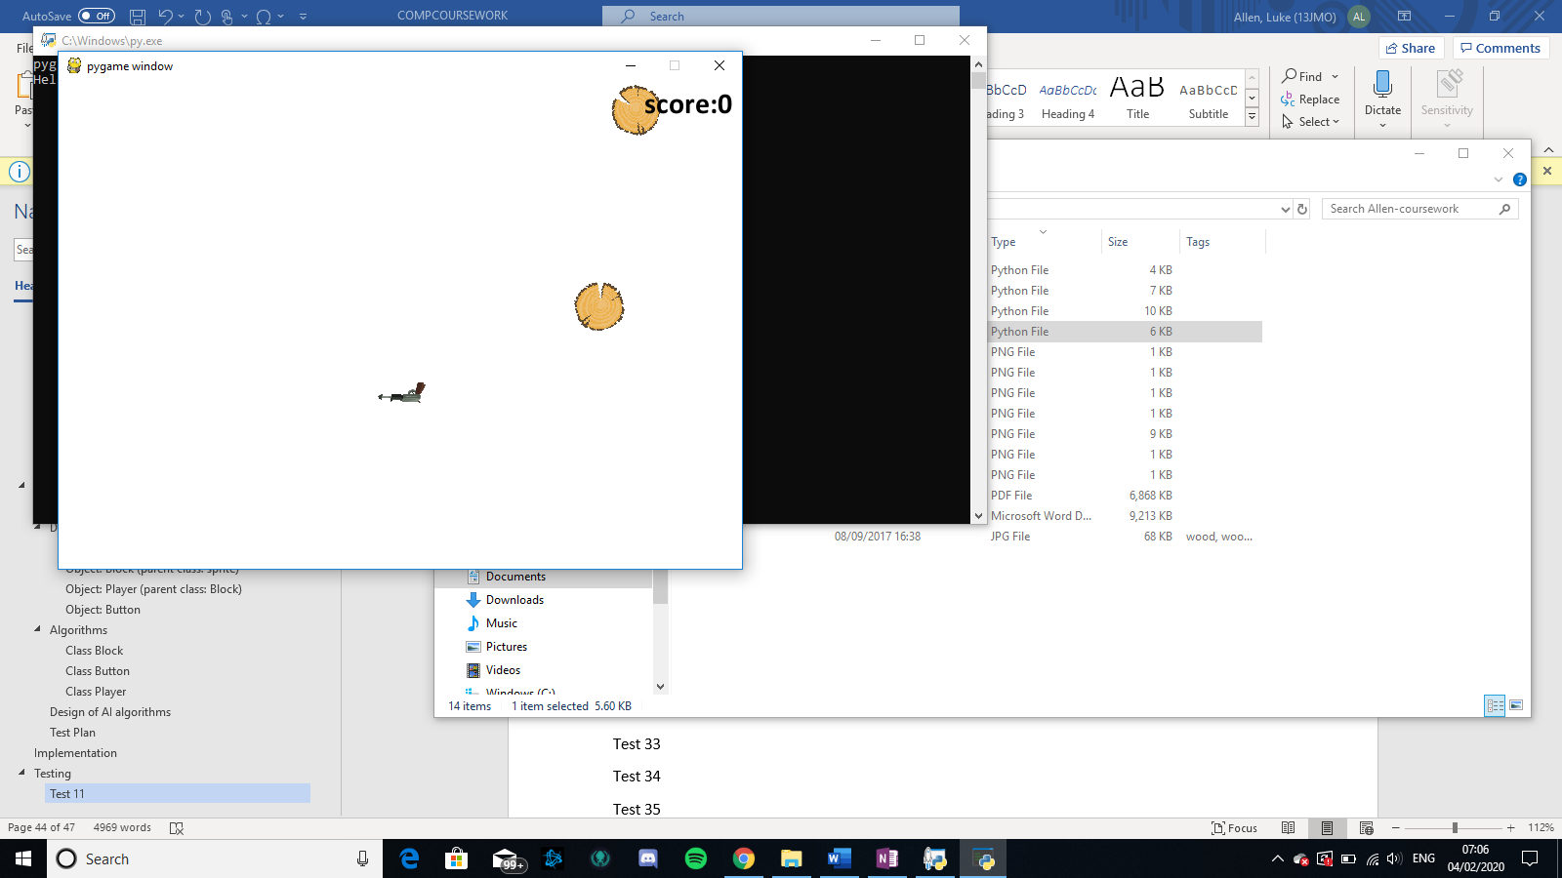

The left screen transitions into the right screen via turning anti-clockwise, (the screen does not go down because of the fact that this is the first spin and the score is 0

## Test 19

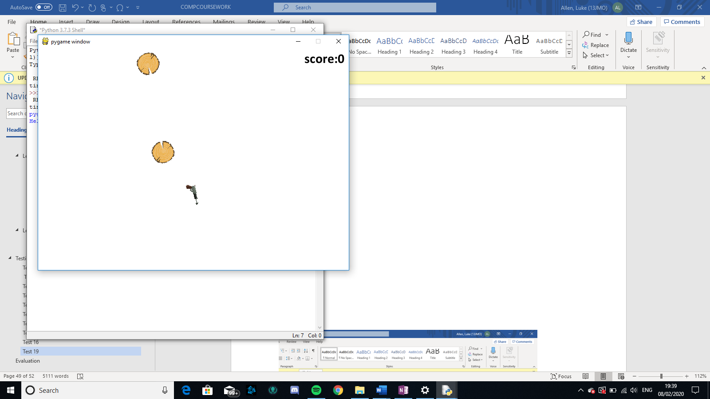 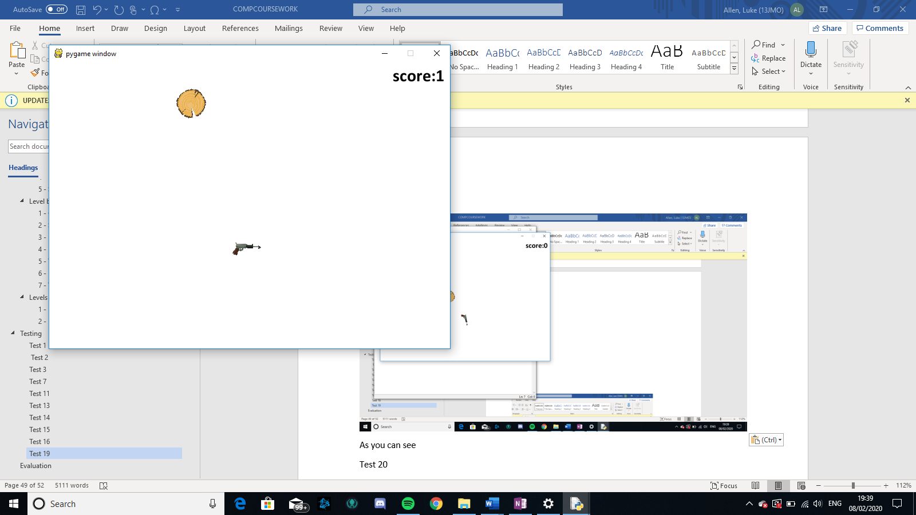

As you can see in the photos above, the gun turned around its center, blue lines are the edge of the screen so you can see in proportion. The gun went down slightly because the screen is moving down.

## Test 20

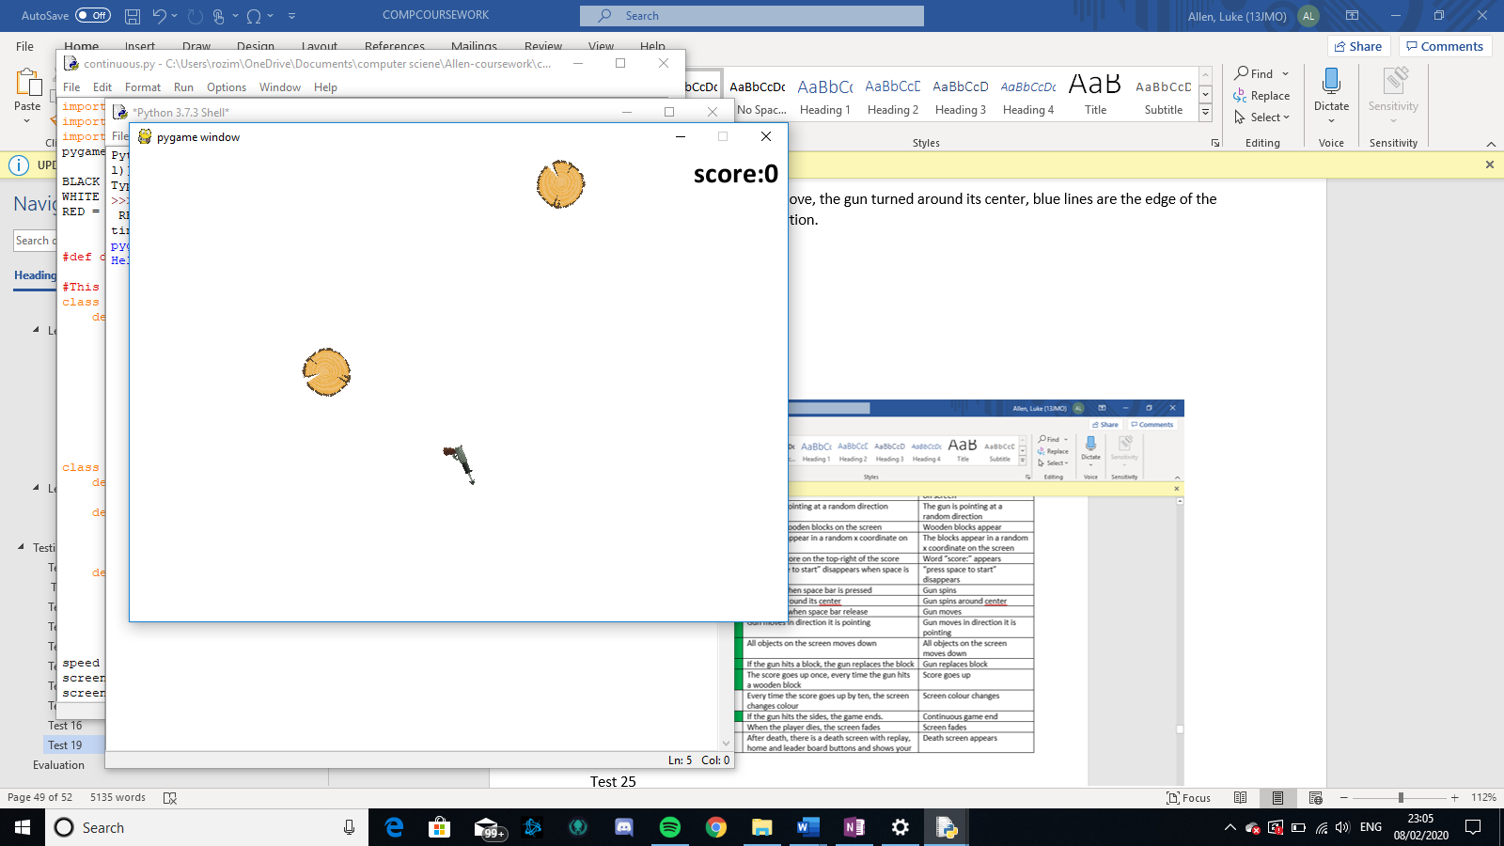 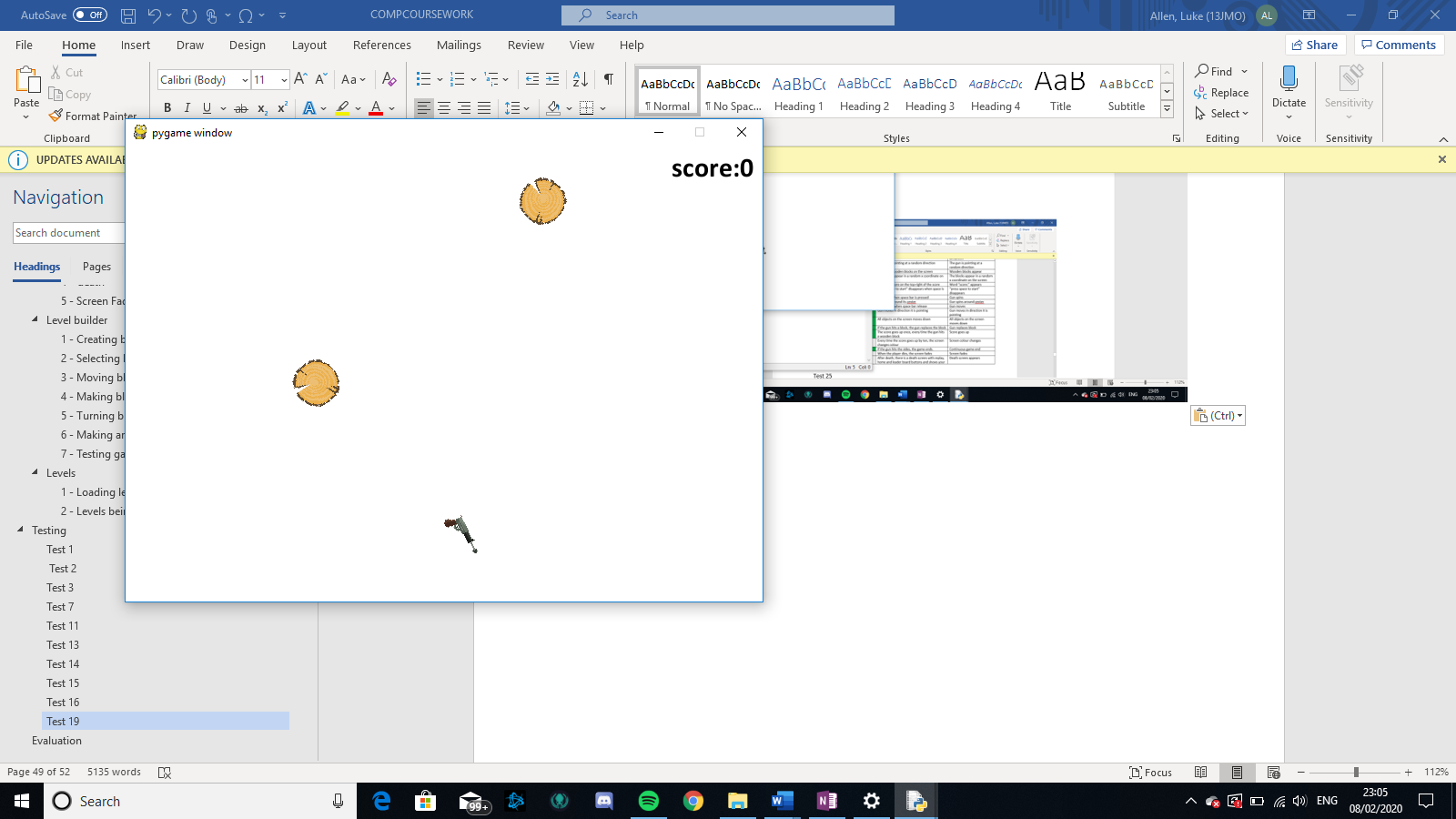

As you can see in the two photos above, the gun is moving in the direction that it is point, although it also has an extra down component as the screen is constantly moving down

## Test 21

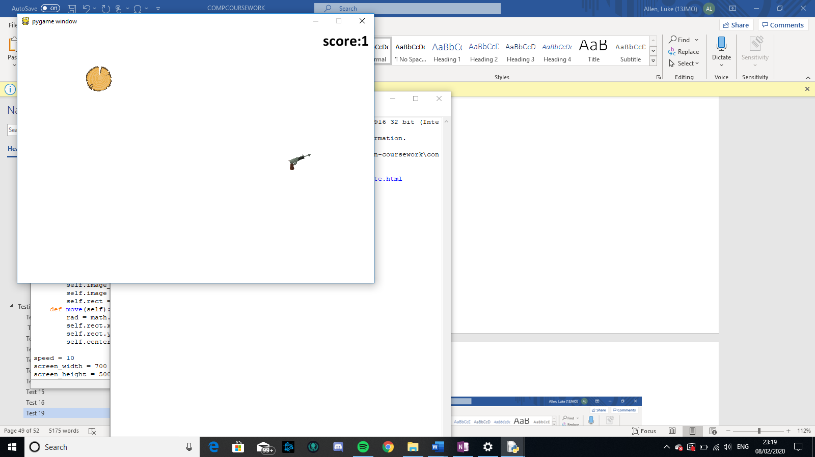 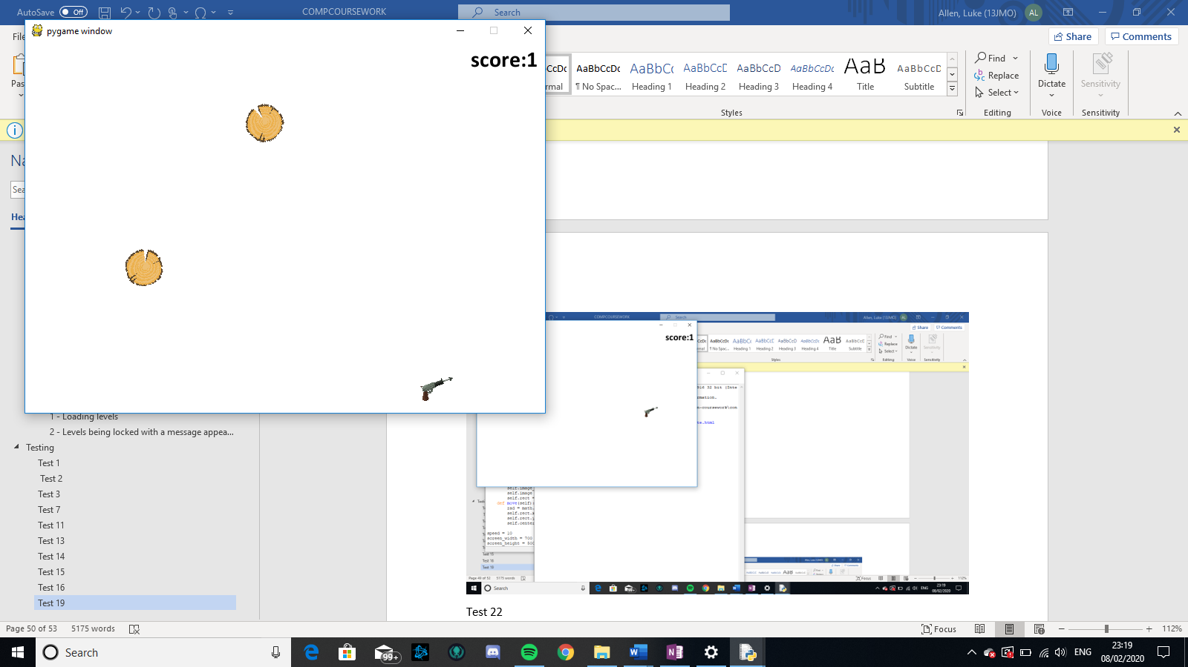

## Test 22

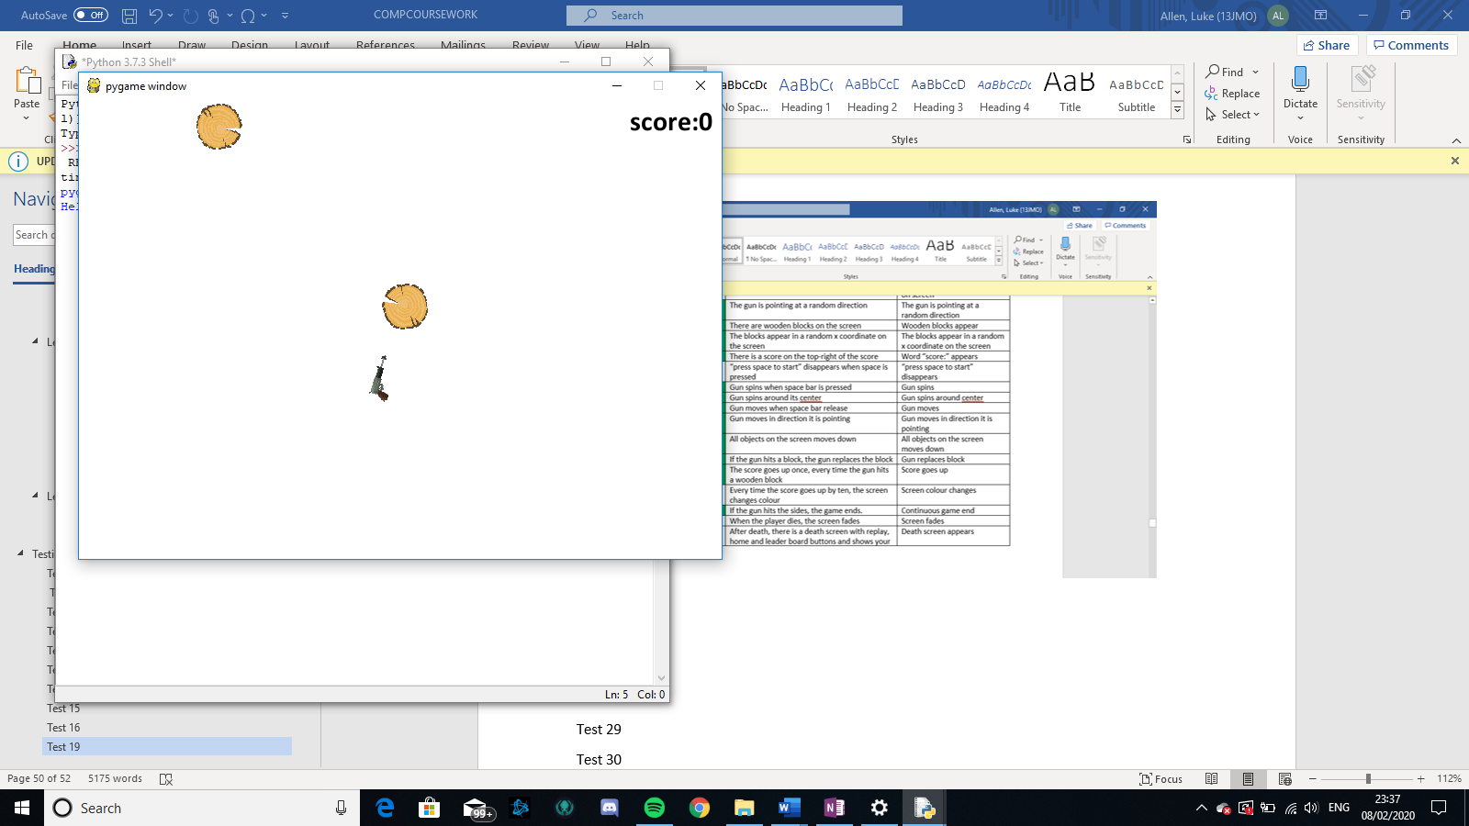 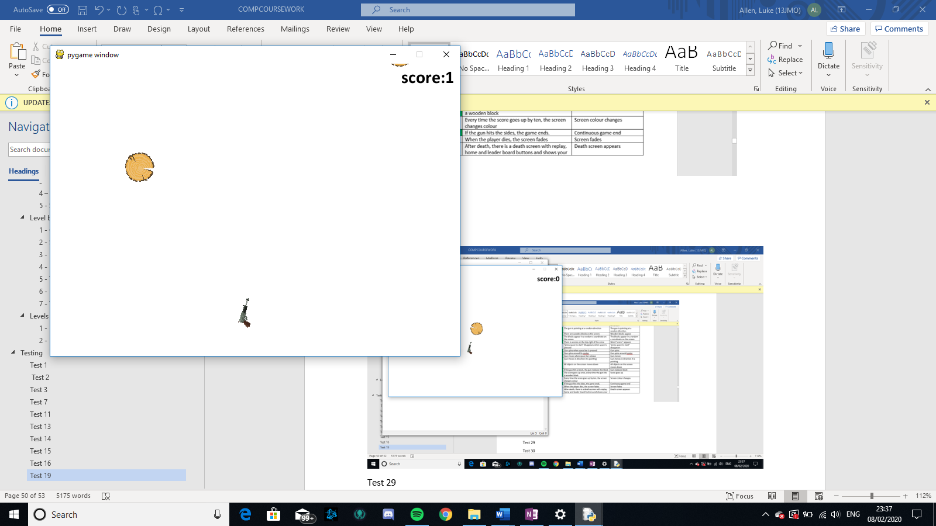

Here to gun has replaced the block but it is lower due to the constant scrolling of the screen

## Test 23



Here in the first photo the gun is about to hit the block, then the block gets hit and has disappeared and the score went up by 1

Test 24

Test 25

Test 26

Test 27

Test 28

Test 29

Test 30

Test 31

## Test 32

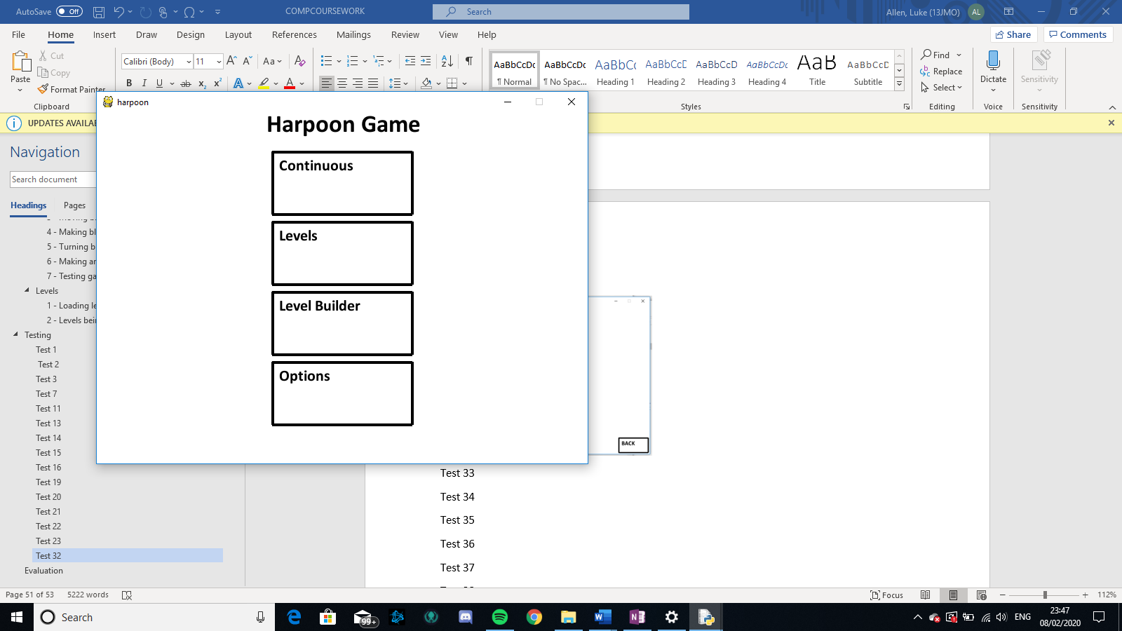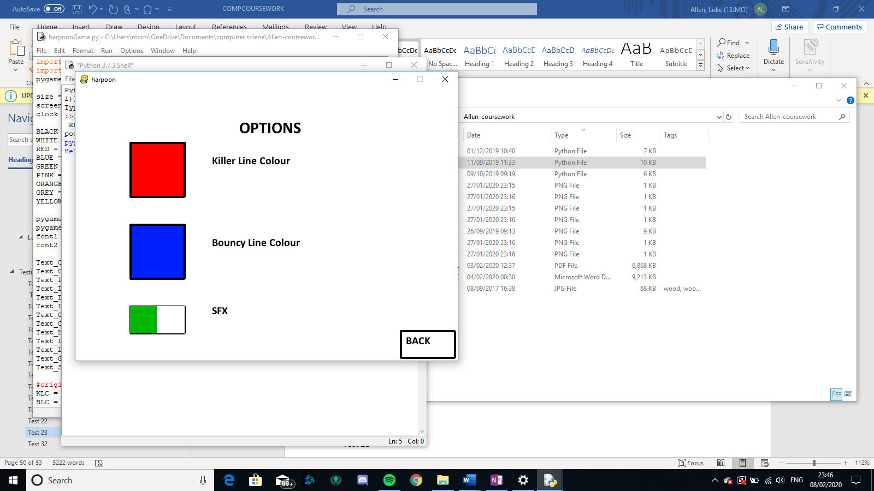



From the top left home page to the options page via the options buttons being clicked and then back to the home page after the back button is pressed

Test 33

Test 34

Test 35

Test 36

Test 37

Test 38

Test 39

Test 40

Test 41

Test 42

Test 43

Test 44

Test 45

Test 46

Test 47

Test 48

Test 49

Test 50

Test 51

Test 52

Test 53

Test 54

Test 55

Test 56

Test 57

Test 58

Test 59

Test 60

Test 61

Test 62

Test 63

Test 64

Test 65

Test 66

Test 67

Test 68

|  |  |  |
| --- | --- | --- |
| **Test** | **Description** | **Exp out** |
| 1 | Screen has area 500 by 700 pixels | Screen displayed |
| 2 | When the game starts, the user will start on the home page | Home page shown |
| 3 | The home page will Say “harpoon game at top”, have a continuous, levels, level_builder and options buttons. | Home page shown |
| 4 | When the continuous button is clicked, it takes you to a page where name/nickname can be inputted | Something happens when button clicked |
| 5 | When the levels button is clicked, takes you to the levels page | Something happens when button clicked |
| 6 | When the level builder button is clicked, it will take you to the create or edit screen | Create or edit screen appears |
| 7 | When the options page is clicked, it will take you to the options page | Something happens when button clicked |
| 8 | Continuous - When typing, the letters you type appear on the screen (in the box) | Letters typed appears |
| 9 | When a typing box is selected, the outline of the box will become thicker | Outline of box becomes thick |
| 10 | Once enter box is pressed, the box will disappear, and game will begin | Box disappears |
| 11 | Gun appear on screen at position | Gun appears |
| 12 | “press space to start” appears on screen | “press space to start” appears on screen |
| 13 | The gun is pointing at a random direction | The gun is pointing at a random direction |
| 14 | There are wooden blocks on the screen | Wooden blocks appear |
| 15 | The blocks appear in a random x coordinate on the screen | The blocks appear in a random x coordinate on the screen |
| 16 | There is a score on the top-right of the score | Word “score:” appears |
| 17 | “press space to start” disappears when space is pressed | “press space to start” disappears |
| 18 | Gun spins when space bar is pressed | Gun spins |
| 19 | Gun spins around its center | Gun spins around center |
| 20 | Gun moves, in direction it is pointing when space bar release | Gun moves in direction it is pointing |
| 21 | All objects on the screen moves down | All objects on the screen moves down |
| 22 | If the gun hits a block, the gun replaces the block | Gun replaces block |
| 23 | The score goes up once, every time the gun hits a wooden block | Score goes up |
| 24 | Every time the score goes up by 5, the screen changes colour | Screen colour changes |
| 25 | If the gun hits the sides, the game ends. | Continuous game end |
| 26 | When the player dies, the screen fades | Screen fades |
| 27 | After death, there is a death screen with replay, home and leader board buttons and shows your best and current score and a settings button in top right corner | Death screen appears |
| 28 | When settings buttons are clicked they will go to settings | Settings appear |
| 29 | If the replay button is pressed, continuous game restarts | Continuous game reappears |
| 30 | If the home button is pressed, the player is taken back to the home screen | Home screen appears |
| 31 | If the leader board button is pressed, a leader board of top ten will come up with the rank, name and score. There will also be a back button | Leaderboard appears |
| 32 | If a back button is pressed, then the player will be taken back to the previous page | Previous page appears |
| 33 | Levels – The levels page loads, with the 3 continuous levels and 3 speed trial levels and a button to play self-created levels | Levels page appears |
| 34 | When a level is clicked the user is taken to the level and the wooden blocks, kl blocks and blocks and final block appears | Level appears |
| 35 | the blocks appear in correct positions | Blocks appear correctly |
| 36 | The blocks do not go down | Blocks don’t move down |
| 37 | The screen always has the player at the center of the screen | Centre of gun doesn’t move |
| 38 | There is a kl at the edge of the levels so that the player can know where the maps ends. | 🡪 |
| 39 | when the player dies on a level, the deathscreen also has another levels button. | Deathscreen appears |
| 40 | When the self built levels button is clicked then a list of the levels | List of levels appears |
| 41 | The self built list will have the levels name, creator, date modified. | List is detailed |
| 42 | When a locked level is clicked, a large lock sign will appear for a second, then go away | Sign appears |
| 43 | If someone hovers of their mouse over a lock, a message will appear saying what you have to do to play this feature. | Message appears where top left corner is where mouse is |
| 44 | In level builder – once button is clicked a screen with only two buttons will appear, one saying “create new” and the other saying “edit” | Blank screen with only 2 boxes saying “create new” and “edit” |
| 45 | The edit button will not work if there are no existing levels | Edit button looks greyer |
| 46 | If the create new button is hit user will be taken to a page where they input name of level, name of creator, and difficulty out of 3 they would find it. Then there will be a be a button saying start creation | Blank page with input boxes for name of level and creator and a drag key for level of difficulty |
| 47 | When start creation is pressed, you will be taken to a blank screen with only the options buttons and a save and quit button | Blank screen with options button on top right and save and quit on top left |
| 48 | On the blank screen if the kl key is pressed, a killer line will appear | Killer coloured block top left of screen |
| 49 | If bl key is pressed, bouncy line will appear | bouncy block top left |
| 50 | If checkpoint key is pressed, checkpoint will appear | Wooden block top left appears |
| 51 | If final block button is pressed, final block will appear. | Golden wooden block top left appears |
| 52 | if a block is clicked on, it will be “selected”, a dotted line will appear around it, it will have small circle at corners and sides and there will be a drag bar at the bottom of screen | Box with circles on edges appears around block |
| 53 | If one of the small circles are clicked and pulled, then the shape of block will change | lock on level builder button |
| 54 | If the drag bar is pulled, then the object will rotate | Object rotates |
| 55 | If the main area of the object is clicked, then it will be dragged wherever the mouse goes | Block follows mouse |
| 56 | The outline of area can be selected and grown | Box appears around large red lined box |
| 57 | A harpoon starts in middle of screen | Green area appears |
| 58 | If you scroll your mouse the entire screen zooms in or out | Zoom out or in |
| 59 | If blank area is dragged, then all the object go in direction of mouse movement | All objects move in direction of mouse |
| 60 | Settings – if settings is clicked, the settings page will appear | Settings appears |
| 61 | If the coloured box is clicked a new page with that colour and other colours appear. | New page appears with other colours |
| 62 | The colours that are already being used have non-black rims around it saying that this cannot be selected | Different coloured rims on different colours |
| 63 | If a black rimed colour is selected than the coloured rim is transferred to the new colour | The coloured rim is transferred to the new colour |
| 64 | If a coloured rimed colour is selected, nothing happens | Nothing happens |
| 65 | if back button is selected, the colour changer page is removed, and new colour replaces old colour | the colour changer page is removed, and new colour replaces old colour |
| 66 | If view controls is clicked then the blank page with different buttons for different controls appear | Blank page with boxes with a letter/key in each box and what they do next to the boxes |
| 67 | If box clicked “click key wanted” appears | “click key wanted” appears |
| 68 | If already used key is clicked, then nothing happens | Nothing happens |
| 69 | If not already used key is clicked, button pressed replaces previous button on the controls | Previous key is replaced by new key |

# Evaluation